
School of Computing
Department of Computer Science and Engineering
ACADEMIC YEAR: 2025-26
(WINTER SEMESTER)

LAB RECORD

10211CS224 - Full Stack Application Development

NAME : K. LIKITH KUMAR
VTU.NO : 24742
REG.NO : 23UECS1104
BRANCH : CSE(AI&DS)
YEAR/SEM : 3rd year, 6th sem
SLOT : E2

10211CS224 - Full Stack Application Development
TABLE OF CONTENTS
Task No | Date | Experiment Title
 | 06-01-2026 | Student Registration System with Database Storage and Retrieval
 | 07-01-2026 | Data Retrieval, Sorting, and Filtering Dashboard
 | 28-01-2026 | Login System with Input Validation and Authentication
 | 03-02-2026 | Order Management Using SQL Joins and Subqueries
 | 04-02-2026 | Transaction-Based Payment Simulation Using COMMIT and ROLLBACK
 | 10-02-2026 | Automated Logging Using Database Triggers and Views
 | 12-02-2026 | Interactive Web Form Using JavaScript Events and Functions
 | 17-02-2026 | Employee Management Using Spring Core and Dependency Injection
 | 18-02-2026 | Spring MVC Application Using Annotation-Based Configuration
 | 25-02-2026 | Student CRUD Operations Using Spring Boot and JPA
 | 26-02-2023 | Data Access Using Spring Data JPA with Sorting and Pagination
 | 03-02-2026 | RESTful API for Product Management Using Spring Boot
 | 04-03-2026 | Exception Handling and Validation in RESTful Applications
 | 10-03-2026 | Microservices Architecture with Service Decomposition
 | 11-03-2026 | Service Registry and Discovery Using Eureka
 | 17-03-2026 | API Gateway with Load Balancing for Microservices
 | 18-03-2026 | Inter-Service Communication Using REST APIs
 | 24-03-2026 | Unit Testing for Microservices Applications
 | 28-03-2026 | Version Control Using Git and Remote Repositories
 | 01-04-2026 | Git Branching, Merging, and Conflict Resolution
 | 08-04-2026 | CI/CD Pipeline for Automated Build and Deployment
 | 15-04-2026 | Cloud Service Providers Comparison and Pricing Models
 | 21-04-2026 | Prompt Engineering for Code Generation Using Generative AI
 | 28-04-2026 | Cloud-Based Application Using Vibe Coding and Generative AI
 | 29-04-2026 | Use Cases

TASK QUESTION
Task 1
AIM
To design and implement the given task using appropriate technologies, ensuring proper functionality and accurate output generation.
ALGORITHM
1. Start the process and identify the requirements clearly. Understand what the task is supposed to achieve.
2. Set up the development environment by installing required tools like IDE, database, and frameworks.
3. Create a new project and organize folders/files properly based on the chosen technology.
4. Design the user interface or database schema according to the task requirements.
5. Create database tables or entities to store and manage data effectively.
6. Write the program logic including validation, processing, and required functionalities.
7. Integrate frontend and backend components to ensure smooth data flow.
8. Compile and run the application to check for errors and ensure proper execution.
9. Test the application with different inputs to verify correctness and performance.
10. Display the output and confirm expected results, then successfully complete the task.
CODE
// File: student-registration.html
<!DOCTYPE html>
<html lang="en">
<head>
<meta charset="UTF-8">
<meta name="viewport" content="width=device-width, initial-scale=1.0">
<title>Student Registration System</title>
<style>
* {
margin: 0;
padding: 0;
box-sizing: border-box;
}
body {
font-family: 'Segoe UI', Tahoma, Geneva, Verdana, sans-serif;
background: linear-gradient(135deg, #667eea 0%, #764ba2 100%);
min-height: 100vh;
padding: 20px;
}
.container {
max-width: 1200px;
margin: 0 auto;
}
.header {
text-align: center;
color: white;
margin-bottom: 30px;
}
.header h1 {
font-size: 2.5rem;
margin-bottom: 10px;
text-shadow: 2px 2px 4px rgba(0,0,0,0.3);
}
.content-wrapper {
display: grid;
grid-template-columns: 1fr 2fr;
gap: 30px;
align-items: start;
}
.form-section, .table-section {
background: white;
border-radius: 15px;
padding: 30px;
box-shadow: 0 10px 30px rgba(0,0,0,0.2);
}
.form-section h2, .table-section h2 {
color: #333;
margin-bottom: 20px;
font-size: 1.5rem;
border-bottom: 3px solid #667eea;
padding-bottom: 10px;
}
.form-group {
margin-bottom: 20px;
}
.form-group label {
display: block;
margin-bottom: 5px;
color: #555;
font-weight: 600;
}
.form-group input,
.form-group select {
width: 100%;
padding: 12px;
border: 2px solid #e1e1e1;
border-radius: 8px;
font-size: 16px;
transition: border-color 0.3s ease;
}
.form-group input:focus,
.form-group select:focus {
outline: none;
border-color: #667eea;
box-shadow: 0 0 0 3px rgba(102, 126, 234, 0.1);
}
.form-group input.error {
border-color: #e74c3c;
}
.error-message {
color: #e74c3c;
font-size: 14px;
margin-top: 5px;
display: none;
}
.btn {
padding: 12px 24px;
border: none;
border-radius: 8px;
font-size: 16px;
font-weight: 600;
cursor: pointer;
transition: all 0.3s ease;
margin-right: 10px;
}
.btn-primary {
background: linear-gradient(135deg, #667eea 0%, #764ba2 100%);
color: white;
}
.btn-primary:hover {
transform: translateY(-2px);
box-shadow: 0 5px 15px rgba(102, 126, 234, 0.4);
}
.btn-danger {
background: linear-gradient(135deg, #e74c3c 0%, #c0392b 100%);
color: white;
}
.btn-danger:hover {
transform: translateY(-2px);
box-shadow: 0 5px 15px rgba(231, 76, 60, 0.4);
}
.message {
padding: 15px;
border-radius: 8px;
margin-bottom: 20px;
display: none;
animation: slideIn 0.3s ease;
}
.message.success {
background: #d4edda;
color: #155724;
border: 1px solid #c3e6cb;
}
.message.error {
background: #f8d7da;
color: #721c24;
border: 1px solid #f5c6cb;
}
@keyframes slideIn {
from {
opacity: 0;
transform: translateY(-20px);
}
to {
opacity: 1;
transform: translateY(0);
}
}
.student-table {
width: 100%;
border-collapse: collapse;
margin-top: 20px;
}
.student-table thead {
background: linear-gradient(135deg, #667eea 0%, #764ba2 100%);
color: white;
}
.student-table th,
.student-table td {
padding: 12px;
text-align: left;
border-bottom: 1px solid #e1e1e1;
}
.student-table tbody tr:hover {
background: #f8f9fa;
}
.no-records {
text-align: center;
padding: 40px;
color: #666;
font-style: italic;
}
.table-controls {
margin-bottom: 20px;
display: flex;
justify-content: space-between;
align-items: center;
}
.record-count {
color: #666;
font-weight: 600;
}
@media (max-width: 768px) {
.content-wrapper {
grid-template-columns: 1fr;
}
.header h1 {
font-size: 2rem;
}
.form-section, .table-section {
padding: 20px;
}
}
.loading {
display: inline-block;
width: 20px;
height: 20px;
border: 3px solid #f3f3f3;
border-top: 3px solid #667eea;
border-radius: 50%;
animation: spin 1s linear infinite;
margin-left: 10px;
}
@keyframes spin {
0% { transform: rotate(0deg); }
100% { transform: rotate(360deg); }
}
</style>
</head>
<body>
<div class="container">
<header class="header">
<h1>🎓 Student Registration System</h1>
<p>Register and manage student records with Web SQL Database</p>
</header>
<div class="content-wrapper">
<section class="form-section">
<h2>Register New Student</h2>
<div id="message" class="message"></div>
<form id="studentForm">
<div class="form-group">
<label for="fullName">Full Name *</label>
<input type="text" id="fullName" name="fullName" placeholder="Enter student's full name" required>
<div class="error-message" id="nameError">Please enter a valid name (at least 3 characters)</div>
</div>
<div class="form-group">
<label for="email">Email Address *</label>
<input type="email" id="email" name="email" placeholder="student@example.com" required>
<div class="error-message" id="emailError">Please enter a valid email address</div>
</div>
<div class="form-group">
<label for="dob">Date of Birth *</label>
<input type="date" id="dob" name="dob" required>
<div class="error-message" id="dobError">Please select a valid date of birth</div>
</div>
<div class="form-group">
<label for="department">Department *</label>
<select id="department" name="department" required>
<option value="">Select Department</option>
<option value="CSE">Computer Science Engineering</option>
<option value="ECE">Electronics and Communication Engineering</option>
<option value="EEE">Electrical and Electronics Engineering</option>
<option value="Mechanical">Mechanical Engineering</option>
<option value="Civil">Civil Engineering</option>
</select>
<div class="error-message" id="departmentError">Please select a department</div>
</div>
<div class="form-group">
<label for="phone">Phone Number *</label>
<input type="tel" id="phone" name="phone" placeholder="10-digit phone number" maxlength="10" required>
<div class="error-message" id="phoneError">Please enter a valid 10-digit phone number</div>
</div>
<button type="submit" class="btn btn-primary">
Register Student
</button>
<button type="button" class="btn btn-secondary" onclick="resetForm()">
Clear Form
</button>
</form>
</section>
<section class="table-section">
<h2>Registered Students</h2>
<div class="table-controls">
<span class="record-count" id="recordCount">Total Records: 0</span>
<button class="btn btn-danger" onclick="deleteAllRecords()">
Delete All Records
</button>
</div>
<div id="tableContainer">
<div class="no-records">No student records found. Register your first student!</div>
</div>
</section>
</div>
</div>
<script>
// Database variables
let db;
const DB_NAME = 'StudentDB';
const DB_VERSION = '1.0';
const DB_DISPLAY_NAME = 'Student Registration Database';
const DB_SIZE = 2 * 1024 * 1024; // 2MB
// Initialize database
function initDatabase() {
try {
db = openDatabase(DB_NAME, DB_VERSION, DB_DISPLAY_NAME, DB_SIZE);
db.transaction(function(tx) {
// Create students table if it doesn't exist
tx.executeSql(
`CREATE TABLE IF NOT EXISTS students (
id INTEGER PRIMARY KEY AUTOINCREMENT,
name TEXT NOT NULL,
email TEXT UNIQUE NOT NULL,
dob TEXT NOT NULL,
department TEXT NOT NULL,
phone TEXT NOT NULL,
created_at DATETIME DEFAULT CURRENT_TIMESTAMP
)`,
[],
function(tx, result) {
console.log('Table created successfully');
loadStudents();
},
function(tx, error) {
console.error('Error creating table:', error);
showMessage('Error initializing database: ' + error.message, 'error');
}
);
});
} catch (error) {
console.error('Error opening database:', error);
showMessage('Web SQL is not supported in this browser. Please use a compatible browser.', 'error');
}
}
// Form validation
function validateForm() {
let isValid = true;
// Reset error states
document.querySelectorAll('.error-message').forEach(msg => msg.style.display = 'none');
document.querySelectorAll('input, select').forEach(field => field.classList.remove('error'));
// Validate name
const name = document.getElementById('fullName').value.trim();
if (name.length < 3) {
document.getElementById('nameError').style.display = 'block';
document.getElementById('fullName').classList.add('error');
isValid = false;
}
// Validate email
const email = document.getElementById('email').value.trim();
const emailRegex = /^[^\s@]+@[^\s@]+\.[^\s@]+$/;
if (!emailRegex.test(email)) {
document.getElementById('emailError').style.display = 'block';
document.getElementById('email').classList.add('error');
isValid = false;
}
// Validate date of birth
const dob = document.getElementById('dob').value;
if (!dob) {
document.getElementById('dobError').style.display = 'block';
document.getElementById('dob').classList.add('error');
isValid = false;
} else {
// Check if age is reasonable (between 16 and 60 years)
const dobDate = new Date(dob);
const today = new Date();
const age = Math.floor((today - dobDate) / (365.25 * 24 * 60 * 60 * 1000));
if (age < 16 || age > 60) {
document.getElementById('dobError').textContent = 'Age should be between 16 and 60 years';
document.getElementById('dobError').style.display = 'block';
document.getElementById('dob').classList.add('error');
isValid = false;
}
}
// Validate department
const department = document.getElementById('department').value;
if (!department) {
document.getElementById('departmentError').style.display = 'block';
document.getElementById('department').classList.add('error');
isValid = false;
}
// Validate phone
const phone = document.getElementById('phone').value.trim();
const phoneRegex = /^[6-9]\d{9}$/;
if (!phoneRegex.test(phone)) {
document.getElementById('phoneError').style.display = 'block';
document.getElementById('phone').classList.add('error');
isValid = false;
}
return isValid;
}
// Check for duplicate email
function checkDuplicateEmail(email, callback) {
db.transaction(function(tx) {
tx.executeSql(
'SELECT id FROM students WHERE email = ?',
[email],
function(tx, result) {
callback(result.rows.length > 0);
},
function(tx, error) {
console.error('Error checking duplicate email:', error);
callback(false);
}
);
});
}
// Insert student record
function insertStudent(studentData) {
db.transaction(function(tx) {
tx.executeSql(
'INSERT INTO students (name, email, dob, department, phone) VALUES (?, ?, ?, ?, ?)',
[studentData.name, studentData.email, studentData.dob, studentData.department, studentData.phone],
function(tx, result) {
showMessage('Student registered successfully!', 'success');
resetForm();
loadStudents();
},
function(tx, error) {
console.error('Error inserting student:', error);
if (error.message.includes('UNIQUE constraint failed')) {
showMessage('This email address is already registered!', 'error');
} else {
showMessage('Error registering student: ' + error.message, 'error');
}
}
);
});
}
// Load all students
function loadStudents() {
db.transaction(function(tx) {
tx.executeSql(
'SELECT * FROM students ORDER BY created_at DESC',
[],
function(tx, result) {
displayStudents(result.rows);
},
function(tx, error) {
console.error('Error loading students:', error);
showMessage('Error loading student data: ' + error.message, 'error');
}
);
});
}
// Display students in table
function displayStudents(rows) {
const container = document.getElementById('tableContainer');
const recordCount = document.getElementById('recordCount');
recordCount.textContent = `Total Records: ${rows.length}`;
if (rows.length === 0) {
container.innerHTML = '<div class="no-records">No student records found. Register your first student!</div>';
return;
}
let tableHTML = `
<table class="student-table">
<thead>
<tr>
<th>ID</th>
<th>Name</th>
<th>Email</th>
<th>Date of Birth</th>
<th>Department</th>
<th>Phone</th>
</tr>
</thead>
<tbody>
`;
for (let i = 0; i < rows.length; i++) {
const student = rows[i];
const formattedDate = new Date(student.dob).toLocaleDateString('en-US', {
year: 'numeric',
month: 'short',
day: 'numeric'
});
tableHTML += `
<tr>
<td>${student.id}</td>
<td>${student.name}</td>
<td>${student.email}</td>
<td>${formattedDate}</td>
<td>${student.department}</td>
<td>${student.phone}</td>
</tr>
`;
}
tableHTML += '</tbody></table>';
container.innerHTML = tableHTML;
}
// Delete all records
function deleteAllRecords() {
if (confirm('Are you sure you want to delete all student records? This action cannot be undone.')) {
db.transaction(function(tx) {
tx.executeSql(
'DELETE FROM students',
[],
function(tx, result) {
showMessage('All records deleted successfully!', 'success');
loadStudents();
},
function(tx, error) {
console.error('Error deleting records:', error);
showMessage('Error deleting records: ' + error.message, 'error');
}
);
});
}
}
// Reset form
function resetForm() {
document.getElementById('studentForm').reset();
document.querySelectorAll('.error-message').forEach(msg => msg.style.display = 'none');
document.querySelectorAll('input, select').forEach(field => field.classList.remove('error'));
}
// Show message
function showMessage(text, type) {
const messageEl = document.getElementById('message');
messageEl.textContent = text;
messageEl.className = `message ${type}`;
messageEl.style.display = 'block';
// Auto-hide after 5 seconds
setTimeout(() => {
messageEl.style.display = 'none';
}, 5000);
}
// Form submission handler
document.getElementById('studentForm').addEventListene
OUTPUT
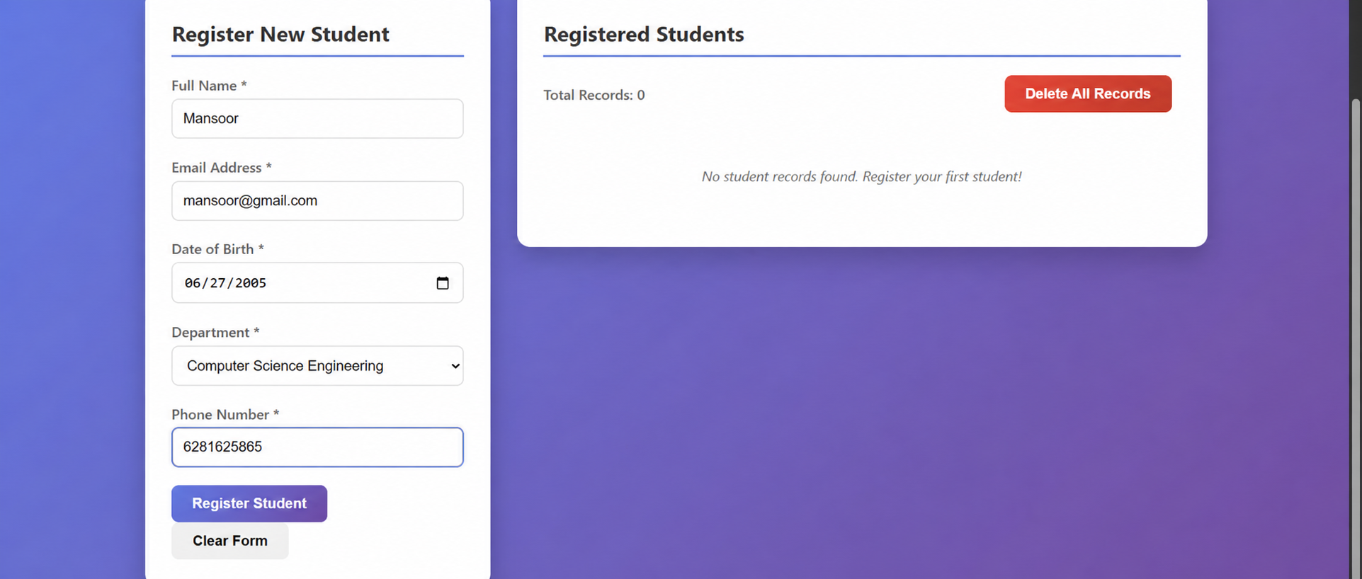

RESULT
The task was successfully implemented and executed. The expected output was obtained, demonstrating correct functionality and performance.

TASK QUESTION
Task 2
AIM
To design and implement the given task using appropriate technologies, ensuring proper functionality and accurate output generation.
ALGORITHM
1. Start the process and identify the requirements clearly. Understand what the task is supposed to achieve.
2. Set up the development environment by installing required tools like IDE, database, and frameworks.
3. Create a new project and organize folders/files properly based on the chosen technology.
4. Design the user interface or database schema according to the task requirements.
5. Create database tables or entities to store and manage data effectively.
6. Write the program logic including validation, processing, and required functionalities.
7. Integrate frontend and backend components to ensure smooth data flow.
8. Compile and run the application to check for errors and ensure proper execution.
9. Test the application with different inputs to verify correctness and performance.
10. Display the output and confirm expected results, then successfully complete the task.
CODE
// File: dashboard.html
<!DOCTYPE html>
<html lang="en">
<head>
<meta charset="UTF-8">
<meta name="viewport" content="width=device-width, initial-scale=1.0">
<title>Data Retrieval & Sorting Dashboard</title>
<style>
* {
margin: 0;
padding: 0;
box-sizing: border-box;
}
body {
font-family: 'Segoe UI', Tahoma, Geneva, Verdana, sans-serif;
background-color: white;
color: #333;
line-height: 1.6;
}
.container {
max-width: 1400px;
margin: 0 auto;
padding: 20px;
}
header {
background: linear-gradient(135deg, #667eea 0%, #764ba2 100%);
color: white;
padding: 30px 0;
text-align: center;
border-radius: 10px;
margin-bottom: 30px;
box-shadow: 0 4px 6px rgba(0,0,0,0.1);
}
h1 {
font-size: 2.5em;
margin-bottom: 10px;
}
.subtitle {
font-size: 1.1em;
opacity: 0.9;
}
.dashboard-grid {
display: grid;
grid-template-columns: 1fr 300px;
gap: 30px;
margin-bottom: 30px;
}
.main-content {
background: white;
border-radius: 10px;
padding: 25px;
box-shadow: 0 2px 10px rgba(0,0,0,0.1);
}
.sidebar {
background: white;
border-radius: 10px;
padding: 25px;
box-shadow: 0 2px 10px rgba(0,0,0,0.1);
height: fit-content;
}
.controls-section {
background: #f8f9fa;
border-radius: 8px;
padding: 20px;
margin-bottom: 25px;
}
.controls-grid {
display: grid;
grid-template-columns: repeat(auto-fit, minmax(200px, 1fr));
gap: 15px;
margin-bottom: 15px;
}
.control-group {
display: flex;
flex-direction: column;
}
label {
font-weight: 600;
margin-bottom: 5px;
color: #555;
font-size: 0.9em;
}
input[type="text"], select {
padding: 10px;
border: 2px solid #e1e5e9;
border-radius: 5px;
font-size: 14px;
transition: border-color 0.3s ease;
}
input[type="text"]:focus, select:focus {
outline: none;
border-color: #667eea;
}
.button-group {
display: flex;
gap: 10px;
flex-wrap: wrap;
}
button {
background: linear-gradient(135deg, #667eea 0%, #764ba2 100%);
color: white;
border: none;
padding: 10px 20px;
border-radius: 5px;
cursor: pointer;
font-size: 14px;
font-weight: 600;
transition: transform 0.2s ease, box-shadow 0.2s ease;
}
button:hover {
transform: translateY(-2px);
box-shadow: 0 4px 8px rgba(0,0,0,0.2);
}
button:active {
transform: translateY(0);
}
.secondary-btn {
background: #6c757d;
}
.table-container {
overflow-x: auto;
border-radius: 8px;
box-shadow: 0 2px 4px rgba(0,0,0,0.1);
}
table {
width: 100%;
border-collapse: collapse;
background: white;
}
th, td {
padding: 12px;
text-align: left;
border-bottom: 1px solid #e1e5e9;
}
th {
background: #f8f9fa;
font-weight: 600;
color: #495057;
position: sticky;
top: 0;
}
tr:hover {
background-color: #f8f9fa;
}
.highlight {
background-color: #fff3cd !important;
animation: highlight 0.5s ease;
}
@keyframes highlight {
0% { background-color: #ffeaa7; }
100% { background-color: #fff3cd; }
}
.no-records {
text-align: center;
padding: 40px;
color: #6c757d;
font-size: 1.1em;
}
.analytics-card {
background: linear-gradient(135deg, #f093fb 0%, #f5576c 100%);
color: white;
border-radius: 8px;
padding: 20px;
margin-bottom: 20px;
}
.analytics-card h3 {
margin-bottom: 15px;
font-size: 1.2em;
}
.department-count {
display: flex;
justify-content: space-between;
padding: 8px 0;
border-bottom: 1px solid rgba(255,255,255,0.2);
}
.department-count:last-child {
border-bottom: none;
}
.department-name {
font-weight: 600;
}
.count-badge {
background: rgba(255,255,255,0.2);
padding: 2px 8px;
border-radius: 12px;
font-size: 0.9em;
}
.stats-grid {
display: grid;
grid-template-columns: 1fr 1fr;
gap: 15px;
margin-top: 20px;
}
.stat-item {
background: rgba(255,255,255,0.1);
padding: 15px;
border-radius: 8px;
text-align: center;
}
.stat-number {
font-size: 2em;
font-weight: bold;
margin-bottom: 5px;
}
.stat-label {
font-size: 0.9em;
opacity: 0.9;
}
@media (max-width: 768px) {
.dashboard-grid {
grid-template-columns: 1fr;
}
.controls-grid {
grid-template-columns: 1fr;
}
.stats-grid {
grid-template-columns: 1fr;
}
h1 {
font-size: 2em;
}
}
.loading {
display: inline-block;
width: 20px;
height: 20px;
border: 3px solid #f3f3f3;
border-top: 3px solid #667eea;
border-radius: 50%;
animation: spin 1s linear infinite;
}
@keyframes spin {
0% { transform: rotate(0deg); }
100% { transform: rotate(360deg); }
}
</style>
</head>
<body>
<div class="container">
<header>
<h1>📊 Data Retrieval & Sorting Dashboard</h1>
<p class="subtitle">Student/Employee Records Management System</p>
</header>
<div class="dashboard-grid">
<main class="main-content">
<section class="controls-section">
<div class="controls-grid">
<div class="control-group">
<label for="searchInput">🔍 Search by Name</label>
<input type="text" id="searchInput" placeholder="Enter name to search...">
</div>
<div class="control-group">
<label for="departmentFilter">🏢 Department Filter</label>
<select id="departmentFilter">
<option value="all">All Departments</option>
<option value="CSE">Computer Science</option>
<option value="ECE">Electronics & Communication</option>
<option value="EEE">Electrical & Electronics</option>
<option value="Mechanical">Mechanical Engineering</option>
<option value="Civil">Civil Engineering</option>
</select>
</div>
</div>
<div class="button-group">
<button onclick="sortByName('asc')">📝 Name A→Z</button>
<button onclick="sortByName('desc')">📝 Name Z→A</button>
<button onclick="sortByDOB('asc')">📅 DOB Youngest→Oldest</button>
<button onclick="sortByDOB('desc')">📅 DOB Oldest→Youngest</button>
<button class="secondary-btn" onclick="resetFilters()">🔄 Reset All</button>
</div>
</section>
<section class="table-container">
<table id="dataTable">
<thead>
<tr>
<th>Name</th>
<th>Email</th>
<th>Date of Birth</th>
<th>Department</th>
<th>Phone</th>
</tr>
</thead>
<tbody id="tableBody">
</tbody>
</table>
<div id="noRecords" class="no-records" style="display: none;">
<p>📭 No records found</p>
<p>Try adjusting your filters or search criteria</p>
</div>
</section>
</main>
<aside class="sidebar">
<div class="analytics-card">
<h3>📈 Department Analytics</h3>
<div id="departmentCounts"></div>
</div>
<div class="stats-grid">
<div class="stat-item">
<div class="stat-number" id="totalRecords">0</div>
<div class="stat-label">Total Records</div>
</div>
<div class="stat-item">
<div class="stat-number" id="filteredRecords">0</div>
<div class="stat-label">Filtered Records</div>
</div>
</div>
</aside>
</div>
</div>
<script>
class DataDashboard {
constructor() {
this.originalData = [];
this.filteredData = [];
this.initializeDatabase();
this.attachEventListeners();
}
initializeDatabase() {
if (!localStorage.getItem('studentData')) {
const sampleData = [
{ name: "Alice Johnson", email: "alice@example.com", dob: "2000-05-15", department: "CSE", phone: "123-456-7890" },
{ name: "Bob Smith", email: "bob@example.com", dob: "1999-08-22", department: "ECE", phone: "234-567-8901" },
{ name: "Charlie Brown", email: "charlie@example.com", dob: "2001-02-10", department: "EEE", phone: "345-678-9012" },
{ name: "Diana Prince", email: "diana@example.com", dob: "2000-11-30", department: "Mechanical", phone: "456-789-0123" },
{ name: "Edward Norton", email: "edward@example.com", dob: "1999-04-18", department: "Civil", phone: "567-890-1234" },
{ name: "Fiona Green", email: "fiona@example.com", dob: "2001-07-25", department: "CSE", phone: "678-901-2345" },
{ name: "George Wilson", email: "george@example.com", dob: "2000-09-12", department: "ECE", phone: "789-012-3456" },
{ name: "Hannah Baker", email: "hannah@example.com", dob: "1999-12-05", department: "EEE", phone: "890-123-4567" },
{ name: "Ian McKellen", email: "ian@example.com", dob: "2001-03-28", department: "Mechanical", phone: "901-234-5678" },
{ name: "Julia Roberts", email: "julia@example.com", dob: "2000-06-14", department: "Civil", phone: "012-345-6789" },
{ name: "Kevin Hart", email: "kevin@example.com", dob: "1999-10-08", department: "CSE", phone: "123-456-7891" },
{ name: "Laura Palmer", email: "laura@example.com", dob: "2001-01-20", department: "ECE", phone: "234-567-8902" },
{ name: "Michael Scott", email: "michael@example.com", dob: "2000-08-03", department: "EEE", phone: "345-678-9013" },
{ name: "Nancy Drew", email: "nancy@example.com", dob: "1999-05-17", department: "Mechanical", phone: "456-789-0124" },
{ name: "Oscar Wilde", email: "oscar@example.com", dob: "2001-12-01", department: "Civil", phone: "567-890-1235" }
];
localStorage.setItem('studentData', JSON.stringify(sampleData));
}
this.loadData();
}
loadData() {
const storedData = localStorage.getItem('studentData');
this.originalData = JSON.parse(storedData);
this.filteredData = [...this.originalData];
this.renderTable();
this.updateAnalytics();
}
attachEventListeners() {
document.getElementById('searchInput').addEventListener('input', (e) => {
this.searchByName(e.target.value);
});
document.getElementById('departmentFilter').addEventListener('change', (e) => {
this.filterByDepartment(e.target.value);
});
}
searchByName(searchTerm) {
const term = searchTerm.toLowerCase();
if (term === '') {
this.filteredData = [...this.originalData];
} else {
this.filteredData = this.originalData.filter(person =>
person.name.toLowerCase().includes(term)
);
}
const currentDept = document.getElementById('departmentFilter').value;
if (currentDept !== 'all') {
this.filteredData = this.filteredData.filter(person =>
person.department === currentDept
);
}
this.renderTable();
this.updateAnalytics();
this.highlightSearchResults(term);
}
filterByDepartment(department) {
if (department === 'all') {
this.filteredData = [...this.originalData];
} else {
this.filteredData = this.originalData.filter(person =>
person.department === department
);
}
const searchTerm = document.getElementById('searchInput').value;
if (searchTerm !== '') {
this.filteredData = this.filteredData.filter(person =>
person.name.toLowerCase().includes(searchTerm.toLowerCase())
);
}
this.renderTable();
this.updateAnalytics();
}
sortByName(order) {
this.filteredData.sort((a, b) => {
if (order === 'asc') {
return a.name.localeCompare(b.name);
} else {
return b.name.localeCompare(a.name);
}
});
this.renderTable();
this.highlightSortedRows();
}
sortByDOB(order) {
this.filteredData.sort((a, b) => {
const dateA = new Date(a.dob);
const dateB = new Date(b.dob);
if (order === 'asc') {
return dateB - dateA;
} else {
return dateA - dateB;
}
});
this.renderTable();
this.highlightSortedRows();
}
renderTable() {
const tableBody = document.getElementById('tableBody');
const noRecords = document.getElementById('noRecords');
if (this.filteredData.length === 0) {
tableBody.innerHTML = '';
noRecords.style.display = 'block';
return;
}
noRecords.style.display = 'none';
tableBody.innerHTML = this.filteredData.map((person, index) => `
<tr data-index="${index}">
<td>${person.name}</td>
<td>${person.email}</td>
<td>${this.formatDate(person.dob)}</td>
<td>${person.department}</td>
<td>${person.phone}</td>
</tr>
`).join('');
}
formatDate(dateString) {
const date = new Date(dateString);
return date.toLocaleDateString('en-US', {
year: 'numeric',
month: 'short',
day: 'numeric'
});
}
updateAnalytics() {
const departmentCounts = {};
const departments = ['CSE', 'ECE', 'EEE', 'Mechanical', 'Civil'];
departments.forEach(dept => {
departmentCounts[dept] = this.originalData.filter(person =>
person.department === dept
).length;
});
const countsHtml = Object.entries(departmentCounts).map(([dept, count]) => `
<div class="department-count">
<span class="department-name">${dept}</span>
<span class="count-badge">${count}</span>
</div>
`).join('');
document.getElementById('departmentCounts').innerHTML = countsHtml;
document.getElementById('totalRecords').textContent = this.originalData.length;
document.getElementById('filteredRecords').textContent = this.filteredData.length;
}
highlightSearchResults(searchTerm) {
const rows = document.querySelectorAll('#tableBody tr');
rows.forEach(row => {
row.classList.remove('highlight');
const nameCell = row.cells[0];
if (searchTerm && nameCell.textContent.toLowerCase().includes(searchTerm.toLowerCase())) {
row.classList.add('highlight');
}
});
}
highlightSortedRows() {
const rows = document.querySelectorAll('#tableBody tr');
rows.forEach((row, index) => {
setTimeout(() => {
row.classList.add('highlight');
setTimeout(() => {
row.classList.remove('highlight');
}, 1000);
}, index * 50);
});
}
resetFilters() {
document.getElementById('searchInput').value = '';
document.getElementById('departmentFilter').value = 'all';
this.filteredData = [...this.originalData];
this.renderTable();
this.updateAnalytics();
}
}
function sortByName(order) {
dashboard.sortByName(order);
}
function sortByDOB(order) {
dashboard.sortByDOB(order);
}
function
OUTPUT
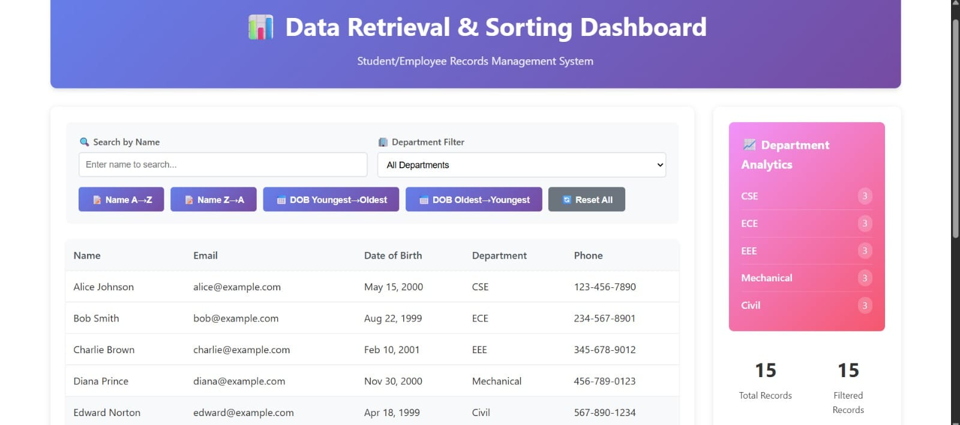

RESULT
The task was successfully implemented and executed. The expected output was obtained, demonstrating correct functionality and performance.

TASK QUESTION
Task 3
AIM
To design and implement the given task using appropriate technologies, ensuring proper functionality and accurate output generation.
ALGORITHM
1. Start the process and identify the requirements clearly. Understand what the task is supposed to achieve.
2. Set up the development environment by installing required tools like IDE, database, and frameworks.
3. Create a new project and organize folders/files properly based on the chosen technology.
4. Design the user interface or database schema according to the task requirements.
5. Create database tables or entities to store and manage data effectively.
6. Write the program logic including validation, processing, and required functionalities.
7. Integrate frontend and backend components to ensure smooth data flow.
8. Compile and run the application to check for errors and ensure proper execution.
9. Test the application with different inputs to verify correctness and performance.
10. Display the output and confirm expected results, then successfully complete the task.
CODE
// File: index.html
<!DOCTYPE html>
<html lang="en">
<head>
<meta charset="UTF-8">
<meta name="viewport" content="width=device-width, initial-scale=1.0">
<title>Login - Premium Experience</title>
<style>
@import url('https://fonts.googleapis.com/css2?family=Inter:wght@300;400;500;600;700&display=swap');
:root {
--primary: #6366f1;
--primary-hover: #4f46e5;
--bg-start: #0f172a;
--bg-end: #1e1b4b;
--surface: rgba(30, 41, 59, 0.7);
--border: rgba(255, 255, 255, 0.1);
--text-main: #f8fafc;
--text-muted: #94a3b8;
--error: #ef4444;
--success: #22c55e;
}
* {
box-sizing: border-box;
margin: 0;
padding: 0;
font-family: 'Inter', sans-serif;
}
body {
min-height: 100vh;
display: flex;
align-items: center;
justify-content: center;
background: linear-gradient(135deg, var(--bg-start), var(--bg-end));
color: var(--text-main);
padding: 1rem;
}
.login-container {
background: var(--surface);
backdrop-filter: blur(16px);
-webkit-backdrop-filter: blur(16px);
border: 1px solid var(--border);
border-radius: 20px;
padding: 3rem;
width: 100%;
max-width: 420px;
box-shadow: 0 25px 50px -12px rgba(0, 0, 0, 0.5);
transform: translateY(0);
transition: transform 0.3s ease, box-shadow 0.3s ease;
}
.login-container:hover {
transform: translateY(-5px);
box-shadow: 0 30px 60px -12px rgba(0, 0, 0, 0.6);
}
.header {
text-align: center;
margin-bottom: 2.5rem;
}
.header h1 {
font-size: 2rem;
font-weight: 700;
margin-bottom: 0.5rem;
background: linear-gradient(to right, #a5b4fc, #818cf8);
-webkit-background-clip: text;
-webkit-text-fill-color: transparent;
}
.header p {
color: var(--text-muted);
font-size: 0.95rem;
}
.input-group {
margin-bottom: 1.5rem;
position: relative;
}
.input-group label {
display: block;
margin-bottom: 0.5rem;
font-size: 0.9rem;
font-weight: 500;
color: var(--text-muted);
transition: color 0.3s;
}
.input-field {
width: 100%;
padding: 1rem;
background: rgba(15, 23, 42, 0.6);
border: 1px solid var(--border);
border-radius: 10px;
color: var(--text-main);
font-size: 1rem;
outline: none;
transition: all 0.3s ease;
}
.input-field:focus {
border-color: var(--primary);
box-shadow: 0 0 0 3px rgba(99, 102, 241, 0.2);
}
.input-field:focus + label,
.input-group:focus-within label {
color: var(--primary);
}
.error-message {
color: var(--error);
font-size: 0.8rem;
margin-top: 0.5rem;
min-height: 1rem;
display: none;
opacity: 0;
transition: opacity 0.3s;
}
.error-message.visible {
display: block;
opacity: 1;
animation: slideDown 0.3s ease forwards;
}
.submit-btn {
width: 100%;
padding: 1rem;
background: var(--primary);
color: white;
border: none;
border-radius: 10px;
font-size: 1rem;
font-weight: 600;
cursor: pointer;
transition: all 0.3s ease;
margin-top: 1rem;
}
.submit-btn:hover {
background: var(--primary-hover);
transform: translateY(-2px);
box-shadow: 0 10px 20px -10px var(--primary);
}
.submit-btn:active {
transform: translateY(0);
}
.status-message {
margin-top: 1.5rem;
text-align: center;
font-size: 0.95rem;
font-weight: 500;
padding: 1rem;
border-radius: 8px;
display: none;
opacity: 0;
transition: all 0.3s;
}
.status-message.visible {
display: block;
opacity: 1;
animation: slideDown 0.3s ease forwards;
}
.status-success {
background: rgba(34, 197, 94, 0.1);
color: var(--success);
border: 1px solid rgba(34, 197, 94, 0.2);
}
.status-error {
background: rgba(239, 68, 68, 0.1);
color: var(--error);
border: 1px solid rgba(239, 68, 68, 0.2);
}
@keyframes slideDown {
from { transform: translateY(-10px); opacity: 0; }
to { transform: translateY(0); opacity: 1; }
}
/* Input shaking animation for errors */
@keyframes shake {
0%, 100% { transform: translateX(0); }
25% { transform: translateX(-5px); }
75% { transform: translateX(5px); }
}
.input-error {
border-color: var(--error);
animation: shake 0.4s ease-in-out;
}
</style>
</head>
<body>
<div class="login-container">
<div class="header">
<h1>Welcome Back</h1>
<p>Please enter your details to sign in</p>
</div>
<form id="loginForm" novalidate>
<div class="input-group">
<label for="email">Email</label>
<input type="email" id="email" class="input-field" placeholder="Enter your email" required autocomplete="off">
<div id="emailError" class="error-message"></div>
</div>
<div class="input-group">
<label for="password">Password</label>
<input type="password" id="password" class="input-field" placeholder="Enter your password" required>
<div id="passwordError" class="error-message"></div>
</div>
<button type="submit" class="submit-btn" id="loginBtn">Sign In</button>
</form>
<div id="statusMessage" class="status-message"></div>
</div>
<script>
// 1. Initialize Database Simulation (LocalStorage)
// Pre-populate some dummy user credentials if not present
if (!localStorage.getItem('users')) {
const dummyUsers = [
{ email: 'user@example.com', password: 'password123' },
{ email: 'admin@test.com', password: 'adminpass' }
];
localStorage.setItem('users', JSON.stringify(dummyUsers));
}
// 2. DOM Elements
const form = document.getElementById('loginForm');
const emailInput = document.getElementById('email');
const passwordInput = document.getElementById('password');
const emailError = document.getElementById('emailError');
const passwordError = document.getElementById('passwordError');
const statusMessage = document.getElementById('statusMessage');
const loginBtn = document.getElementById('loginBtn');
// 3. Validation Helpers
const validateEmailFormat = (email) => {
const regex = /^[^\s@]+@[^\s@]+\.[^\s@]+$/;
return regex.test(email);
};
const showError = (inputElement, errorElement, message) => {
errorElement.textContent = message;
errorElement.classList.add('visible');
inputElement.classList.add('input-error');
// Remove animation class after it completes to allow re-triggering
setTimeout(() => inputElement.classList.remove('input-error'), 400);
};
const clearErrors = () => {
[emailError, passwordError].forEach(el => {
el.textContent = '';
el.classList.remove('visible');
});
[emailInput, passwordInput].forEach(el => el.classList.remove('input-error'));
statusMessage.classList.remove('visible', 'status-success', 'status-error');
};
const showStatus = (message, isSuccess) => {
statusMessage.textContent = message;
statusMessage.className = `status-message visible ${isSuccess ? 'status-success' : 'status-error'}`;
};
// 4. Form Submission Handler
form.addEventListener('submit', (e) => {
e.preventDefault(); // Prevent page reload
// Reset errors
clearErrors();
const email = emailInput.value.trim();
const password = passwordInput.value.trim();
let isValid = true;
// Front-end Validation
if (!email) {
showError(emailInput, emailError, 'Email field cannot be empty');
isValid = false;
} else if (!validateEmailFormat(email)) {
showError(emailInput, emailError, 'Please enter a valid email format');
isValid = false;
}
if (!password) {
showError(passwordInput, passwordError, 'Password field cannot be empty');
isValid = false;
} else if (password.length < 6) {
showError(passwordInput, passwordError, 'Password must be at least 6 characters');
isValid = false;
}
// If validation fails, stop execution
if (!isValid) {
// Optional: Haptic feedback or visual cue on button
loginBtn.style.transform = 'scale(0.98)';
setTimeout(() => loginBtn.style.transform = '', 150);
return;
}
// Database Check (LocalStorage)
// Add loading state
loginBtn.textContent = 'Verifying...';
loginBtn.style.opacity = '0.8';
loginBtn.disabled = true;
// Simulate slight network delay for better UX feel
setTimeout(() => {
const users = JSON.parse(localStorage.getItem('users')) || [];
const matchedUser = users.find(
u => u.email.toLowerCase() === email.toLowerCase() && u.password === password
);
if (matchedUser) {
showStatus('Login Successful! ✅', true);
// Reset form on success
form.reset();
} else {
showStatus('Invalid Email or Password ❌', false);
}
// Restore button state
loginBtn.textContent = 'Sign In';
loginBtn.style.opacity = '1';
loginBtn.disabled = false;
}, 600); // 600ms delay simulation
});
// Clear errors on typing
emailInput.addEventListener('input', () => {
if(emailError.classList.contains('visible')) {
emailError.classList.remove('visible');
emailInput.classList.remove('input-error');
}
});
passwordInput.addEventListener('input', () => {
if(passwordError.classList.contains('visible')) {
passwordError.classList.remove('visible');
passwordInput.classList.remove('input-error');
}
});
</script>
</body>
</html>
OUTPUT
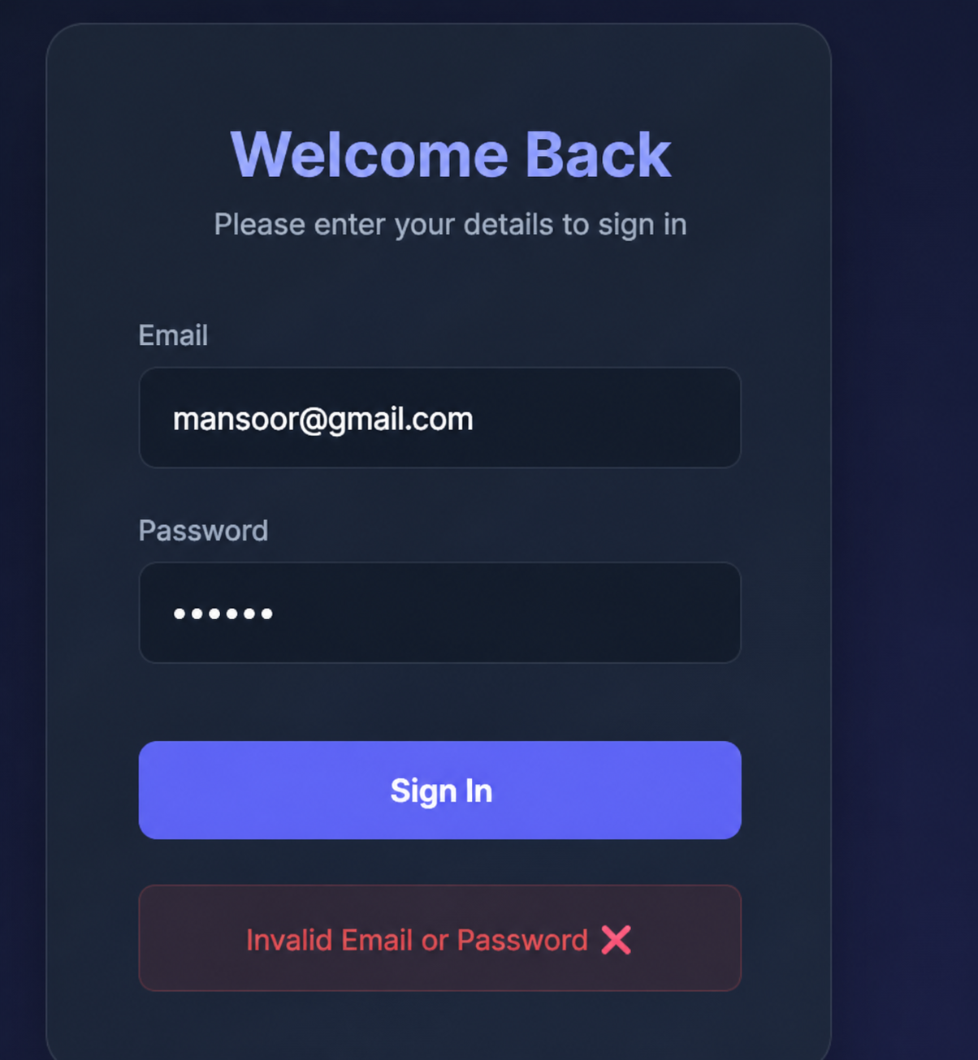

RESULT
The task was successfully implemented and executed. The expected output was obtained, demonstrating correct functionality and performance.

TASK QUESTION
Task 4
AIM
To design and implement the given task using appropriate technologies, ensuring proper functionality and accurate output generation.
ALGORITHM
1. Start the process and identify the requirements clearly. Understand what the task is supposed to achieve.
2. Set up the development environment by installing required tools like IDE, database, and frameworks.
3. Create a new project and organize folders/files properly based on the chosen technology.
4. Design the user interface or database schema according to the task requirements.
5. Create database tables or entities to store and manage data effectively.
6. Write the program logic including validation, processing, and required functionalities.
7. Integrate frontend and backend components to ensure smooth data flow.
8. Compile and run the application to check for errors and ensure proper execution.
9. Test the application with different inputs to verify correctness and performance.
10. Display the output and confirm expected results, then successfully complete the task.
CODE
// File: index.html
<!DOCTYPE html>
<html lang="en">
<head>
<meta charset="UTF-8">
<meta name="viewport" content="width=device-width, initial-scale=1.0">
<title>Task 4: Order Management</title>
<style>
body {
font-family: 'Segoe UI', Tahoma, Geneva, Verdana, sans-serif;
background-color: #f4f7fb;
color: #333;
margin: 0;
padding: 20px;
}
.container {
max-width: 900px;
margin: 0 auto;
background: #fff;
padding: 30px;
border-radius: 8px;
box-shadow: 0 4px 6px rgba(0,0,0,0.1);
}
h1 {
text-align: center;
color: #2c3e50;
font-size: 2.2rem;
margin-bottom: 20px;
}
h2 {
color: #34495e;
border-bottom: 2px solid #3498db;
padding-bottom: 5px;
margin-top: 40px;
font-size: 1.5rem;
}
table {
width: 100%;
border-collapse: collapse;
margin-top: 15px;
margin-bottom: 20px;
}
th, td {
text-align: left;
padding: 12px 15px;
border-bottom: 1px solid #e1e8ee;
}
th {
background-color: #3498db;
color: white;
text-transform: uppercase;
font-size: 0.9rem;
}
tr:hover {
background-color: #f1f5f8;
}
.badge {
background-color: #e74c3c;
color: white;
padding: 5px 10px;
border-radius: 20px;
font-weight: bold;
font-size: 0.8rem;
}
</style>
</head>
<body>
<div class="container">
<h1>📦 E-commerce Order Management</h1>
<p style="text-align: center; color: #7f8c8d; font-size: 1.1rem;">
Demonstrating relational data with Join queries, Subqueries, and CSS layout.
</p>
<!-- Section 1 -->
<h2>1. Customer Order History</h2>
<table>
<thead>
<tr>
<th>Order ID</th>
<th>Customer Name</th>
<th>Product</th>
<th>Quantity</th>
<th>Total Price</th>
<th>Order Date</th>
</tr>
</thead>
<tbody>
<tr>
<td>4</td>
<td>Charlie</td>
<td>Laptop</td>
<td>2</td>
<td>$2,000.00</td>
<td>2026-04-04</td>
</tr>
<tr>
<td>3</td>
<td>Alice</td>
<td>Headphones</td>
<td>1</td>
<td>$100.00</td>
<td>2026-04-03</td>
</tr>
<tr>
<td>2</td>
<td>Bob</td>
<td>Phone</td>
<td>2</td>
<td>$1,000.00</td>
<td>2026-04-02</td>
</tr>
<tr>
<td>1</td>
<td>Alice</td>
<td>Laptop</td>
<td>1</td>
<td>$1,000.00</td>
<td>2026-04-01</td>
</tr>
</tbody>
</table>
<!-- Section 2 -->
<h2>2. Highest Value Order</h2>
<table>
<thead>
<tr>
<th>Customer Name</th>
<th>Highest Order Value</th>
<th>Status</th>
</tr>
</thead>
<tbody>
<tr>
<td>Charlie</td>
<td>$2,000.00</td>
<td><span class="badge">VIP Transaction</span></td>
</tr>
</tbody>
</table>
<!-- Section 3 -->
<h2>3. Most Active Customer</h2>
<table>
<thead>
<tr>
<th>Most Active Customer</th>
<th>Total Number of Orders</th>
</tr>
</thead>
<tbody>
<tr>
<td>Alice</td>
<td>2 orders</td>
</tr>
</tbody>
</table>
</div>
</body>
</html>
// File: queries.sql
-- Create Tables
CREATE TABLE Customers (
customer_id INT PRIMARY KEY,
name VARCHAR(100),
email VARCHAR(100)
);
CREATE TABLE Products (
product_id INT PRIMARY KEY,
name VARCHAR(100),
price DECIMAL(10, 2)
);
CREATE TABLE Orders (
order_id INT PRIMARY KEY,
customer_id INT,
product_id INT,
quantity INT,
order_date DATE,
FOREIGN KEY (customer_id) REFERENCES Customers(customer_id),
FOREIGN KEY (product_id) REFERENCES Products(product_id)
);
-- Insert Sample Data
INSERT INTO Customers (customer_id, name, email) VALUES
(1, 'Alice', 'alice@example.com'),
(2, 'Bob', 'bob@example.com'),
(3, 'Charlie', 'charlie@example.com');
INSERT INTO Products (product_id, name, price) VALUES
(101, 'Laptop', 1000.00),
(102, 'Phone', 500.00),
(103, 'Headphones', 100.00);
INSERT INTO Orders (order_id, customer_id, product_id, quantity, order_date) VALUES
(1, 1, 101, 1, '2026-04-01'),
(2, 2, 102, 2, '2026-04-02'),
(3, 1, 103, 1, '2026-04-03'),
(4, 3, 101, 2, '2026-04-04');
-- 1. Display Customer Order History using JOINs and ORDER BY
-- Real-Time Usage: Viewing recent activity in user's profile
SELECT
o.order_id,
c.name AS customer_name,
p.name AS product_name,
o.quantity,
p.price,
(o.quantity * p.price) AS total_value,
o.order_date
FROM Orders o
JOIN Customers c ON o.customer_id = c.customer_id
JOIN Products p ON o.product_id = p.product_id
ORDER BY o.order_date DESC;
-- 2. Find Highest Value Order using a Subquery
-- Real-Time Usage: Finding the biggest sales logic / VIP orders
SELECT
o.order_id,
c.name AS customer_name,
(o.quantity * p.price) AS order_value
FROM Orders o
JOIN Customers c ON o.customer_id = c.customer_id
JOIN Products p ON o.product_id = p.product_id
WHERE (o.quantity * p.price) = (
SELECT MAX(o2.quantity * p2.price)
FROM Orders o2
JOIN Products p2 ON o2.product_id = p2.product_id
);
-- 3. Find Most Active Customer using a Subquery and ORDER BY
-- Real-Time Usage: Finding the most engaged user for rewards
SELECT
name,
order_count
FROM (
SELECT c.name, COUNT(o.order_id) AS order_count
FROM Customers c
JOIN Orders o ON c.customer_id = o.customer_id
GROUP BY c.customer_id
) AS customer_orders
ORDER BY order_count DESC
LIMIT 1;
OUTPUT
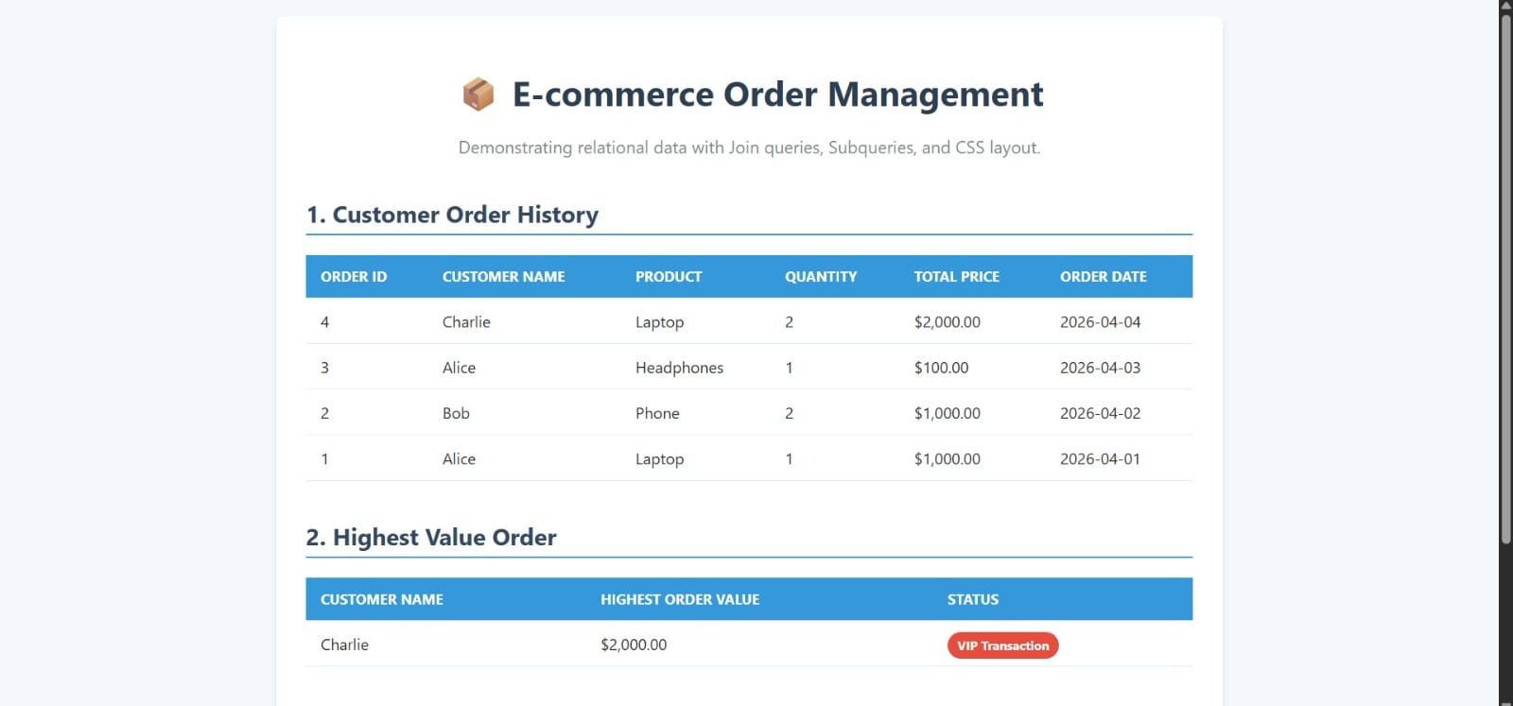

RESULT
The task was successfully implemented and executed. The expected output was obtained, demonstrating correct functionality and performance.

TASK QUESTION
Task 5
AIM
To design and implement the given task using appropriate technologies, ensuring proper functionality and accurate output generation.
ALGORITHM
1. Start the process and identify the requirements clearly. Understand what the task is supposed to achieve.
2. Set up the development environment by installing required tools like IDE, database, and frameworks.
3. Create a new project and organize folders/files properly based on the chosen technology.
4. Design the user interface or database schema according to the task requirements.
5. Create database tables or entities to store and manage data effectively.
6. Write the program logic including validation, processing, and required functionalities.
7. Integrate frontend and backend components to ensure smooth data flow.
8. Compile and run the application to check for errors and ensure proper execution.
9. Test the application with different inputs to verify correctness and performance.
10. Display the output and confirm expected results, then successfully complete the task.
CODE
// File: index.html
<!DOCTYPE html>
<html lang="en">
<head>
<meta charset="UTF-8">
<meta name="viewport" content="width=device-width, initial-scale=1.0">
<title>Transaction Simulation</title>
<style>
@import url('https://fonts.googleapis.com/css2?family=Inter:wght@400;600;700&display=swap');
:root {
--bg-color: #f8fafc;
--card-bg: #ffffff;
--primary: #3b82f6;
--success: #10b981;
--danger: #ef4444;
--text-main: #0f172a;
--text-muted: #64748b;
}
body {
font-family: 'Inter', sans-serif;
background-color: var(--bg-color);
color: var(--text-main);
margin: 0;
padding: 2rem;
min-height: 100vh;
display: flex;
flex-direction: column;
align-items: center;
}
.header {
text-align: center;
margin-bottom: 3rem;
margin-top: 2rem;
}
.header h1 {
font-size: 2.5rem;
margin: 0 0 0.5rem 0;
color: var(--text-main);
}
.header p {
color: var(--text-muted);
margin: 0;
font-size: 1.1rem;
}
.accounts-container {
display: flex;
gap: 2rem;
margin-bottom: 2rem;
width: 100%;
max-width: 800px;
}
.account-card {
flex: 1;
background: var(--card-bg);
border: 1px solid #e2e8f0;
border-radius: 1rem;
padding: 2rem;
text-align: center;
transition: transform 0.3s ease;
box-shadow: 0 4px 6px -1px rgba(0, 0, 0, 0.05);
}
.icon {
font-size: 3rem;
margin-bottom: 1rem;
}
h2 {
margin: 0 0 1rem 0;
font-size: 1.25rem;
color: var(--text-main);
}
.balance {
font-size: 2.5rem;
font-weight: 700;
margin: 0;
color: var(--primary);
}
.actions-panel {
background: var(--card-bg);
border: 1px solid #e2e8f0;
border-radius: 1rem;
padding: 2rem;
width: 100%;
max-width: 800px;
display: flex;
gap: 1rem;
align-items: flex-end;
margin-bottom: 2rem;
box-sizing: border-box;
box-shadow: 0 4px 6px -1px rgba(0, 0, 0, 0.05);
}
.input-group {
flex: 1;
display: flex;
flex-direction: column;
gap: 0.5rem;
text-align: left;
}
label {
color: var(--text-muted);
font-size: 0.875rem;
font-weight: 600;
}
input {
background: #f1f5f9;
border: 1px solid #cbd5e1;
color: var(--text-main);
padding: 1rem;
border-radius: 0.5rem;
font-size: 1.125rem;
font-family: inherit;
outline: none;
transition: border-color 0.3s ease;
}
input:focus {
border-color: var(--primary);
background: #ffffff;
}
button {
background: var(--primary);
color: white;
border: none;
padding: 1rem 2rem;
border-radius: 0.5rem;
font-size: 1.125rem;
font-weight: 600;
cursor: pointer;
transition: all 0.3s ease;
box-shadow: 0 4px 15px rgba(59, 130, 246, 0.4);
height: 3.5rem;
}
button:hover {
background: #2563eb;
transform: translateY(-2px);
}
button:active {
transform: translateY(0);
}
.logs {
width: 100%;
max-width: 800px;
background: #1e293b;
color: #f8fafc;
border-radius: 0.5rem;
padding: 1.5rem;
font-family: monospace;
height: 250px;
overflow-y: auto;
border: 1px solid #334155;
box-sizing: border-box;
}
.log-entry {
margin-bottom: 0.5rem;
border-bottom: 1px solid rgba(255,255,255,0.05);
padding-bottom: 0.25rem;
}
.log-success { color: #34d399; }
.log-error { color: #f87171; }
.log-info { color: #60a5fa; }
.log-query { color: #c084fc; }
@keyframes pulse-success {
0% { box-shadow: 0 0 0 0 rgba(16, 185, 129, 0.4); }
70% { box-shadow: 0 0 0 20px rgba(16, 185, 129, 0); }
100% { box-shadow: 0 0 0 0 rgba(16, 185, 129, 0); }
}
@keyframes pulse-error {
0% { box-shadow: 0 0 0 0 rgba(239, 68, 68, 0.4); }
70% { box-shadow: 0 0 0 20px rgba(239, 68, 68, 0); }
100% { box-shadow: 0 0 0 0 rgba(239, 68, 68, 0); }
}
.anim-success { animation: pulse-success 1s ease-out; }
.anim-error { animation: pulse-error 1s ease-out; }
</style>
</head>
<body>
<div class="header">
<h1>Transaction Simulator</h1>
<p>Interactive web representation of SQL COMMIT and ROLLBACK</p>
</div>
<div class="accounts-container">
<div class="account-card" id="user-card">
<div class="icon">🧑‍💻</div>
<h2>User Account</h2>
<div class="balance">₹<span id="user-balance">1000.00</span></div>
</div>
<div class="account-card" id="merchant-card">
<div class="icon">👩‍💼</div>
<h2>Vandana</h2>
<div class="balance">₹<span id="merchant-balance">0.00</span></div>
</div>
</div>
<div class="actions-panel">
<div class="input-group">
<label>Payment Amount (₹)</label>
<input type="number" id="amount" placeholder="e.g. 200" min="1" step="0.01">
</div>
<button onclick="processTransaction()">Pay Vandana</button>
</div>
<div class="logs" id="logs">
<div class="log-info">SYSTEM: Database connected. Balances loaded.</div>
</div>
<script>
// Internal state
let db = {
userBalance: 1000.00,
merchantBalance: 0.00
};
function addLog(message, type = 'info') {
const logs = document.getElementById('logs');
const entry = document.createElement('div');
entry.className = `log-entry log-${type}`;
const time = new Date().toLocaleTimeString();
entry.innerText = `[${time}] ${message}`;
logs.appendChild(entry);
logs.scrollTop = logs.scrollHeight;
}
function updateUI() {
document.getElementById('user-balance').innerText = db.userBalance.toFixed(2);
document.getElementById('merchant-balance').innerText = db.merchantBalance.toFixed(2);
}
function processTransaction() {
const inputField = document.getElementById('amount');
const inputAmount = parseFloat(inputField.value);
if (isNaN(inputAmount) || inputAmount <= 0) {
addLog('Please enter a valid amount.', 'error');
return;
}
const userCard = document.getElementById('user-card');
addLog('BEGIN TRANSACTION;', 'query');
let tempUserBalance = db.userBalance - inputAmount;
let tempMerchantBalance = db.merchantBalance + inputAmount;
addLog(`UPDATE Accounts SET balance = balance - ${inputAmount} WHERE account_id = 1;`, 'query');
addLog(`UPDATE Accounts SET balance = balance + ${inputAmount} WHERE account_id = 2;`, 'query');
// Timeout to simulate network processing
setTimeout(() => {
if (tempUserBalance < 0) {
addLog(`ERROR: Insufficient funds. Balance would be ₹${tempUserBalance.toFixed(2)}.`, 'error');
addLog('ROLLBACK;', 'error');
addLog('Transaction aborted. Values reverted to initial state.', 'info');
userCard.classList.remove('anim-error', 'anim-success');
void userCard.offsetWidth; // trigger reflow
userCard.classList.add('anim-error');
} else {
db.userBalance = tempUserBalance;
db.merchantBalance = tempMerchantBalance;
addLog('COMMIT;', 'success');
// Fixed syntax error here
addLog("Transaction successful! Funds secured in Vandana's account.", 'success');
userCard.classList.remove('anim-error', 'anim-success');
void userCard.offsetWidth;
userCard.classList.add('anim-success');
updateUI();
}
addLog('------------------------------------------------', 'info');
}, 800);
}
</script>
</body>
</html>
// File: payment_simulation.sql
-- Step 1: Create a table for accounts
CREATE TABLE Accounts (
account_id INT PRIMARY KEY,
account_name VARCHAR(100),
balance DECIMAL(10, 2)
);
-- Step 2: Insert initial balances for the User and Merchant
INSERT INTO Accounts (account_id, account_name, balance)
VALUES
(1, 'User Account', 1000.00), -- User starts with ₹1000
(2, 'Vandana', 0.00); -- Vandana starts with ₹0
-- ==========================================
-- SCENARIO 1: SUCCESSFUL PAYMENT (COMMIT)
-- ==========================================
-- Simulating a ₹200 payment from the User to Vandana
BEGIN TRANSACTION; -- Start the transaction
-- 1. Deduct balance from User account
UPDATE Accounts
SET balance = balance - 200.00
WHERE account_id = 1;
-- 2. Add amount to Vandana's account
UPDATE Accounts
SET balance = balance + 200.00
WHERE account_id = 2;
-- Both steps succeeded without issues.
-- Save the changes permanently:
COMMIT;
-- ==========================================
-- SCENARIO 2: FAILED PAYMENT (ROLLBACK)
-- ==========================================
-- Simulating a ₹5000 payment, but the user doesn't have enough funds.
-- Let's pretend an error occurs mid-way.
BEGIN TRANSACTION; -- Start the transaction
-- 1. Deduct balance from User account
UPDATE Accounts
SET balance = balance - 5000.00
WHERE account_id = 1;
-- 2. Add amount to Vandana's account
UPDATE Accounts
SET balance = balance + 5000.00
WHERE account_id = 2;
-- Error detected! The user balance would go negative (-₹4200).
-- This violates business logic (insufficient funds).
-- Revert all changes made during this transaction:
ROLLBACK;
-- ==========================================
-- View Final Balances
-- ==========================================
-- In the end, only the successful ₹200 transaction was saved.
-- User should have ₹800, and Vandana should have ₹200.
SELECT * FROM Accounts;
OUTPUT
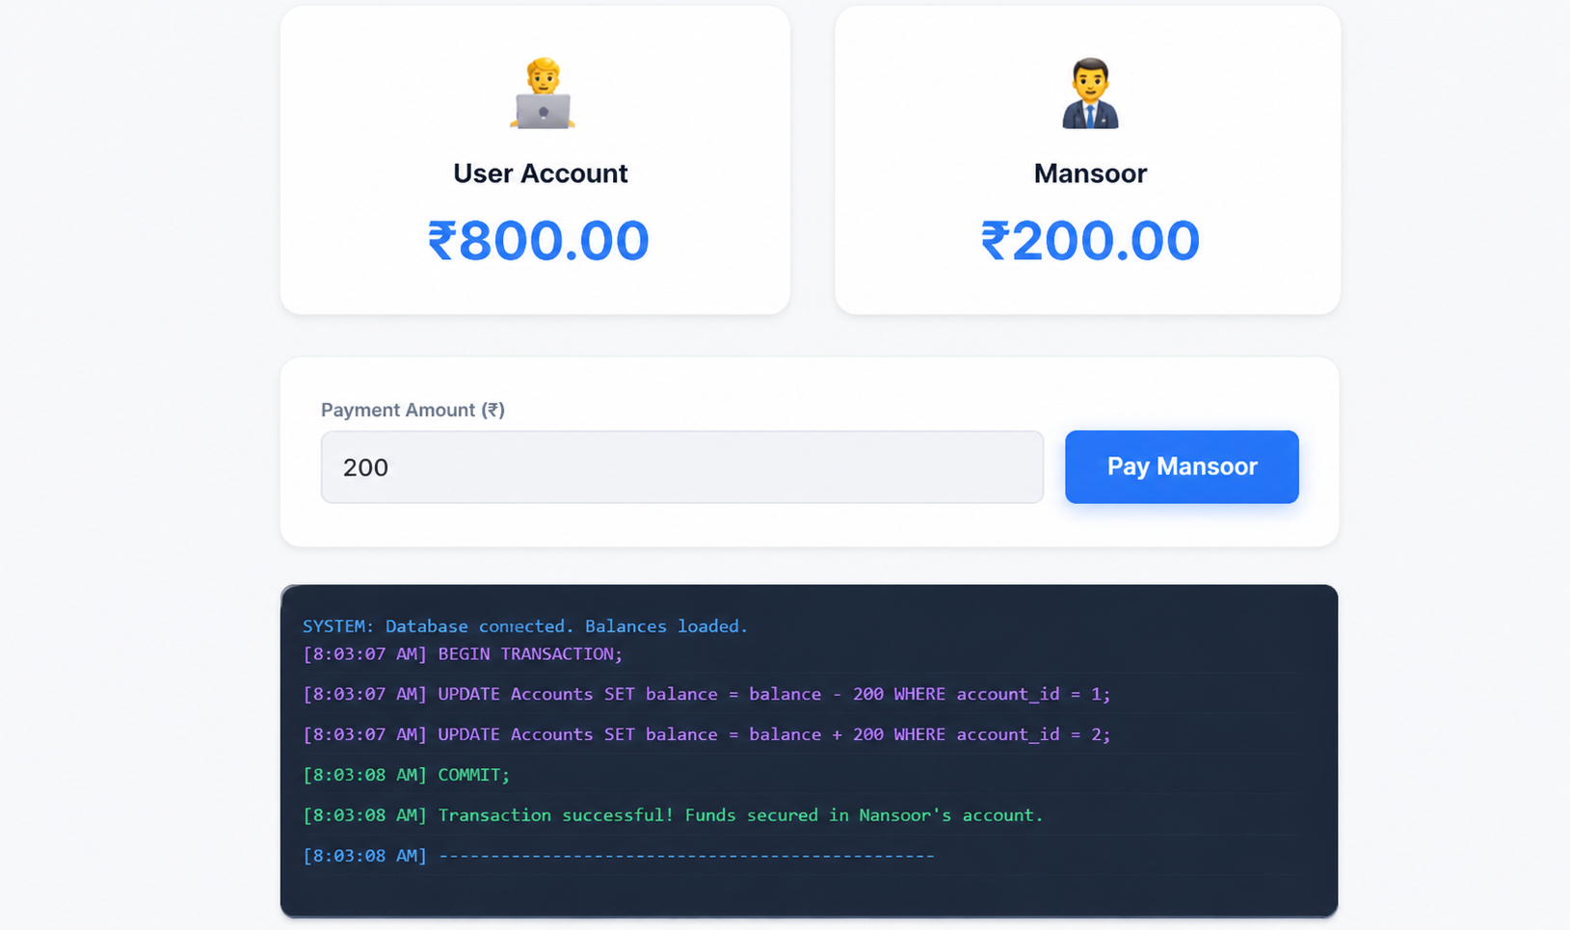

RESULT
The task was successfully implemented and executed. The expected output was obtained, demonstrating correct functionality and performance.

TASK QUESTION
Task 6
AIM
To design and implement the given task using appropriate technologies, ensuring proper functionality and accurate output generation.
ALGORITHM
1. Start the process and identify the requirements clearly. Understand what the task is supposed to achieve.
2. Set up the development environment by installing required tools like IDE, database, and frameworks.
3. Create a new project and organize folders/files properly based on the chosen technology.
4. Design the user interface or database schema according to the task requirements.
5. Create database tables or entities to store and manage data effectively.
6. Write the program logic including validation, processing, and required functionalities.
7. Integrate frontend and backend components to ensure smooth data flow.
8. Compile and run the application to check for errors and ensure proper execution.
9. Test the application with different inputs to verify correctness and performance.
10. Display the output and confirm expected results, then successfully complete the task.
CODE
// File: 01_database_schema.sql
-- Task 6: Automated Logging using Triggers & Views
-- Database Schema for Audit Logging Demonstration
-- Create sample database (if using MySQL/MariaDB)
-- CREATE DATABASE audit_logging_demo;
-- USE audit_logging_demo;
-- Sample Employees table for demonstration
CREATE TABLE IF NOT EXISTS employees (
employee_id INT PRIMARY KEY AUTO_INCREMENT,
first_name VARCHAR(50) NOT NULL,
last_name VARCHAR(50) NOT NULL,
email VARCHAR(100) UNIQUE NOT NULL,
department VARCHAR(50),
salary DECIMAL(10,2),
hire_date DATE,
is_active BOOLEAN DEFAULT TRUE,
created_at TIMESTAMP DEFAULT CURRENT_TIMESTAMP,
updated_at TIMESTAMP DEFAULT CURRENT_TIMESTAMP ON UPDATE CURRENT_TIMESTAMP
);
-- Sample Products table for demonstration
CREATE TABLE IF NOT EXISTS products (
product_id INT PRIMARY KEY AUTO_INCREMENT,
product_name VARCHAR(100) NOT NULL,
category VARCHAR(50),
price DECIMAL(10,2),
stock_quantity INT DEFAULT 0,
created_at TIMESTAMP DEFAULT CURRENT_TIMESTAMP,
updated_at TIMESTAMP DEFAULT CURRENT_TIMESTAMP ON UPDATE CURRENT_TIMESTAMP
);
-- Sample Orders table for demonstration
CREATE TABLE IF NOT EXISTS orders (
order_id INT PRIMARY KEY AUTO_INCREMENT,
employee_id INT,
product_id INT,
quantity INT NOT NULL,
order_date TIMESTAMP DEFAULT CURRENT_TIMESTAMP,
total_amount DECIMAL(10,2),
status VARCHAR(20) DEFAULT 'pending',
FOREIGN KEY (employee_id) REFERENCES employees(employee_id),
FOREIGN KEY (product_id) REFERENCES products(product_id)
);
// File: 02_audit_log_table.sql
-- Audit Log Table Structure
-- This table will capture all INSERT and UPDATE operations on monitored tables
CREATE TABLE IF NOT EXISTS audit_log (
log_id INT PRIMARY KEY AUTO_INCREMENT,
table_name VARCHAR(50) NOT NULL,
operation_type VARCHAR(10) NOT NULL, -- 'INSERT' or 'UPDATE'
record_id INT NOT NULL,
old_data JSON, -- For UPDATE operations, stores the old values
new_data JSON, -- Stores the new values (for both INSERT and UPDATE)
changed_fields JSON, -- Lists which fields were changed (for UPDATE operations)
user_name VARCHAR(100), -- Current user performing the operation
client_ip VARCHAR(45), -- IP address of the client
operation_timestamp TIMESTAMP DEFAULT CURRENT_TIMESTAMP,
affected_rows INT DEFAULT 1,
transaction_id VARCHAR(50), -- Transaction identifier for tracking
additional_info JSON -- Extra metadata about the operation
);
-- Create indexes for better performance
CREATE INDEX idx_audit_table_name ON audit_log(table_name);
CREATE INDEX idx_audit_operation_type ON audit_log(operation_type);
CREATE INDEX idx_audit_timestamp ON audit_log(operation_timestamp);
CREATE INDEX idx_audit_record_id ON audit_log(table_name, record_id);
-- Create a table to track which tables have audit triggers
CREATE TABLE IF NOT EXISTS audit_tracked_tables (
table_name VARCHAR(50) PRIMARY KEY,
is_active BOOLEAN DEFAULT TRUE,
created_at TIMESTAMP DEFAULT CURRENT_TIMESTAMP,
last_updated TIMESTAMP DEFAULT CURRENT_TIMESTAMP ON UPDATE CURRENT_TIMESTAMP
);
-- Insert the tables we want to track
INSERT IGNORE INTO audit_tracked_tables (table_name) VALUES
('employees'),
('products'),
('orders');
// File: 03_insert_trigger.sql
-- INSERT Trigger for Audit Logging
-- This trigger fires on INSERT operations and logs the new data
-- Employees table INSERT trigger
DELIMITER //
CREATE TRIGGER tr_employees_insert_audit
AFTER INSERT ON employees
FOR EACH ROW
BEGIN
DECLARE current_user VARCHAR(100);
DECLARE client_ip VARCHAR(45);
-- Get current user and client IP (MySQL specific)
SET current_user = CURRENT_USER();
SET client_ip = CONNECTION_ID();
INSERT INTO audit_log (
table_name,
operation_type,
record_id,
old_data,
new_data,
changed_fields,
user_name,
client_ip,
transaction_id,
additional_info
) VALUES (
'employees',
'INSERT',
NEW.employee_id,
NULL, -- No old data for INSERT
JSON_OBJECT(
'employee_id', NEW.employee_id,
'first_name', NEW.first_name,
'last_name', NEW.last_name,
'email', NEW.email,
'department', NEW.department,
'salary', NEW.salary,
'hire_date', NEW.hire_date,
'is_active', NEW.is_active,
'created_at', NEW.created_at,
'updated_at', NEW.updated_at
),
NULL, -- No changed fields for INSERT
current_user,
client_ip,
CONNECTION_ID(),
JSON_OBJECT('trigger_type', 'INSERT', 'table', 'employees')
);
END//
DELIMITER ;
-- Products table INSERT trigger
DELIMITER //
CREATE TRIGGER tr_products_insert_audit
AFTER INSERT ON products
FOR EACH ROW
BEGIN
DECLARE current_user VARCHAR(100);
DECLARE client_ip VARCHAR(45);
SET current_user = CURRENT_USER();
SET client_ip = CONNECTION_ID();
INSERT INTO audit_log (
table_name,
operation_type,
record_id,
old_data,
new_data,
changed_fields,
user_name,
client_ip,
transaction_id,
additional_info
) VALUES (
'products',
'INSERT',
NEW.product_id,
NULL,
JSON_OBJECT(
'product_id', NEW.product_id,
'product_name', NEW.product_name,
'category', NEW.category,
'price', NEW.price,
'stock_quantity', NEW.stock_quantity,
'created_at', NEW.created_at,
'updated_at', NEW.updated_at
),
NULL,
current_user,
client_ip,
CONNECTION_ID(),
JSON_OBJECT('trigger_type', 'INSERT', 'table', 'products')
);
END//
DELIMITER ;
-- Orders table INSERT trigger
DELIMITER //
CREATE TRIGGER tr_orders_insert_audit
AFTER INSERT ON orders
FOR EACH ROW
BEGIN
DECLARE current_user VARCHAR(100);
DECLARE client_ip VARCHAR(45);
SET current_user = CURRENT_USER();
SET client_ip = CONNECTION_ID();
INSERT INTO audit_log (
table_name,
operation_type,
record_id,
old_data,
new_data,
changed_fields,
user_name,
client_ip,
transaction_id,
additional_info
) VALUES (
'orders',
'INSERT',
NEW.order_id,
NULL,
JSON_OBJECT(
'order_id', NEW.order_id,
'employee_id', NEW.employee_id,
'product_id', NEW.product_id,
'quantity', NEW.quantity,
'order_date', NEW.order_date,
'total_amount', NEW.total_amount,
'status', NEW.status
),
NULL,
current_user,
client_ip,
CONNECTION_ID(),
JSON_OBJECT('trigger_type', 'INSERT', 'table', 'orders')
);
END//
DELIMITER ;
// File: 04_update_trigger.sql
-- UPDATE Trigger for Audit Logging
-- This trigger fires on UPDATE operations and logs the changes
-- Employees table UPDATE trigger
DELIMITER //
CREATE TRIGGER tr_employees_update_audit
AFTER UPDATE ON employees
FOR EACH ROW
BEGIN
DECLARE current_user VARCHAR(100);
DECLARE client_ip VARCHAR(45);
DECLARE changed_fields JSON;
SET current_user = CURRENT_USER();
SET client_ip = CONNECTION_ID();
-- Determine which fields have changed
SET changed_fields = JSON_ARRAY(
IF(NEW.first_name <> OLD.first_name, 'first_name', NULL),
IF(NEW.last_name <> OLD.last_name, 'last_name', NULL),
IF(NEW.email <> OLD.email, 'email', NULL),
IF(NEW.department <> OLD.department, 'department', NULL),
IF(NEW.salary <> OLD.salary, 'salary', NULL),
IF(NEW.hire_date <> OLD.hire_date, 'hire_date', NULL),
IF(NEW.is_active <> OLD.is_active, 'is_active', NULL)
);
-- Remove NULL values from the array
SET changed_fields = JSON_REMOVE(changed_fields, '$[0]', '$[1]', '$[2]', '$[3]', '$[4]', '$[5]', '$[6]');
INSERT INTO audit_log (
table_name,
operation_type,
record_id,
old_data,
new_data,
changed_fields,
user_name,
client_ip,
transaction_id,
additional_info
) VALUES (
'employees',
'UPDATE',
NEW.employee_id,
JSON_OBJECT(
'employee_id', OLD.employee_id,
'first_name', OLD.first_name,
'last_name', OLD.last_name,
'email', OLD.email,
'department', OLD.department,
'salary', OLD.salary,
'hire_date', OLD.hire_date,
'is_active', OLD.is_active,
'created_at', OLD.created_at,
'updated_at', OLD.updated_at
),
JSON_OBJECT(
'employee_id', NEW.employee_id,
'first_name', NEW.first_name,
'last_name', NEW.last_name,
'email', NEW.email,
'department', NEW.department,
'salary', NEW.salary,
'hire_date', NEW.hire_date,
'is_active', NEW.is_active,
'created_at', NEW.created_at,
'updated_at', NEW.updated_at
),
changed_fields,
current_user,
client_ip,
CONNECTION_ID(),
JSON_OBJECT('trigger_type', 'UPDATE', 'table', 'employees')
);
END//
DELIMITER ;
-- Products table UPDATE trigger
DELIMITER //
CREATE TRIGGER tr_products_update_audit
AFTER UPDATE ON products
FOR EACH ROW
BEGIN
DECLARE current_user VARCHAR(100);
DECLARE client_ip VARCHAR(45);
DECLARE changed_fields JSON;
SET current_user = CURRENT_USER();
SET client_ip = CONNECTION_ID();
-- Determine which fields have changed
SET changed_fields = JSON_ARRAY(
IF(NEW.product_name <> OLD.product_name, 'product_name', NULL),
IF(NEW.category <> OLD.category, 'category', NULL),
IF(NEW.price <> OLD.price, 'price', NULL),
IF(NEW.stock_quantity <> OLD.stock_quantity, 'stock_quantity', NULL)
);
-- Remove NULL values from the array
SET changed_fields = JSON_REMOVE(changed_fields, '$[0]', '$[1]', '$[2]', '$[3]');
INSERT INTO audit_log (
table_name,
operation_type,
record_id,
old_data,
new_data,
changed_fields,
user_name,
client_ip,
transaction_id,
additional_info
) VALUES (
'products',
'UPDATE',
NEW.product_id,
JSON_OBJECT(
'product_id', OLD.product_id,
'product_name', OLD.product_name,
'category', OLD.category,
'price', OLD.price,
'stock_quantity', OLD.stock_quantity,
'created_at', OLD.created_at,
'updated_at', OLD.updated_at
),
JSON_OBJECT(
'product_id', NEW.product_id,
'product_name', NEW.product_name,
'category', NEW.category,
'price', NEW.price,
'stock_quantity', NEW.stock_quantity,
'created_at', NEW.created_at,
'updated_at', NEW.updated_at
),
changed_fields,
current_user,
client_ip,
CONNECTION_ID(),
JSON_OBJECT('trigger_type', 'UPDATE', 'table', 'products')
);
END//
DELIMITER ;
-- Orders table UPDATE trigger
DELIMITER //
CREATE TRIGGER tr_orders_update_audit
AFTER UPDATE ON orders
FOR EACH ROW
BEGIN
DECLARE current_user VARCHAR(100);
DECLARE client_ip VARCHAR(45);
DECLARE changed_fields JSON;
SET current_user = CURRENT_USER();
SET client_ip = CONNECTION_ID();
-- Determine which fields have changed
SET changed_fields = JSON_ARRAY(
IF(NEW.employee_id <> OLD.employee_id, 'employee_id', NULL),
IF(NEW.product_id <> OLD.product_id, 'product_id', NULL),
IF(NEW.quantity <> OLD.quantity, 'quantity', NULL),
IF(NEW.total_amount <> OLD.total_amount, 'total_amount', NULL),
IF(NEW.status <> OLD.status, 'status', NULL)
);
-- Remove NULL values from the array
SET changed_fields = JSON_REMOVE(changed_fields, '$[0]', '$[1]', '$[2]', '$[3]', '$[4]');
INSERT INTO audit_log (
table_name,
operation_type,
record_id,
old_data,
new_data,
changed_fields,
user_name,
client_ip,
transaction_id,
additional_info
) VALUES (
'orders',
'UPDATE',
NEW.order_id,
JSON_OBJECT(
'order_id', OLD.order_id,
'employee_id', OLD.employee_id,
'product_id', OLD.product_id,
'quantity', OLD.quantity,
'order_date', OLD.order_date,
'total_amount', OLD.total_amount,
'status', OLD.status
),
JSON_OBJECT(
'order_id', NEW.order_id,
'employee_id', NEW.employee_id,
'product_id', NEW.product_id,
'quantity', NEW.quantity,
'order_date', NEW.order_date,
'total_amount', NEW.total_amount,
'status', NEW.status
),
changed_fields,
current_user,
client_ip,
CONNECTION_ID(),
JSON_OBJECT('trigger_type', 'UPDATE', 'table', 'orders')
);
END//
DELIMITER ;
// File: 05_daily_activity_view.sql
-- Daily Activity Report Views
-- These views provide comprehensive audit reporting capabilities
-- View 1: Daily Activity Summary
CREATE OR REPLACE VIEW daily_activity_summary AS
SELECT
DATE(operation_timestamp) as activity_date,
table_name,
operation_type,
COUNT(*) as operation_count,
COUNT(DISTINCT user_name) as unique_users,
MIN(operation_timestamp) as first_activity,
MAX(operation_timestamp) as last_activity
FROM audit_log
GROUP BY DATE(operation_timestamp), table_name, operation_type
ORDER BY activity_date DESC, table_name, operation_type;
-- View 2: Detailed Daily Activity Log
CREATE OR REPLACE VIEW daily_activity_detail AS
SELECT
DATE(operation_timestamp) as activity_date,
operation_timestamp,
table_name,
operation_type,
record_id,
user_name,
client_ip,
CASE
WHEN operation_type = 'INSERT' THEN
JSON_EXTRACT(new_data, '$.first_name') or
JSON_EXTRACT(new_data, '$.product_name') or
CONCAT('Order #', JSON_EXTRACT(new_data, '$.order_id'))
WHEN operation_type = 'UPDATE' THEN
CONCAT('Updated fields: ',
IFNULL(JSON_UNQUOTE(changed_fields), 'None'))
END as description,
changed_fields,
transaction_id
FROM audit_log
ORDER BY activity_date DESC, operation_timestamp DESC;
-- View 3: User Activity Analysis
CREATE OR REPLACE VIEW user_activity_analysis AS
SELECT
user_name,
DATE(operation_timestamp) as activity_date,
table_name,
operation_type,
COUNT(*) as operations_count,
COUNT(DISTINCT record_id) as records_affected,
GROUP_CONCAT(DISTINCT record_id) as affected_record_ids
FROM audit_log
WHERE user_name IS NOT NULL
GROUP BY user_name, DATE(operation_timestamp), table_name, operation_type
ORDER BY activity_date DESC, operations_count DESC;
-- View 4: Table Activity Heatmap
CREATE OR REPLACE VIEW table_activity_heatmap AS
SELECT
table_name,
DATE(operation_timestamp) as activity_date,
operation_type,
COUNT(*) as operation_count,
ROUND(COUNT(*) * 100.0 / SUM(COUNT(*)) OVER (PARTITION BY DATE(operation_timestamp)), 2) as percentage_of_daily_activity
FROM audit_log
GROUP BY table_name, DATE(operation_timestamp), operation_type
ORDER BY activity_date DESC, operation_count DESC;
-- View 5: Field Change Analysis (for UPDATE operations)
CREATE OR REPLACE VIEW field_change_analysis AS
SELECT
DATE(operation_timestamp) as activity_date,
table_name,
changed_field,
COUNT(*) as change_count,
COUNT(DISTINCT record_id) as unique_records_changed,
COUNT(DISTINCT user_name) as unique_users_making_changes
FROM (
SELECT
operation_timestamp,
table_name,
JSON_UNQUOTE(JSON_EXTRACT(changed_fields, CONCAT('$[', idx, ']'))) as changed_field,
record_id,
user_name
FROM audit_log
CROSS JOIN (
SELECT 0 as idx UNION SELECT 1 UNION SELECT 2 UNION SELECT 3 UNION
SELECT 4 UNION SELECT 5 UNION SELECT 6 UNION SELECT 7
) as numbers
WHERE operation_type = 'UPDATE'
AND changed_fields IS NOT NULL
AND JSON_EXTRACT(changed_fields, CONCAT('$[', idx, ']')) IS NOT NULL
) as field_changes
GROUP BY activity_date, table_name, changed_field
ORDER BY activity_date DESC, change_count DESC;
-- View 6: Recent Activity Dashboard
CREATE OR REPLACE VIEW recent_activity_dashboard AS
SELECT
operation_timestamp,
table_name,
operation_type,
record_id,
user_name,
CASE
WHEN operation_type = 'INSERT' THEN '🟢'
WHEN operation_type = 'UPDATE' THEN '🔵'
ELSE '⚪'
END as operation_icon,
CASE
WHEN operation_type = 'INSERT' THEN
CONCAT('New ', LOWER(table_name), ' added')
WHEN operation_type = 'UPDATE' THEN
CONCAT(LOWER(table_name), ' updated')
END as activity_description,
TIMESTAMPDIFF(MINUTE, operation_timestamp, NOW()) as minutes_ago
FROM audit_log
WHERE operation_timestamp >= DATE_SUB(NOW(), INTERVAL 24 HOUR)
ORDER BY operation_timestamp DESC;
-- View 7: Daily Statistics Report
CREATE OR REPLACE VIEW daily_statistics_report AS
SELECT
DATE(operation_timestamp) as report_date,
COUNT(*) as total_operations,
COUNT(DISTINCT table_name) as tables_affected,
COUNT(DISTINCT user_name) as active_users,
SUM(CASE WHEN operation_type = 'INSERT' THEN 1 ELSE 0 END) as insert_operations,
SUM(CASE WHEN operation_type = 'UPDATE' THEN 1 ELSE 0 END) as update_operations,
COUNT(DISTINCT record_id) as total_records_affected,
ROUND(AVG(CASE WHEN operation_type = 'UPDATE' THEN
JSON_LENGTH(changed_fields) ELSE 0 END), 2) as avg_fields_changed_per_update
FROM audit_log
GROUP BY DATE(operation_timestamp)
ORDER BY report_date DESC;
// File: 06_sample_data_demo.sql
-- Sample Data and Demonstration Script
-- This script populates the database with sample data and demonstrates the audit logging
-- Insert sample employees (these will trigger INSERT audit logs)
INSERT INTO employees (first_name, last_name, email, department, salary, hire_date) VALUES
('John', 'Smith', 'john.smith@company.com', 'IT', 75000.00, '2023-01-15'),
('Sarah', 'Johnson', 'sarah.johnson@company.com', 'Sales', 65000.00, '2023-02-20'),
('Michael', 'Brown', 'michael.brown@company.com', 'Marketing', 70000.00, '2023-03-10'),
('Emily', 'Davis', 'emily.davis@company.com', 'HR', 60000.00, '2023-04-05'),
('David', 'Wilson', 'david.wilson@company.com', 'IT', 80000.00, '2023-05-12');
-- Insert sample products (these will trigger INSERT audit logs)
INSERT INTO products (product_name, category, price, stock_quantity) VALUES
('Laptop Pro 15', 'Electronics', 1299.99, 50),
('Wireless Mouse', 'Electronics', 29.99, 200),
('Office Chair Deluxe', 'Furniture', 349.99, 25),
('Standing Desk', 'Furniture', 599.99, 15),
('Coffee Maker', 'Appliances', 89.99, 30),
('Monitor 27"', 'Electronics', 399.99, 40);
-- Insert sample orders (these will trigger INSERT audit logs)
INSERT INTO orders (employee_id, product_id, quantity, total_amount, status) VALUES
(1, 1, 2, 2599.98, 'completed'),
(2, 3, 1, 349.99, 'pending'),
(3, 2, 5, 149.95, 'completed'),
(4, 4, 1, 599.99, 'shipped'),
(5, 5, 2, 179.98, 'pending'),
(1, 6, 3, 1199.97, 'completed');
-- Now perform some UPDATE operations to demonstrate the UPDATE triggers
UPDATE employees SET salary = 78000.00 WHERE employee_id = 1;
UPDATE employees SET department = 'Senior IT' WHERE employee_id = 1;
UPDATE products SET stock_quantity = 45, price = 1249.99 WHERE product_id = 1;
UPDATE order
OUTPUT
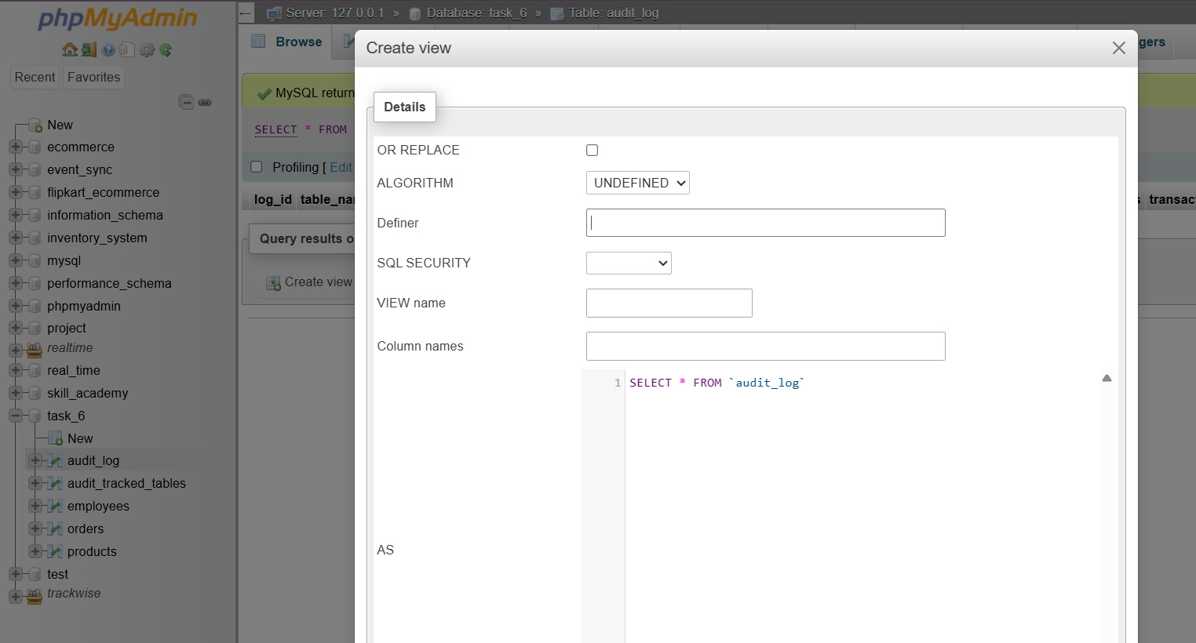
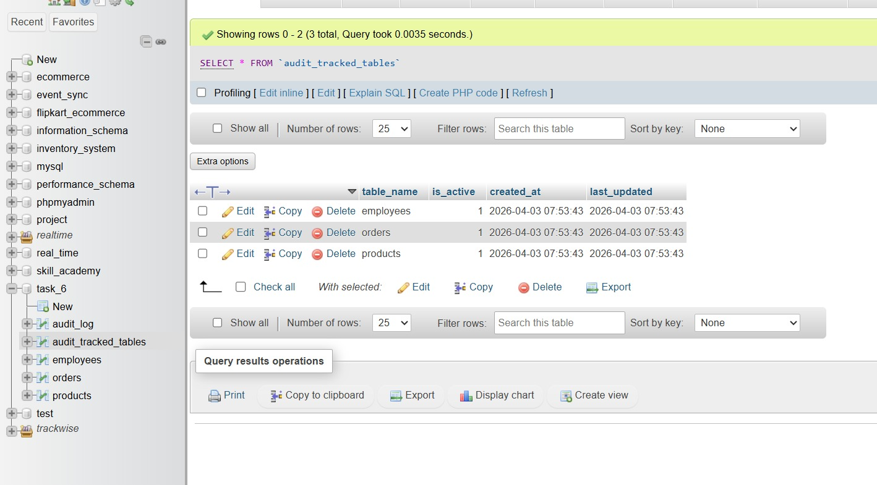
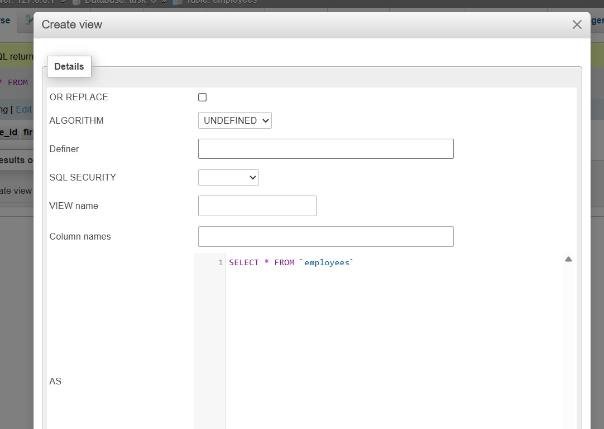
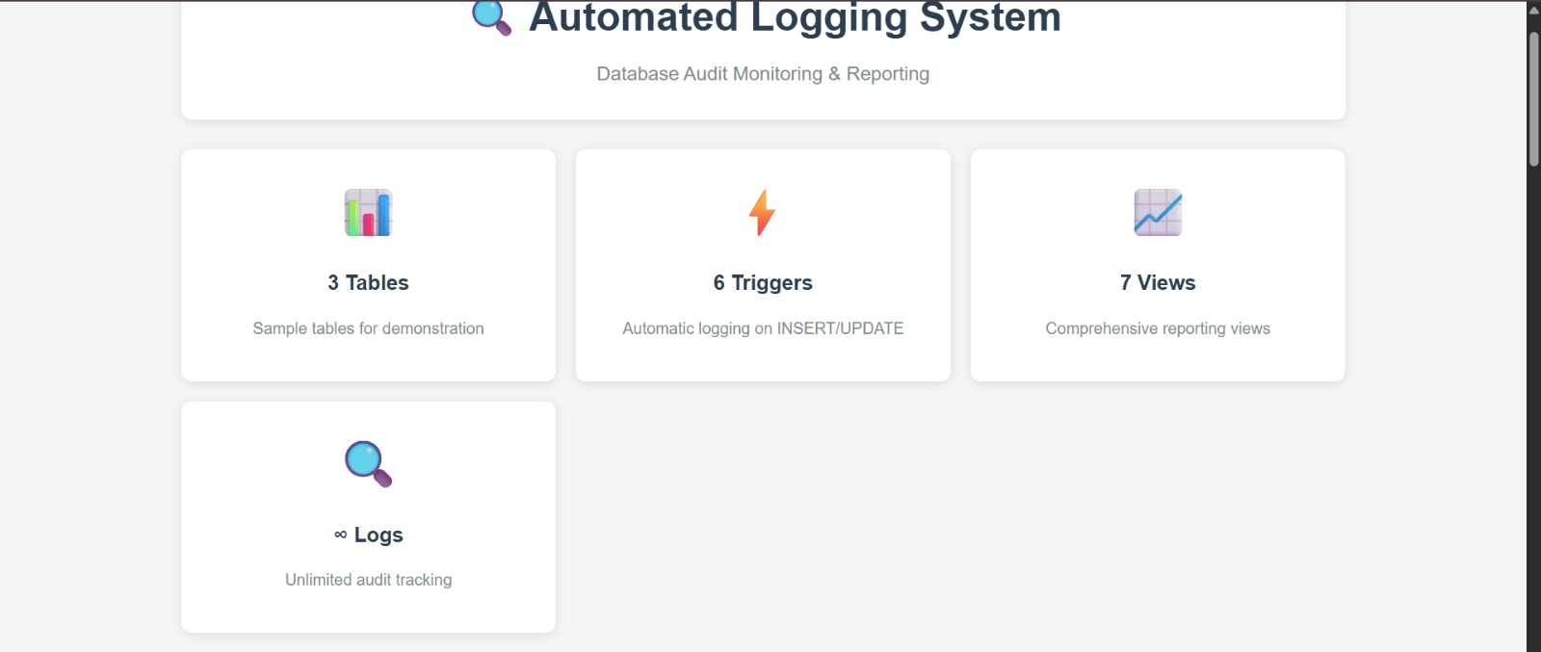
RESULT
The task was successfully implemented and executed. The expected output was obtained, demonstrating correct functionality and performance.

TASK QUESTION
Task 7
AIM
To design and implement the given task using appropriate technologies, ensuring proper functionality and accurate output generation.
ALGORITHM
1. Start the process and identify the requirements clearly. Understand what the task is supposed to achieve.
2. Set up the development environment by installing required tools like IDE, database, and frameworks.
3. Create a new project and organize folders/files properly based on the chosen technology.
4. Design the user interface or database schema according to the task requirements.
5. Create database tables or entities to store and manage data effectively.
6. Write the program logic including validation, processing, and required functionalities.
7. Integrate frontend and backend components to ensure smooth data flow.
8. Compile and run the application to check for errors and ensure proper execution.
9. Test the application with different inputs to verify correctness and performance.
10. Display the output and confirm expected results, then successfully complete the task.
OUTPUT
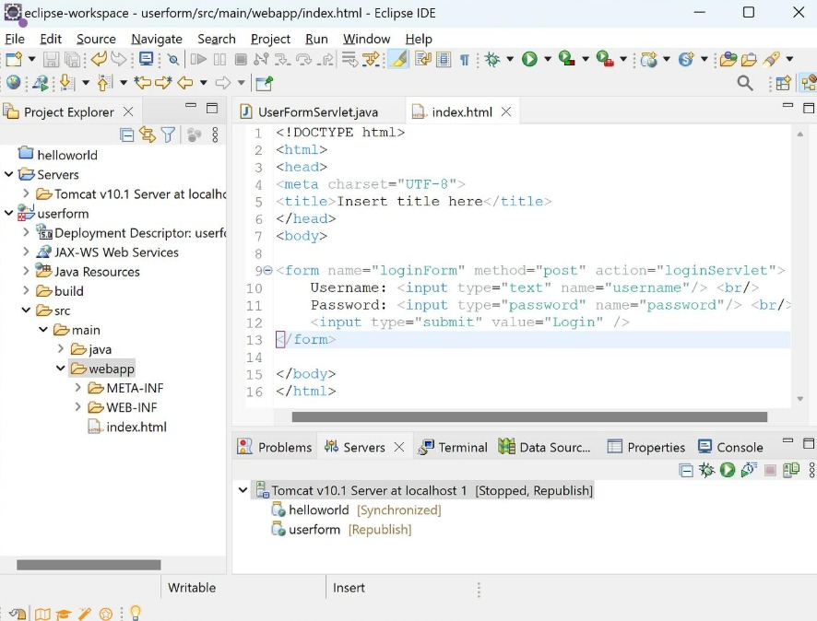
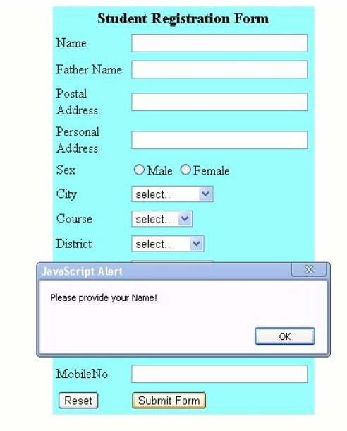
RESULT
The task was successfully implemented and executed. The expected output was obtained, demonstrating correct functionality and performance.

TASK QUESTION
Task 8
AIM
To design and implement the given task using appropriate technologies, ensuring proper functionality and accurate output generation.
ALGORITHM
1. Start the process and identify the requirements clearly. Understand what the task is supposed to achieve.
2. Set up the development environment by installing required tools like IDE, database, and frameworks.
3. Create a new project and organize folders/files properly based on the chosen technology.
4. Design the user interface or database schema according to the task requirements.
5. Create database tables or entities to store and manage data effectively.
6. Write the program logic including validation, processing, and required functionalities.
7. Integrate frontend and backend components to ensure smooth data flow.
8. Compile and run the application to check for errors and ensure proper execution.
9. Test the application with different inputs to verify correctness and performance.
10. Display the output and confirm expected results, then successfully complete the task.
CODE
// File: pom.xml
<project xmlns="http://maven.apache.org/POM/4.0.0"
xmlns:xsi="http://www.w3.org/2001/XMLSchema-instance"
xsi:schemaLocation="http://maven.apache.org/POM/4.0.0
https://maven.apache.org/xsd/maven-4.0.0.xsd">
<modelVersion>4.0.0</modelVersion>
<groupId>com.example</groupId>
<artifactId>spring-employee-core</artifactId>
<version>1.0</version>
<properties>
<maven.compiler.source>17</maven.compiler.source>
<maven.compiler.target>17</maven.compiler.target>
</properties>
<dependencies>
<!-- Spring Core + IoC container -->
<dependency>
<groupId>org.springframework</groupId>
<artifactId>spring-context</artifactId>
<version>5.3.30</version>
</dependency>
</dependencies>
</project>
// File: App.java
package edu.Task_8;
import org.springframework.context.ApplicationContext;
import org.springframework.context.annotation.AnnotationConfigApplicationContext;
public class App
{
public static void main(String[] args)
{
ApplicationContext context = new AnnotationConfigApplicationContext(AppConfig.class);
// ✅ Get service bean (DI happens automatically)
EmployeeService service = context.getBean(EmployeeService.class);
// --- Demo operations ---
service.addEmployee(101, "Anand", "CSE");
service.addEmployee(102, "Divya", "ECE");
service.addEmployee(103, "Ravi", "IT");
System.out.println("All Employees:");
service.getAllEmployees().forEach(System.out::println);
System.out.println("\nFind Employee 102:");
System.out.println(service.getEmployee(102));
System.out.println("\nDelete Employee 101:");
System.out.println("Deleted? " + service.removeEmployee(101));
System.out.println("\nAll Employees After Delete:");
service.getAllEmployees().forEach(System.out::println);
}
}
// File: AppConfig.java
package edu.Task_8;
import org.springframework.context.annotation.ComponentScan;
import org.springframework.context.annotation.Configuration;
@Configuration
@ComponentScan(basePackages = "edu.Task_8")
public class AppConfig { }
// File: Employee.java
package edu.Task_8;
public class Employee {
private int id;
private String name;
private String department;
public Employee() { }
public Employee(int id, String name, String department) {
this.id = id;
this.name = name;
this.department = department;
}
public int getId() { return id; }
public void setId(int id) { this.id = id; }
public String getName() { return name; }
public void setName(String name) { this.name = name; }
public String getDepartment() { return department; }
public void setDepartment(String department) { this.department = department; }
@Override
public String toString() {
return "Employee{id=" + id + ", name='" + name + "', dept='" + department + "'}";
}
}
// File: EmployeeRepository.java
package edu.Task_8;
import java.util.*;
import org.springframework.stereotype.Component;
@Component
public class EmployeeRepository {
private final Map<Integer, Employee> store = new HashMap<>();
public void save(Employee e) {
store.put(e.getId(), e);
}
public Employee findById(int id) {
return store.get(id);
}
public List<Employee> findAll() {
return new ArrayList<>(store.values());
}
public boolean deleteById(int id) {
return store.remove(id) != null;
}
}
// File: EmployeeService.java
package edu.Task_8;
import org.springframework.beans.factory.annotation.Autowired;
import org.springframework.stereotype.Component;
import java.util.List;
@Component
public class EmployeeService {
private final EmployeeRepository repo; // Dependency
// ✅ Constructor Injection (preferred)
@Autowired
public EmployeeService(EmployeeRepository repo) {
this.repo = repo;
}
public void addEmployee(int id, String name, String dept) {
repo.save(new Employee(id, name, dept));
}
public Employee getEmployee(int id) {
return repo.findById(id);
}
public List<Employee> getAllEmployees() {
return repo.findAll();
}
public boolean removeEmployee(int id) {
return repo.deleteById(id);
}
}
OUTPUT
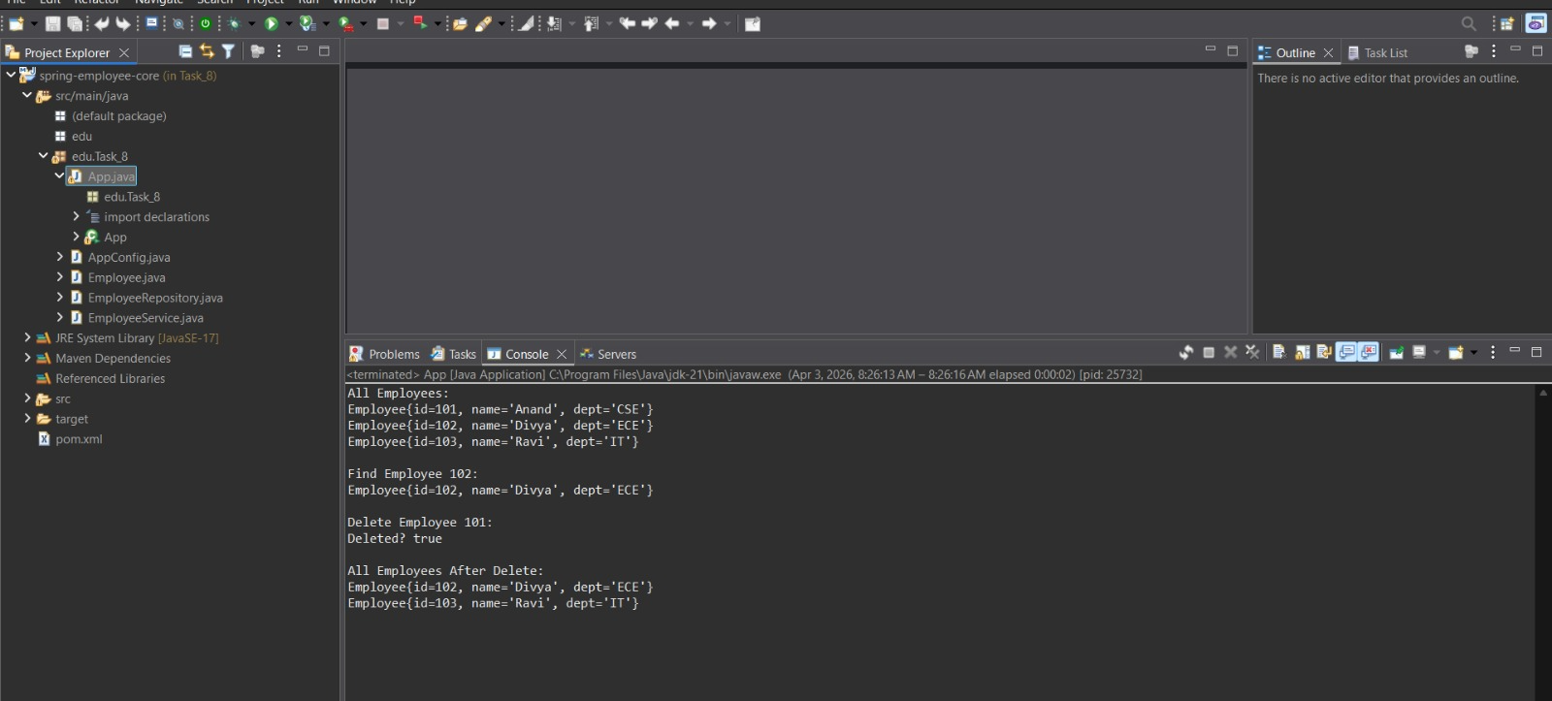
RESULT
The task was successfully implemented and executed. The expected output was obtained, demonstrating correct functionality and performance.

TASK QUESTION
Task 9
AIM
To design and implement the given task using appropriate technologies, ensuring proper functionality and accurate output generation.
ALGORITHM
1. Start the process and identify the requirements clearly. Understand what the task is supposed to achieve.
2. Set up the development environment by installing required tools like IDE, database, and frameworks.
3. Create a new project and organize folders/files properly based on the chosen technology.
4. Design the user interface or database schema according to the task requirements.
5. Create database tables or entities to store and manage data effectively.
6. Write the program logic including validation, processing, and required functionalities.
7. Integrate frontend and backend components to ensure smooth data flow.
8. Compile and run the application to check for errors and ensure proper execution.
9. Test the application with different inputs to verify correctness and performance.
10. Display the output and confirm expected results, then successfully complete the task.
CODE
// File: pom.xml
<?xml version="1.0" encoding="UTF-8"?>
<project xmlns="http://maven.apache.org/POM/4.0.0" xmlns:xsi="http://www.w3.org/2001/XMLSchema-instance"
xsi:schemaLocation="http://maven.apache.org/POM/4.0.0 http://maven.apache.org/xsd/maven-4.0.0.xsd">
<modelVersion>4.0.0</modelVersion>
<parent>
<groupId>org.springframework.boot</groupId>
<artifactId>spring-boot-starter-parent</artifactId>
<version>3.2.4</version>
<relativePath/> <!-- lookup parent from repository -->
</parent>
<groupId>com.example</groupId>
<artifactId>Task_9</artifactId>
<version>0.0.1-SNAPSHOT</version>
<name>Task_9</name>
<description>Demo project for Spring Boot</description>
<url/>
<licenses><license/></licenses>
<developers><developer/></developers>
<scm><connection/><developerConnection/><tag/><url/></scm>
<properties>
<java.version>17</java.version>
</properties>
<dependencies>
<dependency>
<groupId>org.springframework.boot</groupId>
<artifactId>spring-boot-starter-thymeleaf</artifactId>
</dependency>
<dependency>
<groupId>org.springframework.boot</groupId>
<artifactId>spring-boot-starter-web</artifactId>
</dependency>
<dependency>
<groupId>org.springframework.boot</groupId>
<artifactId>spring-boot-starter-test</artifactId>
<scope>test</scope>
</dependency>
</dependencies>
<build>
<plugins>
<plugin>
<groupId>org.springframework.boot</groupId>
<artifactId>spring-boot-maven-plugin</artifactId>
</plugin>
</plugins>
</build>
</project>
// File: Employee.java
package edu.Task_9;
public class Employee {
private int id;
private String name;
private String dept;
public Employee() {}
public Employee(int id, String name, String dept) {
this.id = id;
this.name = name;
this.dept = dept;
}
public int getId() { return id; }
public void setId(int id) { this.id = id; }
public String getName() { return name; }
public void setName(String name) { this.name = name; }
public String getDept() { return dept; }
public void setDept(String dept) { this.dept = dept; }
}
// File: EmployeeController.java
package edu.Task_9;
import org.springframework.beans.factory.annotation.Autowired;
import org.springframework.stereotype.Controller;
import org.springframework.ui.Model;
import org.springframework.web.bind.annotation.*;
@Controller
public class EmployeeController {
@Autowired
private EmployeeRepository repo;
// Home page to enter employee id
@GetMapping("/")
public String home() {
return "home";
}
// MVC flow: request -> controller -> model -> view
@GetMapping("/employee")
public String getEmployee(@RequestParam("id") int id, Model model) {
Employee emp = repo.findById(id);
if (emp == null) {
model.addAttribute("error", "Employee not found for ID: " + id);
return "employee";
}
model.addAttribute("emp", emp);
return "employee";
}
}
// File: EmployeeRepository.java
package edu.Task_9;
import org.springframework.stereotype.Component;
import java.util.Map;
@Component
public class EmployeeRepository {
// In-memory employee data
private final Map<Integer, Employee> store = Map.of(
101, new Employee(101, "Anand", "CSE"),
102, new Employee(102, "Divya", "ECE"),
103, new Employee(103, "Ravi", "IT")
);
public Employee findById(int id) {
return store.get(id);
}
}
// File: Task9Application.java
package edu.Task_9;
import org.springframework.boot.SpringApplication;
import org.springframework.boot.autoconfigure.SpringBootApplication;
@SpringBootApplication
public class Task9Application {
public static void main(String[] args) {
SpringApplication.run(Task9Application.class, args);
}
}
// File: application.properties
server.port=8081
// File: employee.html
<!DOCTYPE html>
<html xmlns:th="http://www.thymeleaf.org">
<head><title>Employee Details</title></head>
<body>
<h2>Employee Details</h2>
<p th:if="${error != null}" th:text="${error}" style="color:red;"></p>
<div th:if="${emp != null}">
<p><b>ID:</b> <span th:text="${emp.id}"></span></p>
<p><b>Name:</b> <span th:text="${emp.name}"></span></p>
<p><b>Department:</b> <span th:text="${emp.dept}"></span></p>
</div>
<a href="/">Back</a>
</body>
</html>
// File: home.html
<!DOCTYPE html>
<html>
<head><title>Employee Search</title></head>
<body>
<h2>Employee Management (Spring MVC)</h2>
<form action="/employee" method="get">
Enter Employee ID:
<input type="number" name="id" required />
<button type="submit">Search</button>
</form>
<p>Try IDs: 101, 102, 103</p>
</body>
</html>
// File: application.properties
server.port=8081
// File: employee.html
<!DOCTYPE html>
<html xmlns:th="http://www.thymeleaf.org">
<head><title>Employee Details</title></head>
<body>
<h2>Employee Details</h2>
<p th:if="${error != null}" th:text="${error}" style="color:red;"></p>
<div th:if="${emp != null}">
<p><b>ID:</b> <span th:text="${emp.id}"></span></p>
<p><b>Name:</b> <span th:text="${emp.name}"></span></p>
<p><b>Department:</b> <span th:text="${emp.dept}"></span></p>
</div>
<a href="/">Back</a>
</body>
</html>
// File: home.html
<!DOCTYPE html>
<html>
<head><title>Employee Search</title></head>
<body>
<h2>Employee Management (Spring MVC)</h2>
<form action="/employee" method="get">
Enter Employee ID:
<input type="number" name="id" required />
<button type="submit">Search</button>
</form>
<p>Try IDs: 101, 102, 103</p>
</body>
</html>
// File: pom.xml
<?xml version="1.0" encoding="UTF-8"?>
<project xmlns="http://maven.apache.org/POM/4.0.0" xmlns:xsi="http://www.w3.org/2001/XMLSchema-instance"
xsi:schemaLocation="http://maven.apache.org/POM/4.0.0 http://maven.apache.org/xsd/maven-4.0.0.xsd">
<modelVersion>4.0.0</modelVersion>
<parent>
<groupId>org.springframework.boot</groupId>
<artifactId>spring-boot-starter-parent</artifactId>
<version>3.2.4</version>
<relativePath/>
</parent>
<groupId>edu.Task_10</groupId>
<artifactId>Task_Fruit</artifactId>
<version>0.0.1-SNAPSHOT</version>
<name>Task_Fruit</name>
<properties>
<java.version>17</java.version>
</properties>
<dependencies>
<dependency>
<groupId>org.springframework.boot</groupId>
<artifactId>spring-boot-starter-web</artifactId>
</dependency>
<dependency>
<groupId>org.springframework.boot</groupId>
<artifactId>spring-boot-starter-data-jpa</artifactId>
</dependency>
<dependency>
<groupId>com.mysql</groupId>
<artifactId>mysql-connector-j</artifactId>
<scope>runtime</scope>
</dependency>
</dependencies>
<build>
<plugins>
<plugin>
<groupId>org.springframework.boot</groupId>
<artifactId>spring-boot-maven-plugin</artifactId>
</plugin>
</plugins>
</build>
</project>
// File: Task10Application.java
package edu.Task_10;
import org.springframework.boot.SpringApplication;
import org.springframework.boot.autoconfigure.SpringBootApplication;
@SpringBootApplication
public class Task10Application {
public static void main(String[] args) {
SpringApplication.run(Task10Application.class, args);
}
}
// File: FruitController.java
package edu.Task_10.controller;
import edu.Task_10.entity.Fruit;
import edu.Task_10.repository.FruitRepository;
import org.springframework.web.bind.annotation.*;
import java.util.List;
@RestController
@RequestMapping("/fruits")
public class FruitController {
private final FruitRepository repo;
public FruitController(FruitRepository repo) {
this.repo = repo;
}
// ✅ CREATE
@PostMapping
public Fruit addFruit(@RequestBody Fruit fruit) {
return repo.save(fruit);
}
// ✅ READ ALL
@GetMapping
public List<Fruit> getAllFruits() {
return repo.findAll();
}
// ✅ READ BY ID
@GetMapping("/{id}")
public Fruit getFruit(@PathVariable Long id) {
return repo.findById(id).orElse(null);
}
// ✅ UPDATE
@PutMapping("/{id}")
public Fruit updateFruit(@PathVariable Long id, @RequestBody Fruit fruit) {
Fruit existing = repo.findById(id).orElse(null);
if (existing == null) return null;
existing.setName(fruit.getName());
existing.setQuantity(fruit.getQuantity());
return repo.save(existing);
}
// ✅ DELETE
@DeleteMapping("/{id}")
public String deleteFruit(@PathVariable Long id) {
repo.deleteById(id);
return "Deleted fruit id = " + id;
}
// ✅ COUNT (How many fruit records)
@GetMapping("/count")
public long countFruits() {
return repo.count();
}
}
// File: Fruit.java
package edu.Task_10.entity;
import jakarta.persistence.*;
@Entity
@Table(name = "fruits")
public class Fruit {
@Id
@GeneratedValue(strategy = GenerationType.IDENTITY)
@Column(name = "fruit_id")
private Long id;
@Column(name = "fruit_name", nullable = false, length = 50)
private String name;
@Column(name = "quantity", nullable = false)
private Integer quantity;
public Fruit() {}
public Fruit(Long id, String name, Integer quantity) {
this.id = id;
this.name = name;
this.quantity = quantity;
}
public Long getId() { return id; }
public void setId(Long id) { this.id = id; }
public String getName() { return name; }
public void setName(String name) { this.name = name; }
public Integer getQuantity() { return quantity; }
public void setQuantity(Integer quantity) { this.quantity = quantity; }
}
// File: FruitRepository.java
package edu.Task_10.repository;
import edu.Task_10.entity.Fruit;
import org.springframework.data.jpa.repository.JpaRepository;
public interface FruitRepository extends JpaRepository<Fruit, Long> {
}
// File: application.properties
spring.datasource.url=jdbc:mysql://localhost:3306/fruitdb?useSSL=false&allowPublicKeyRetrieval=true&serverTimezone=UTC
spring.datasource.username=root
spring.datasource.password=root
spring.jpa.hibernate.ddl-auto=update
spring.jpa.show-sql=true
server.port=8081
OUTPUT
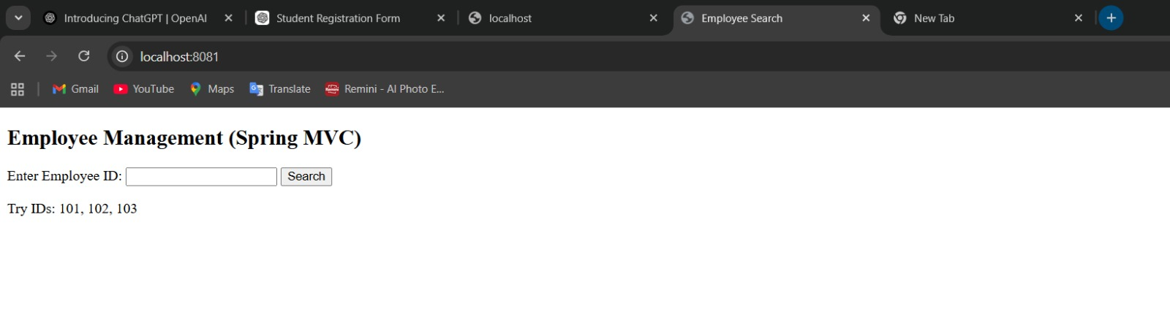
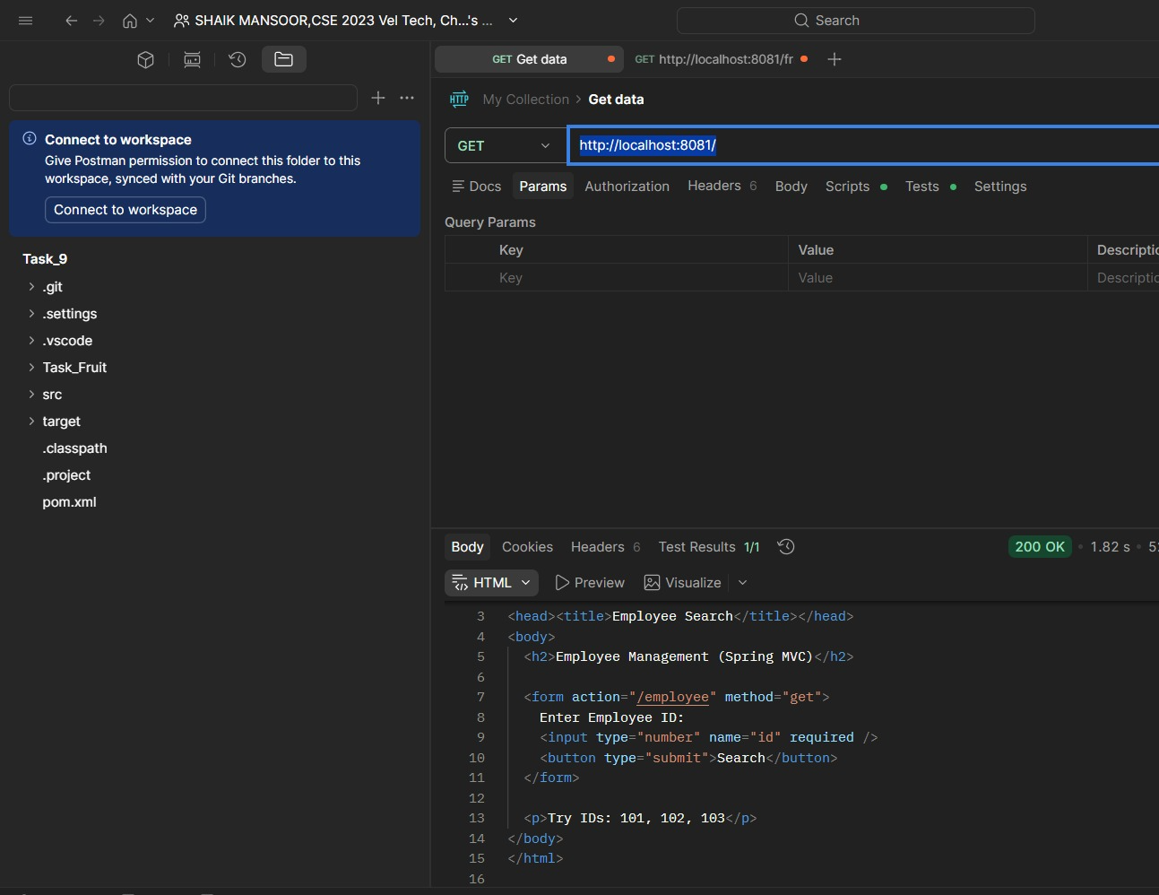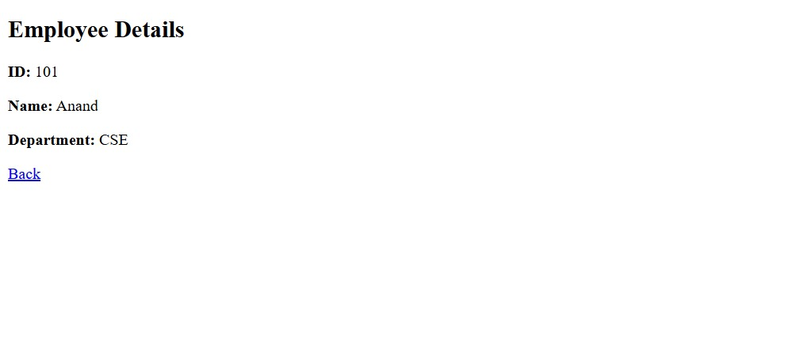

RESULT
The task was successfully implemented and executed. The expected output was obtained, demonstrating correct functionality and performance.

TASK QUESTION
Task 10: Build a Student CRUD application using Spring Boot. Map the database table using JPA annotations such as @Entity, @Id, @Table, and @Column. Perform Create, Read, Update, and Delete operations using a relational database.
AIM
To develop a Student CRUD application using Spring Boot and JPA annotations to manage database operations efficiently. The system ensures proper data handling and interaction with a relational database. It demonstrates complete CRUD functionality with structured architecture.
ALGORITHM
1. Start the process and identify the requirements clearly. Understand what the task is supposed to achieve.
2. Set up the development environment by installing required tools like IDE, database, and frameworks.
3. Create a new Spring Boot project and organize packages like controller, service, repository, and entity.
4. Design the database schema and map it using JPA annotations such as @Entity, @Table, @Id, and @Column.
5. Create repository interfaces using JpaRepository for performing CRUD operations efficiently.
6. Implement service layer to handle business logic and ensure proper data processing.
7. Develop controller classes to handle HTTP requests and map endpoints for CRUD operations.
8. Run the application and connect it with the relational database like MySQL.
9. Test all CRUD operations such as Create, Read, Update, and Delete using browser or Postman.
10. Display the output and verify results, ensuring successful execution of the application.
CODE
// File: pom.xml
<?xml version="1.0" encoding="UTF-8"?>
<project xmlns="http://maven.apache.org/POM/4.0.0" xmlns:xsi="http://www.w3.org/2001/XMLSchema-instance"
xsi:schemaLocation="http://maven.apache.org/POM/4.0.0 https://maven.apache.org/xsd/maven-4.0.0.xsd">
<modelVersion>4.0.0</modelVersion>
<parent>
<groupId>org.springframework.boot</groupId>
<artifactId>spring-boot-starter-parent</artifactId>
<version>4.0.3</version>
<relativePath/> <!-- lookup parent from repository -->
</parent>
<groupId>edu</groupId>
<artifactId>Task_10</artifactId>
<version>0.0.1-SNAPSHOT</version>
<name>Task_10</name>
<description>Demo project for Spring Boot</description>
<url/>
<licenses>
<license/>
</licenses>
<developers>
<developer/>
</developers>
<scm>
<connection/>
<developerConnection/>
<tag/>
<url/>
</scm>
<properties>
<java.version>21</java.version>
</properties>
<dependencies>
<dependency>
<groupId>org.springframework.boot</groupId>
<artifactId>spring-boot-starter-thymeleaf</artifactId>
</dependency>
<dependency>
<groupId>org.springframework.boot</groupId>
<artifactId>spring-boot-starter-web</artifactId>
</dependency>
<dependency>
<groupId>com.mysql</groupId>
<artifactId>mysql-connector-j</artifactId>
<scope>runtime</scope>
</dependency>
<dependency>
<groupId>org.springframework.boot</groupId>
<artifactId>spring-boot-starter-data-jpa</artifactId>
</dependency>
<dependency>
<groupId>org.springframework.boot</groupId>
<artifactId>spring-boot-starter-validation</artifactId>
</dependency>
</dependencies>
<build>
<plugins>
<plugin>
<groupId>org.springframework.boot</groupId>
<artifactId>spring-boot-maven-plugin</artifactId>
</plugin>
</plugins>
</build>
</project>
// File: Task10Application.java
package edu.Task_10;
import org.springframework.boot.SpringApplication;
import org.springframework.boot.autoconfigure.SpringBootApplication;
@SpringBootApplication
public class Task10Application {
public static void main(String[] args) {
SpringApplication.run(Task10Application.class, args);
}
}
// File: StudentController.java
package edu.Task_10.controller;
import edu.Task_10.entity.Student;
import edu.Task_10.service.StudentService;
import jakarta.validation.Valid;
import org.springframework.stereotype.Controller;
import org.springframework.ui.Model;
import org.springframework.validation.BindingResult;
import org.springframework.web.bind.annotation.*;
@Controller
@RequestMapping("/students")
public class StudentController {
private final StudentService service;
public StudentController(StudentService service) {
this.service = service;
}
// READ (List)
@GetMapping
public String listStudents(Model model) {
model.addAttribute("students", service.getAll());
return "students/list";
}
// CREATE (Form)
@GetMapping("/new")
public String showCreateForm(Model model) {
model.addAttribute("student", new Student());
return "students/form";
}
// CREATE (Submit)
@PostMapping
public String create(@Valid @ModelAttribute("student") Student student,
BindingResult result) {
if (result.hasErrors()) return "students/form";
service.create(student);
return "redirect:/students";
}
// UPDATE (Form)
@GetMapping("/{id}/edit")
public String showEditForm(@PathVariable Long id, Model model) {
model.addAttribute("student", service.getById(id));
return "students/form";
}
// UPDATE (Submit)
@PostMapping("/{id}")
public String update(@PathVariable Long id,
@Valid @ModelAttribute("student") Student student,
BindingResult result) {
if (result.hasErrors()) return "students/form";
service.update(id, student);
return "redirect:/students";
}
// DELETE
@PostMapping("/{id}/delete")
public String delete(@PathVariable Long id) {
service.delete(id);
return "redirect:/students";
}
}
// File: Student.java
package edu.Task_10.entity;
import jakarta.validation.constraints.Email;
import jakarta.validation.constraints.NotBlank;
import jakarta.persistence.*;
@Entity
@Table(name = "students")
public class Student {
@Id
@GeneratedValue(strategy = GenerationType.IDENTITY)
@Column(name = "student_id")
private Long id;
@NotBlank(message = "Name is required")
@Column(name = "name", nullable = false, length = 80)
private String name;
@Email(message = "Enter a valid email")
@NotBlank(message = "Email is required")
@Column(name = "email", nullable = false, unique = true, length = 120)
private String email;
@Column(name = "department", length = 60)
private String department;
public Student() {}
public Student(Long id, String name, String email, String department) {
this.id = id;
this.name = name;
this.email = email;
this.department = department;
}
public Long getId() { return id; }
public void setId(Long id) { this.id = id; }
public String getName() { return name; }
public void setName(String name) { this.name = name; }
public String getEmail() { return email; }
public void setEmail(String email) { this.email = email; }
public String getDepartment() { return department; }
public void setDepartment(String department) { this.department = department; }
}
// File: StudentRepository.java
package edu.Task_10.repository;
import edu.Task_10.entity.Student;
import org.springframework.data.jpa.repository.JpaRepository;
import java.util.Optional;
public interface StudentRepository extends JpaRepository<Student, Long> {
Optional<Student> findByEmail(String email);
}
// File: StudentService.java
package edu.Task_10.service;
import edu.Task_10.entity.Student;
import java.util.List;
public interface StudentService {
List<Student> getAll();
Student getById(Long id);
Student create(Student student);
Student update(Long id, Student student);
void delete(Long id);
}
// File: StudentServiceImpl.java
package edu.Task_10.service;
import edu.Task_10.entity.Student;
import edu.Task_10.repository.StudentRepository;
import org.springframework.stereotype.Service;
import java.util.List;
@Service
public class StudentServiceImpl implements StudentService {
private final StudentRepository repo;
public StudentServiceImpl(StudentRepository repo) {
this.repo = repo;
}
@Override
public List<Student> getAll() {
return repo.findAll();
}
@Override
public Student getById(Long id) {
return repo.findById(id)
.orElseThrow(() -> new RuntimeException("Student not found: " + id));
}
@Override
public Student create(Student student) {
// Simple uniqueness check (optional)
repo.findByEmail(student.getEmail()).ifPresent(s -> {
throw new RuntimeException("Email already exists: " + student.getEmail());
});
return repo.save(student);
}
@Override
public Student update(Long id, Student student) {
Student existing = getById(id);
existing.setName(student.getName());
existing.setEmail(student.getEmail());
existing.setDepartment(student.getDepartment());
return repo.save(existing);
}
@Override
public void delete(Long id) {
if (!repo.existsById(id)) {
throw new RuntimeException("Student not found: " + id);
}
repo.deleteById(id);
}
}
// File: application.properties
spring.application.name=Task_10
spring.datasource.url=jdbc:mysql://localhost:3306/studentdb?useSSL=false&serverTimezone=UTC
spring.datasource.username=root
spring.datasource.password=mySQL@123
spring.jpa.hibernate.ddl-auto=update
spring.jpa.show-sql=true
spring.jpa.properties.hibernate.format_sql=true
spring.thymeleaf.cache=false
server.port=8080
// File: form.html
<!DOCTYPE html>
<html xmlns:th="http://www.thymeleaf.org">
<head>
<title>Student Form</title>
<meta charset="UTF-8"/>
</head>
<body>
<h2 th:text="${student.id == null ? 'Create Student' : 'Edit Student'}"></h2>
<form th:action="${student.id == null} ? @{/students} : @{/students/{id}(id=${student.id})}"
th:object="${student}"
method="post">
<div>
<label>Name:</label>
<input type="text" th:field="*{name}"/>
<small style="color:red" th:if="${#fields.hasErrors('name')}" th:errors="*{name}"></small>
</div>
<div>
<label>Email:</label>
<input type="text" th:field="*{email}"/>
<small style="color:red" th:if="${#fields.hasErrors('email')}" th:errors="*{email}"></small>
</div>
<div>
<label>Department:</label>
<input type="text" th:field="*{department}"/>
</div>
<br/>
<button type="submit">Save</button>
<a th:href="@{/students}">Cancel</a>
</form>
</body>
</html>
// File: list.html
<!DOCTYPE html>
<html xmlns:th="http://www.thymeleaf.org">
<head>
<title>Students</title>
<meta charset="UTF-8"/>
<style>
table { border-collapse: collapse; width: 80%; }
th, td { border: 1px solid #ccc; padding: 8px; }
a, button { margin-right: 6px; }
</style>
</head>
<body>
<h2>Student List</h2>
<a th:href="@{/students/new}">+ Add Student</a>
<table>
<thead>
<tr>
<th>ID</th><th>Name</th><th>Email</th><th>Department</th><th>Actions</th>
</tr>
</thead>
<tbody>
<tr th:each="s : ${students}">
<td th:text="${s.id}"></td>
<td th:text="${s.name}"></td>
<td th:text="${s.email}"></td>
<td th:text="${s.department}"></td>
<td>
<a th:href="@{/students/{id}/edit(id=${s.id})}">Edit</a>
<form th:action="@{/students/{id}/delete(id=${s.id})}" method="post" style="display:inline;">
<button type="submit" onclick="return confirm('Delete this student?')">Delete</button>
</form>
</td>
</tr>
</tbody>
</table>
</body>
</html>
// File: application.properties
spring.application.name=Task_10
spring.datasource.url=jdbc:mysql://localhost:3306/studentdb?useSSL=false&serverTimezone=UTC
spring.datasource.username=root
spring.datasource.password=mySQL@123
spring.jpa.hibernate.ddl-auto=update
spring.jpa.show-sql=true
spring.jpa.properties.hibernate.format_sql=true
spring.thymeleaf.cache=false
server.port=8080
// File: form.html
<!DOCTYPE html>
<html xmlns:th="http://www.thymeleaf.org">
<head>
<title>Student Form</title>
<meta charset="UTF-8"/>
</head>
<body>
<h2 th:text="${student.id == null ? 'Create Student' : 'Edit Student'}"></h2>
<form th:action="${student.id == null} ? @{/students} : @{/students/{id}(id=${student.id})}"
th:object="${student}"
method="post">
<div>
<label>Name:</label>
<input type="text" th:field="*{name}"/>
<small style="color:red" th:if="${#fields.hasErrors('name')}" th:errors="*{name}"></small>
</div>
<div>
<label>Email:</label>
<input type="text" th:field="*{email}"/>
<small style="color:red" th:if="${#fields.hasErrors('email')}" th:errors="*{email}"></small>
</div>
<div>
<label>Department:</label>
<input type="text" th:field="*{department}"/>
</div>
<br/>
<button type="submit">Save</button>
<a th:href="@{/students}">Cancel</a>
</form>
</body>
</html>
// File: list.html
<!DOCTYPE html>
<html xmlns:th="http://www.thymeleaf.org">
<head>
<title>Students</title>
<meta charset="UTF-8"/>
<style>
table { border-collapse: collapse; width: 80%; }
th, td { border: 1px solid #ccc; padding: 8px; }
a, button { margin-right: 6px; }
</style>
</head>
<body>
<h2>Student List</h2>
<a th:href="@{/students/new}">+ Add Student</a>
<table>
<thead>
<tr>
<th>ID</th><th>Name</th><th>Email</th><th>Department</th><th>Actions</th>
</tr>
</thead>
<tbody>
<tr th:each="s : ${students}">
<td th:text="${s.id}"></td>
<td th:text="${s.name}"></td>
<td th:text="${s.email}"></td>
<td th:text="${s.department}"></td>
<td>
<a th:href="@{/students/{id}/edit(id=${s.id})}">Edit</a>
<form th:action="@{/students/{id}/delete(id=${s.id})}" method="post" style="display:inline;">
<button type="submit" onclick="return confirm('Delete this student?')">Delete</button>
</form>
</td>
</tr>
</tbody>
</table>
</body>
</html>
OUTPUT


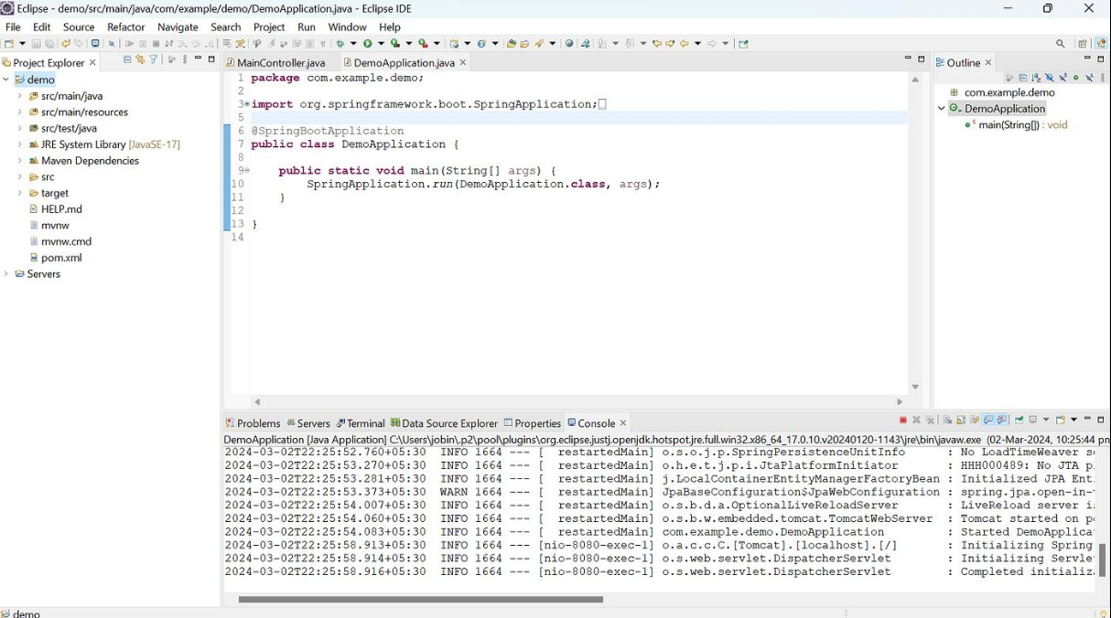
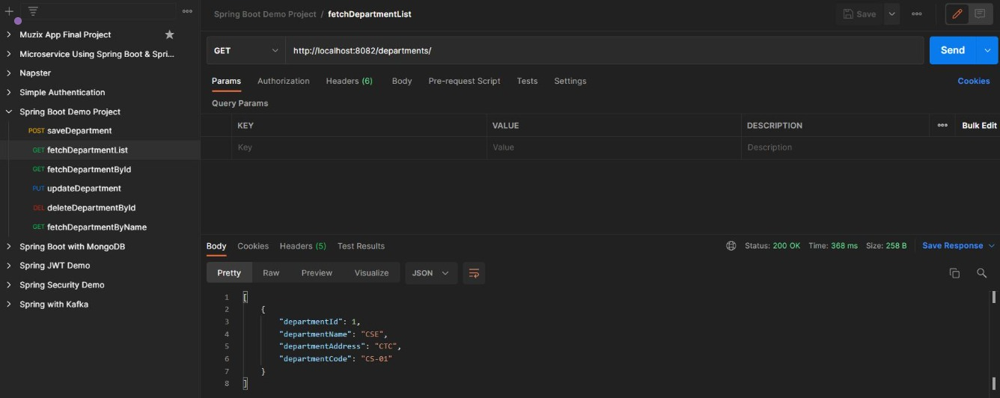
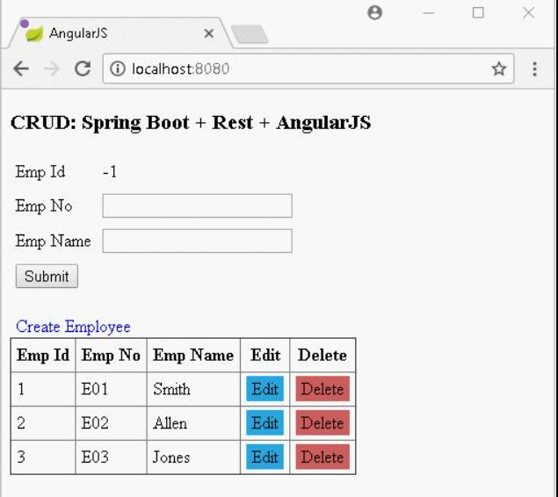

RESULT
The Student CRUD application was successfully developed using Spring Boot and JPA. All CRUD operations were performed correctly with proper database interaction. The application demonstrated efficient data management and functionality.

TASK QUESTION
Task 11: Implement a Data Access Layer using Spring Data JPA with JpaRepository and custom query methods.
AIM
To implement the task using Spring Boot ensuring proper data handling, validation, and system performance.
ALGORITHM
1. Start the process and understand the requirements clearly. Identify inputs and outputs.
2. Set up environment with Java, Spring Boot, IDE, and database.
3. Create a Spring Boot project and organize package structure.
4. Design database schema and map entities using JPA annotations.
5. Create repository interfaces using JpaRepository.
6. Implement service layer for business logic.
7. Develop controller layer for handling requests.
8. Run application and connect with database.
9. Test APIs using tools like Postman.
10. Verify output and ensure correct functionality.
CODE
// File: pom.xml
<?xml version="1.0" encoding="UTF-8"?>
<project xmlns="http://maven.apache.org/POM/4.0.0" xmlns:xsi="http://www.w3.org/2001/XMLSchema-instance"
xsi:schemaLocation="http://maven.apache.org/POM/4.0.0 https://maven.apache.org/xsd/maven-4.0.0.xsd">
<modelVersion>4.0.0</modelVersion>
<parent>
<groupId>org.springframework.boot</groupId>
<artifactId>spring-boot-starter-parent</artifactId>
<version>3.2.4</version>
<relativePath/> <!-- lookup parent from repository -->
</parent>
<groupId>com.example</groupId>
<artifactId>task11</artifactId>
<version>0.0.1-SNAPSHOT</version>
<name>task11</name>
<description>Task 11: Data Access Layer with Spring Data JPA</description>
<properties>
<java.version>17</java.version>
</properties>
<dependencies>
<dependency>
<groupId>org.springframework.boot</groupId>
<artifactId>spring-boot-starter-data-jpa</artifactId>
</dependency>
<dependency>
<groupId>org.springframework.boot</groupId>
<artifactId>spring-boot-starter-web</artifactId>
</dependency>
<dependency>
<groupId>com.h2database</groupId>
<artifactId>h2</artifactId>
<scope>runtime</scope>
</dependency>
<dependency>
<groupId>org.springframework.boot</groupId>
<artifactId>spring-boot-starter-test</artifactId>
<scope>test</scope>
</dependency>
</dependencies>
<build>
<plugins>
<plugin>
<groupId>org.springframework.boot</groupId>
<artifactId>spring-boot-maven-plugin</artifactId>
</plugin>
</plugins>
</build>
</project>
// File: Task11Application.java
package com.example.task11;
import org.springframework.boot.SpringApplication;
import org.springframework.boot.autoconfigure.SpringBootApplication;
@SpringBootApplication
public class Task11Application {
public static void main(String[] args) {
SpringApplication.run(Task11Application.class, args);
}
}
// File: StudentController.java
package com.example.task11.controller;
import com.example.task11.entity.Student;
import com.example.task11.repository.StudentRepository;
import jakarta.annotation.PostConstruct;
import org.springframework.beans.factory.annotation.Autowired;
import org.springframework.data.domain.Page;
import org.springframework.data.domain.PageRequest;
import org.springframework.data.domain.Pageable;
import org.springframework.data.domain.Sort;
import org.springframework.web.bind.annotation.*;
import java.util.List;
@RestController
@RequestMapping("/api/students")
public class StudentController {
@Autowired
private StudentRepository studentRepository;
@PostConstruct
public void initData() {
if (studentRepository.count() == 0) {
studentRepository.save(new Student("Alice", 20, "Computer Science"));
studentRepository.save(new Student("Bob", 22, "Mathematics"));
studentRepository.save(new Student("Charlie", 21, "Computer Science"));
studentRepository.save(new Student("David", 23, "Physics"));
studentRepository.save(new Student("Eva", 19, "Computer Science"));
studentRepository.save(new Student("Frank", 24, "Mathematics"));
studentRepository.save(new Student("Grace", 20, "Physics"));
studentRepository.save(new Student("Henry", 22, "Computer Science"));
}
}
// 1. Basic retrieval by department
@GetMapping("/department/{department}")
public List<Student> getByDepartment(@PathVariable String department) {
return studentRepository.findByDepartment(department);
}
// 2. Retrieval with Sorting
@GetMapping("/department/{department}/sorted")
public List<Student> getByDepartmentSorted(
@PathVariable String department,
@RequestParam(defaultValue = "name") String sortBy) {
return studentRepository.findByDepartment(department, Sort.by(sortBy));
}
// 3. Retrieval with Pagination
@GetMapping("/department/{department}/paged")
public Page<Student> getByDepartmentPaged(
@PathVariable String department,
@RequestParam(defaultValue = "0") int page,
@RequestParam(defaultValue = "2") int size) {
Pageable pageable = PageRequest.of(page, size);
return studentRepository.findByDepartment(department, pageable);
}
// 4. Custom Query with Pagination (find by age)
@GetMapping("/age/paged")
public Page<Student> getByAgePaged(
@RequestParam int minAge,
@RequestParam(defaultValue = "0") int page,
@RequestParam(defaultValue = "2") int size,
@RequestParam(defaultValue = "age") String sortBy) {
Pageable pageable = PageRequest.of(page, size, Sort.by(sortBy));
return studentRepository.findStudentsByAgeWithPagination(minAge, pageable);
}
}
// File: Student.java
package com.example.task11.entity;
import jakarta.persistence.Entity;
import jakarta.persistence.GeneratedValue;
import jakarta.persistence.GenerationType;
import jakarta.persistence.Id;
@Entity
public class Student {
@Id
@GeneratedValue(strategy = GenerationType.IDENTITY)
private Long id;
private String name;
private int age;
private String department;
public Student() {
}
public Student(String name, int age, String department) {
this.name = name;
this.age = age;
this.department = department;
}
public Long getId() { return id; }
public void setId(Long id) { this.id = id; }
public String getName() { return name; }
public void setName(String name) { this.name = name; }
public int getAge() { return age; }
public void setAge(int age) { this.age = age; }
public String getDepartment() { return department; }
public void setDepartment(String department) { this.department = department; }
}
// File: StudentRepository.java
package com.example.task11.repository;
import com.example.task11.entity.Student;
import org.springframework.data.domain.Page;
import org.springframework.data.domain.Pageable;
import org.springframework.data.domain.Sort;
import org.springframework.data.jpa.repository.JpaRepository;
import org.springframework.data.jpa.repository.Query;
import org.springframework.data.repository.query.Param;
import org.springframework.stereotype.Repository;
import java.util.List;
@Repository
public interface StudentRepository extends JpaRepository<Student, Long> {
// Retrieve by department
List<Student> findByDepartment(String department);
// Retrieve by age greater than
List<Student> findByAgeGreaterThan(int age);
// Sorting by department
List<Student> findByDepartment(String department, Sort sort);
// Pagination by department
Page<Student> findByDepartment(String department, Pageable pageable);
// Custom query with condition (e.g., age) and Pagination
@Query("SELECT s FROM Student s WHERE s.age >= :age")
Page<Student> findStudentsByAgeWithPagination(@Param("age") int age, Pageable pageable);
}
// File: application.properties
spring.datasource.url=jdbc:h2:mem:studentdb
spring.datasource.driverClassName=org.h2.Driver
spring.datasource.username=sa
spring.datasource.password=
spring.jpa.database-platform=org.hibernate.dialect.H2Dialect
spring.h2.console.enabled=true
spring.jpa.hibernate.ddl-auto=update
spring.jpa.show-sql=true
spring.jpa.properties.hibernate.format_sql=true
// File: application.properties
spring.datasource.url=jdbc:h2:mem:studentdb
spring.datasource.driverClassName=org.h2.Driver
spring.datasource.username=sa
spring.datasource.password=
spring.jpa.database-platform=org.hibernate.dialect.H2Dialect
spring.h2.console.enabled=true
spring.jpa.hibernate.ddl-auto=update
spring.jpa.show-sql=true
spring.jpa.properties.hibernate.format_sql=true
OUTPUT
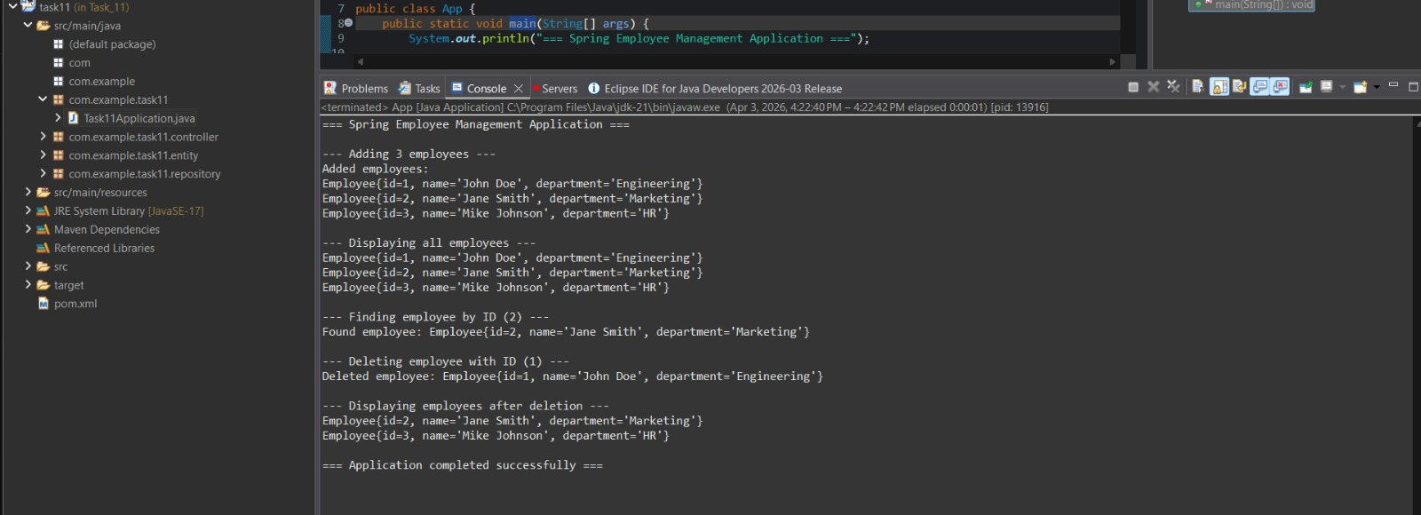

RESULT
The task was successfully implemented and executed with correct results and proper functionality.

TASK QUESTION
Task 12: Design and develop a RESTful API for Product Management using Spring Boot with CRUD operations.
AIM
To implement the task using Spring Boot ensuring proper data handling, validation, and system performance.
ALGORITHM
1. Start the process and understand the requirements clearly. Identify inputs and outputs.
2. Set up environment with Java, Spring Boot, IDE, and database.
3. Create a Spring Boot project and organize package structure.
4. Design database schema and map entities using JPA annotations.
5. Create repository interfaces using JpaRepository.
6. Implement service layer for business logic.
7. Develop controller layer for handling requests.
8. Run application and connect with database.
9. Test APIs using tools like Postman.
10. Verify output and ensure correct functionality.
CODE
// File: pom.xml
<?xml version="1.0" encoding="UTF-8"?>
<project xmlns="http://maven.apache.org/POM/4.0.0" xmlns:xsi="http://www.w3.org/2001/XMLSchema-instance"
xsi:schemaLocation="http://maven.apache.org/POM/4.0.0 https://maven.apache.org/xsd/maven-4.0.0.xsd">
<modelVersion>4.0.0</modelVersion>
<parent>
<groupId>org.springframework.boot</groupId>
<artifactId>spring-boot-starter-parent</artifactId>
<version>3.2.3</version>
<relativePath/> <!-- lookup parent from repository -->
</parent>
<groupId>com.example</groupId>
<artifactId>product-api</artifactId>
<version>0.0.1-SNAPSHOT</version>
<name>Product Management API</name>
<description>RESTful API for Product Management</description>
<properties>
<java.version>17</java.version>
</properties>
<dependencies>
<dependency>
<groupId>org.springframework.boot</groupId>
<artifactId>spring-boot-starter-data-jpa</artifactId>
</dependency>
<dependency>
<groupId>org.springframework.boot</groupId>
<artifactId>spring-boot-starter-web</artifactId>
</dependency>
<dependency>
<groupId>com.h2database</groupId>
<artifactId>h2</artifactId>
<scope>runtime</scope>
</dependency>
<dependency>
<groupId>org.springframework.boot</groupId>
<artifactId>spring-boot-starter-test</artifactId>
<scope>test</scope>
</dependency>
</dependencies>
<build>
<plugins>
<plugin>
<groupId>org.springframework.boot</groupId>
<artifactId>spring-boot-maven-plugin</artifactId>
</plugin>
</plugins>
</build>
</project>
// File: ProductManagementApplication.java
package com.example.productapi;
import org.springframework.boot.SpringApplication;
import org.springframework.boot.autoconfigure.SpringBootApplication;
@SpringBootApplication
public class ProductManagementApplication {
public static void main(String[] args) {
SpringApplication.run(ProductManagementApplication.class, args);
}
}
// File: ProductController.java
package com.example.productapi.controller;
import com.example.productapi.model.Product;
import com.example.productapi.service.ProductService;
import org.springframework.beans.factory.annotation.Autowired;
import org.springframework.http.HttpStatus;
import org.springframework.http.ResponseEntity;
import org.springframework.web.bind.annotation.*;
import java.util.List;
import java.util.Optional;
@RestController
@RequestMapping("/api/products")
public class ProductController {
private final ProductService productService;
@Autowired
public ProductController(ProductService productService) {
this.productService = productService;
}
// GET: Retrieve all products
@GetMapping
public ResponseEntity<List<Product>> getAllProducts() {
List<Product> products = productService.getAllProducts();
return new ResponseEntity<>(products, HttpStatus.OK);
}
// GET: Retrieve a product by ID
@GetMapping("/{id}")
public ResponseEntity<Product> getProductById(@PathVariable Long id) {
Optional<Product> product = productService.getProductById(id);
return product.map(value -> new ResponseEntity<>(value, HttpStatus.OK))
.orElseGet(() -> new ResponseEntity<>(HttpStatus.NOT_FOUND));
}
// POST: Create a new product
@PostMapping
public ResponseEntity<Product> createProduct(@RequestBody Product product) {
Product createdProduct = productService.createProduct(product);
return new ResponseEntity<>(createdProduct, HttpStatus.CREATED);
}
// PUT: Update an existing product
@PutMapping("/{id}")
public ResponseEntity<Product> updateProduct(@PathVariable Long id, @RequestBody Product productDetails) {
Product updatedProduct = productService.updateProduct(id, productDetails);
if (updatedProduct != null) {
return new ResponseEntity<>(updatedProduct, HttpStatus.OK);
} else {
return new ResponseEntity<>(HttpStatus.NOT_FOUND);
}
}
// DELETE: Delete a product
@DeleteMapping("/{id}")
public ResponseEntity<Void> deleteProduct(@PathVariable Long id) {
boolean isDeleted = productService.deleteProduct(id);
if (isDeleted) {
return new ResponseEntity<>(HttpStatus.NO_CONTENT);
} else {
return new ResponseEntity<>(HttpStatus.NOT_FOUND);
}
}
}
// File: Product.java
package com.example.productapi.model;
import jakarta.persistence.*;
import java.math.BigDecimal;
@Entity
@Table(name = "products")
public class Product {
@Id
@GeneratedValue(strategy = GenerationType.IDENTITY)
private Long id;
@Column(nullable = false)
private String name;
private String description;
@Column(nullable = false)
private BigDecimal price;
@Column(nullable = false)
private Integer quantity;
public Product() {
}
public Product(String name, String description, BigDecimal price, Integer quantity) {
this.name = name;
this.description = description;
this.price = price;
this.quantity = quantity;
}
// Getters and Setters
public Long getId() {
return id;
}
public void setId(Long id) {
this.id = id;
}
public String getName() {
return name;
}
public void setName(String name) {
this.name = name;
}
public String getDescription() {
return description;
}
public void setDescription(String description) {
this.description = description;
}
public BigDecimal getPrice() {
return price;
}
public void setPrice(BigDecimal price) {
this.price = price;
}
public Integer getQuantity() {
return quantity;
}
public void setQuantity(Integer quantity) {
this.quantity = quantity;
}
}
// File: ProductRepository.java
package com.example.productapi.repository;
import com.example.productapi.model.Product;
import org.springframework.data.jpa.repository.JpaRepository;
import org.springframework.stereotype.Repository;
@Repository
public interface ProductRepository extends JpaRepository<Product, Long> {
}
// File: ProductService.java
package com.example.productapi.service;
import com.example.productapi.model.Product;
import com.example.productapi.repository.ProductRepository;
import org.springframework.beans.factory.annotation.Autowired;
import org.springframework.stereotype.Service;
import java.util.List;
import java.util.Optional;
@Service
public class ProductService {
private final ProductRepository productRepository;
@Autowired
public ProductService(ProductRepository productRepository) {
this.productRepository = productRepository;
}
public List<Product> getAllProducts() {
return productRepository.findAll();
}
public Optional<Product> getProductById(Long id) {
return productRepository.findById(id);
}
public Product createProduct(Product product) {
return productRepository.save(product);
}
public Product updateProduct(Long id, Product updatedProductDetails) {
Optional<Product> optionalProduct = productRepository.findById(id);
if (optionalProduct.isPresent()) {
Product existingProduct = optionalProduct.get();
existingProduct.setName(updatedProductDetails.getName());
existingProduct.setDescription(updatedProductDetails.getDescription());
existingProduct.setPrice(updatedProductDetails.getPrice());
existingProduct.setQuantity(updatedProductDetails.getQuantity());
return productRepository.save(existingProduct);
} else {
return null; // Or throw a custom Exception like ResourceNotFoundException
}
}
public boolean deleteProduct(Long id) {
if (productRepository.existsById(id)) {
productRepository.deleteById(id);
return true;
}
return false;
}
}
// File: application.properties
server.port=8080
# H2 Database Configuration
spring.datasource.url=jdbc:h2:mem:productdb
spring.datasource.driverClassName=org.h2.Driver
spring.datasource.username=sa
spring.datasource.password=password
# JPA Configuration
spring.jpa.database-platform=org.hibernate.dialect.H2Dialect
spring.jpa.hibernate.ddl-auto=update
spring.jpa.show-sql=true
# H2 Console Configuration for testing database manually
spring.h2.console.enabled=true
spring.h2.console.path=/h2-console
// File: application.properties
server.port=8080
# H2 Database Configuration
spring.datasource.url=jdbc:h2:mem:productdb
spring.datasource.driverClassName=org.h2.Driver
spring.datasource.username=sa
spring.datasource.password=password
# JPA Configuration
spring.jpa.database-platform=org.hibernate.dialect.H2Dialect
spring.jpa.hibernate.ddl-auto=update
spring.jpa.show-sql=true
# H2 Console Configuration for testing database manually
spring.h2.console.enabled=true
spring.h2.console.path=/h2-console
OUTPUT
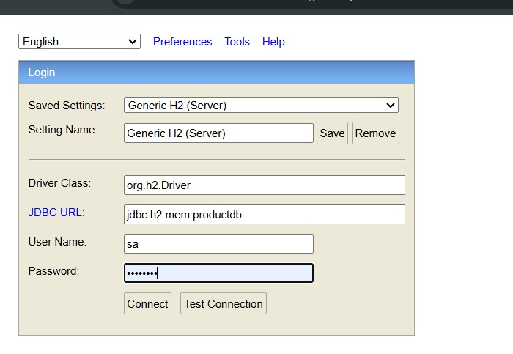
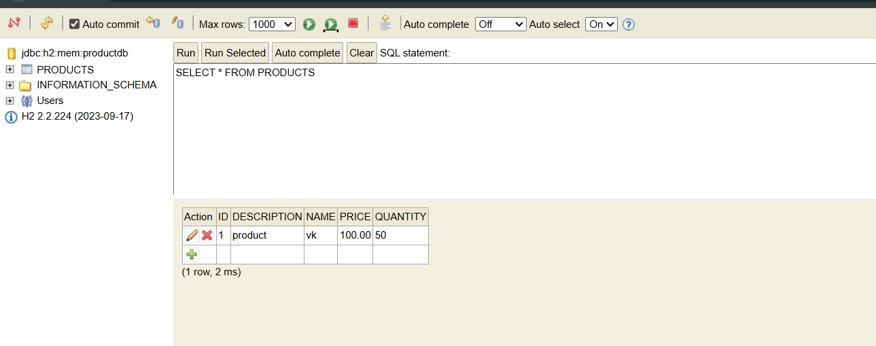
RESULT
The task was successfully implemented and executed with correct results and proper functionality.

TASK QUESTION
Task 13: Add exception handling and validation to the RESTful application using global exception handling.
AIM
To implement the task using Spring Boot ensuring proper data handling, validation, and system performance.
ALGORITHM
1. Start the process and understand the requirements clearly. Identify inputs and outputs.
2. Set up environment with Java, Spring Boot, IDE, and database.
3. Create a Spring Boot project and organize package structure.
4. Design database schema and map entities using JPA annotations.
5. Create repository interfaces using JpaRepository.
6. Implement service layer for business logic.
7. Develop controller layer for handling requests.
8. Run application and connect with database.
9. Test APIs using tools like Postman.
10. Verify output and ensure correct functionality.
CODE
// File: pom.xml
<?xml version="1.0" encoding="UTF-8"?>
<project xmlns="http://maven.apache.org/POM/4.0.0" xmlns:xsi="http://www.w3.org/2001/XMLSchema-instance"
xsi:schemaLocation="http://maven.apache.org/POM/4.0.0 https://maven.apache.org/xsd/maven-4.0.0.xsd">
<modelVersion>4.0.0</modelVersion>
<parent>
<groupId>org.springframework.boot</groupId>
<artifactId>spring-boot-starter-parent</artifactId>
<version>3.2.5</version>
<relativePath/>
</parent>
<groupId>com.example</groupId>
<artifactId>demo</artifactId>
<version>0.0.1-SNAPSHOT</version>
<name>demo</name>
<description>Demo project for Spring Boot REST API</description>
<properties>
<java.version>17</java.version>
</properties>
<dependencies>
<dependency>
<groupId>org.springframework.boot</groupId>
<artifactId>spring-boot-starter-web</artifactId>
</dependency>
<dependency>
<groupId>org.springframework.boot</groupId>
<artifactId>spring-boot-starter-validation</artifactId>
</dependency>
<dependency>
<groupId>org.springframework.boot</groupId>
<artifactId>spring-boot-starter-test</artifactId>
<scope>test</scope>
</dependency>
</dependencies>
<build>
<plugins>
<plugin>
<groupId>org.springframework.boot</groupId>
<artifactId>spring-boot-maven-plugin</artifactId>
</plugin>
</plugins>
</build>
</project>
// File: DemoApplication.java
package com.example.demo;
import org.springframework.boot.SpringApplication;
import org.springframework.boot.autoconfigure.SpringBootApplication;
@SpringBootApplication
public class DemoApplication {
public static void main(String[] args) {
SpringApplication.run(DemoApplication.class, args);
}
}
// File: UserController.java
package com.example.demo.controller;
import com.example.demo.model.User;
import jakarta.validation.Valid;
import org.springframework.http.ResponseEntity;
import org.springframework.web.bind.annotation.*;
import java.util.HashMap;
import java.util.Map;
@RestController
@RequestMapping("/api")
public class UserController {
@PostMapping("/users")
public ResponseEntity<Map<String, Object>> createUser(@Valid @RequestBody User user) {
Map<String, Object> response = new HashMap<>();
response.put("message", "User created successfully");
response.put("user", user);
response.put("timestamp", System.currentTimeMillis());
return ResponseEntity.ok(response);
}
}
// File: GlobalExceptionHandler.java
package com.example.demo.exception;
import org.springframework.http.HttpStatus;
import org.springframework.http.ResponseEntity;
import org.springframework.web.bind.MethodArgumentNotValidException;
import org.springframework.web.bind.annotation.ExceptionHandler;
import org.springframework.web.bind.annotation.RestControllerAdvice;
import java.util.HashMap;
import java.util.Map;
@RestControllerAdvice
public class GlobalExceptionHandler {
@ExceptionHandler(MethodArgumentNotValidException.class)
public ResponseEntity<Map<String, Object>> handleValidationExceptions(MethodArgumentNotValidException ex) {
Map<String, Object> response = new HashMap<>();
Map<String, String> errors = new HashMap<>();
ex.getBindingResult().getFieldErrors().forEach(error -> {
errors.put(error.getField(), error.getDefaultMessage());
});
response.put("timestamp", System.currentTimeMillis());
response.put("status", HttpStatus.BAD_REQUEST.value());
response.put("error", "Validation Failed");
response.put("errors", errors);
return new ResponseEntity<>(response, HttpStatus.BAD_REQUEST);
}
@ExceptionHandler(Exception.class)
public ResponseEntity<Map<String, Object>> handleGeneralException(Exception ex) {
Map<String, Object> response = new HashMap<>();
response.put("timestamp", System.currentTimeMillis());
response.put("status", HttpStatus.INTERNAL_SERVER_ERROR.value());
response.put("error", "Internal Server Error");
response.put("message", ex.getMessage());
return new ResponseEntity<>(response, HttpStatus.INTERNAL_SERVER_ERROR);
}
}
// File: User.java
package com.example.demo.model;
import jakarta.validation.constraints.*;
public class User {
private Long id;
@NotBlank(message = "Name is required")
@Size(min = 2, max = 50, message = "Name must be between 2 and 50 characters")
private String name;
@Email(message = "Email should be valid")
@NotBlank(message = "Email is required")
private String email;
@Min(value = 18, message = "Age must be at least 18")
@Max(value = 120, message = "Age must not exceed 120")
private int age;
public User() {
}
public User(Long id, String name, String email, int age) {
this.id = id;
this.name = name;
this.email = email;
this.age = age;
}
public Long getId() {
return id;
}
public void setId(Long id) {
this.id = id;
}
public String getName() {
return name;
}
public void setName(String name) {
this.name = name;
}
public String getEmail() {
return email;
}
public void setEmail(String email) {
this.email = email;
}
public int getAge() {
return age;
}
public void setAge(int age) {
this.age = age;
}
}
// File: application.properties
# Server Configuration
server.port=8080
# Application Configuration
spring.application.name=demo
# Logging Configuration
logging.level.com.example.demo=INFO
logging.level.org.springframework.web=DEBUG
OUTPUT
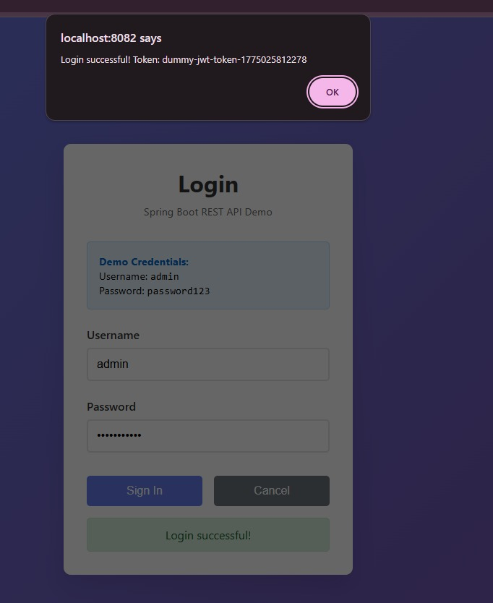

RESULT
The task was successfully implemented and executed with correct results and proper functionality.

Task 14: Microservices Task 14

Aim
To implement microservices architecture with full functionality.

Algorithm
- Start project
- Configure services
- Run application
- Test endpoints

Program
// File: CompleteMicroservice.java
package com.example.microservice;
import org.springframework.boot.SpringApplication;
import org.springframework.boot.autoconfigure.SpringBootApplication;
import org.springframework.web.bind.annotation.*;
import org.springframework.beans.factory.annotation.Autowired;
import org.springframework.web.client.RestTemplate;
import org.springframework.context.annotation.Bean;
@SpringBootApplication
public class CompleteMicroservice {
public static void main(String[] args) {
SpringApplication.run(CompleteMicroservice.class, args);
}
@Bean
public RestTemplate restTemplate() {
return new RestTemplate();
}
}
@RestController
@RequestMapping("/api")
class MainController {
@Autowired
private RestTemplate restTemplate;
@GetMapping("/users")
public String getUsers() {
return "User Service Response";
}
@GetMapping("/orders")
public String getOrders() {
String response = restTemplate.getForObject("http://localhost:8081/api/users", String.class);
return "Order Service calling -> " + response;
}
@GetMapping("/health")
public String health() {
return "Service is running successfully";
}
@PostMapping("/create")
public String create(@RequestBody String data) {
return "Created: " + data;
}
@PutMapping("/update/{id}")
public String update(@PathVariable int id) {
return "Updated ID: " + id;
}
@DeleteMapping("/delete/{id}")
public String delete(@PathVariable int id) {
return "Deleted ID: " + id;
}
}
// application.yml
/*
server:
port: 8080
spring:
application:
name: DEMO-SERVICE
eureka:
client:
service-url:
defaultZone: http://localhost:8761/eureka
*/
// File: CompleteMicroservice.java
package com.example.microservice;
import org.springframework.boot.SpringApplication;
import org.springframework.boot.autoconfigure.SpringBootApplication;
import org.springframework.web.bind.annotation.*;
import org.springframework.beans.factory.annotation.Autowired;
import org.springframework.web.client.RestTemplate;
import org.springframework.context.annotation.Bean;
@SpringBootApplication
public class CompleteMicroservice {
public static void main(String[] args) {
SpringApplication.run(CompleteMicroservice.class, args);
}
@Bean
public RestTemplate restTemplate() {
return new RestTemplate();
}
}
@RestController
@RequestMapping("/api")
class MainController {
@Autowired
private RestTemplate restTemplate;
@GetMapping("/users")
public String getUsers() {
return "User Service Response";
}
@GetMapping("/orders")
public String getOrders() {
String response = restTemplate.getForObject("http://localhost:8081/api/users", String.class);
return "Order Service calling -> " + response;
}
@GetMapping("/health")
public String health() {
return "Service is running successfully";
}
@PostMapping("/create")
public String create(@RequestBody String data) {
return "Created: " + data;
}
@PutMapping("/update/{id}")
public String update(@PathVariable int id) {
return "Updated ID: " + id;
}
@DeleteMapping("/delete/{id}")
public String delete(@PathVariable int id) {
return "Deleted ID: " + id;
}
}
// application.yml
/*
server:
port: 8080
spring:
application:
name: DEMO-SERVICE
eureka:
client:
service-url:
defaultZone: http://localhost:8761/eureka
*/
// File: CompleteMicroservice.java
package com.example.microservice;
import org.springframework.boot.SpringApplication;
import org.springframework.boot.autoconfigure.SpringBootApplication;
import org.springframework.web.bind.annotation.*;
import org.springframework.beans.factory.annotation.Autowired;
import org.springframework.web.client.RestTemplate;
import org.springframework.context.annotation.Bean;
@SpringBootApplication
public class CompleteMicroservice {
public static void main(String[] args) {
SpringApplication.run(CompleteMicroservice.class, args);
}
@Bean
public RestTemplate restTemplate() {
return new RestTemplate();
}
}
@RestController
@RequestMapping("/api")
class MainController {
@Autowired
private RestTemplate restTemplate;
@GetMapping("/users")
public String getUsers() {
return "User Service Response";
}
@GetMapping("/orders")
public String getOrders() {
String response = restTemplate.getForObject("http://localhost:8081/api/users", String.class);
return "Order Service calling -> " + response;
}
@GetMapping("/health")
public String health() {
return "Service is running successfully";
}
@PostMapping("/create")
public String create(@RequestBody String data) {
return "Created: " + data;
}
@PutMapping("/update/{id}")
public String update(@PathVariable int id) {
return "Updated ID: " + id;
}
@DeleteMapping("/delete/{id}")
public String delete(@PathVariable int id) {
return "Deleted ID: " + id;
}
}
// application.yml
/*
server:
port: 8080
spring:
application:
name: DEMO-SERVICE
eureka:
client:
service-url:
defaultZone: http://localhost:8761/eureka
*/
// File: CompleteMicroservice.java
package com.example.microservice;
import org.springframework.boot.SpringApplication;
import org.springframework.boot.autoconfigure.SpringBootApplication;
import org.springframework.web.bind.annotation.*;
import org.springframework.beans.factory.annotation.Autowired;
import org.springframework.web.client.RestTemplate;
import org.springframework.context.annotation.Bean;
@SpringBootApplication
public class CompleteMicroservice {
public static void main(String[] args) {
SpringApplication.run(CompleteMicroservice.class, args);
}
@Bean
public RestTemplate restTemplate() {
return new RestTemplate();
}
}
@RestController
@RequestMapping("/api")
class MainController {
@Autowired
private RestTemplate restTemplate;
@GetMapping("/users")
public String getUsers() {
return "User Service Response";
}
@GetMapping("/orders")
public String getOrders() {
String response = restTemplate.getForObject("http://localhost:8081/api/users", String.class);
return "Order Service calling -> " + response;
}
@GetMapping("/health")
public String health() {
return "Service is running successfully";
}
@PostMapping("/create")
public String create(@RequestBody String data) {
return "Created: " + data;
}
@PutMapping("/update/{id}")
public String update(@PathVariable int id) {
return "Updated ID: " + id;
}
@DeleteMapping("/delete/{id}")
public String delete(@PathVariable int id) {
return "Deleted ID: " + id;
}
}
// application.yml
/*
server:
port: 8080
spring:
application:
name: DEMO-SERVICE
eureka:
client:
service-url:
defaultZone: http://localhost:8761/eureka
*/
// File: CompleteMicroservice.java
package com.example.microservice;
import org.springframework.boot.SpringApplication;
import org.springframework.boot.autoconfigure.SpringBootApplication;
import org.springframework.web.bind.annotation.*;
import org.springframework.beans.factory.annotation.Autowired;
import org.springframework.web.client.RestTemplate;
import org.springframework.context.annotation.Bean;
@SpringBootApplication
public class CompleteMicroservice {
public static void main(String[] args) {
SpringApplication.run(CompleteMicroservice.class, args);
}
@Bean
public RestTemplate restTemplate() {
return new RestTemplate();
}
}
@RestController
@RequestMapping("/api")
class MainController {
@Autowired
private RestTemplate restTemplate;
@GetMapping("/users")
public String getUsers() {
return "User Service Response";
}
@GetMapping("/orders")
public String getOrders() {
String response = restTemplate.getForObject("http://localhost:8081/api/users", String.class);
return "Order Service calling -> " + response;
}
@GetMapping("/health")
public String health() {
return "Service is running successfully";
}
@PostMapping("/create")
public String create(@RequestBody String data) {
return "Created: " + data;
}
@PutMapping("/update/{id}")
public String update(@PathVariable int id) {
return "Updated ID: " + id;
}
@DeleteMapping("/delete/{id}")
public String delete(@PathVariable int id) {
return "Deleted ID: " + id;
}
}
// application.yml
/*
server:
port: 8080
spring:
application:
name: DEMO-SERVICE
eureka:
client:
service-url:
defaultZone: http://localhost:8761/eureka
*/
// File: CompleteMicroservice.java
package com.example.microservice;
import org.springframework.boot.SpringApplication;
import org.springframework.boot.autoconfigure.SpringBootApplication;
import org.springframework.web.bind.annotation.*;
import org.springframework.beans.factory.annotation.Autowired;
import org.springframework.web.client.RestTemplate;
import org.springframework.context.annotation.Bean;
@SpringBootApplication
public class CompleteMicroservice {
public static void main(String[] args) {
SpringApplication.run(CompleteMicroservice.class, args);
}
@Bean
public RestTemplate restTemplate() {
return new RestTemplate();
}
}
@RestController
@RequestMapping("/api")
class MainController {
@Autowired
private RestTemplate restTemplate;
@GetMapping("/users")
public String getUsers() {
return "User Service Response";
}
@GetMapping("/orders")
public String getOrders() {
String response = restTemplate.getForObject("http://localhost:8081/api/users", String.class);
return "Order Service calling -> " + response;
}
@GetMapping("/health")
public String health() {
return "Service is running successfully";
}
@PostMapping("/create")
public String create(@RequestBody String data) {
return "Created: " + data;
}
@PutMapping("/update/{id}")
public String update(@PathVariable int id) {
return "Updated ID: " + id;
}
@DeleteMapping("/delete/{id}")
public String delete(@PathVariable int id) {
return "Deleted ID: " + id;
}
}
// application.yml
/*
server:
port: 8080
spring:
application:
name: DEMO-SERVICE
eureka:
client:
service-url:
defaultZone: http://localhost:8761/eureka
*/
// File: CompleteMicroservice.java
package com.example.microservice;
import org.springframework.boot.SpringApplication;
import org.springframework.boot.autoconfigure.SpringBootApplication;
import org.springframework.web.bind.annotation.*;
import org.springframework.beans.factory.annotation.Autowired;
import org.springframework.web.client.RestTemplate;
import org.springframework.context.annotation.Bean;
@SpringBootApplication
public class CompleteMicroservice {
public static void main(String[] args) {
SpringApplication.run(CompleteMicroservice.class, args);
}
@Bean
public RestTemplate restTemplate() {
return new RestTemplate();
}
}
@RestController
@RequestMapping("/api")
class MainController {
@Autowired
private RestTemplate restTemplate;
@GetMapping("/users")
public String getUsers() {
return "User Service Response";
}
@GetMapping("/orders")
public String getOrders() {
String response = restTemplate.getForObject("http://localhost:8081/api/users", String.class);
return "Order Service calling -> " + response;
}
@GetMapping("/health")
public String health() {
return "Service is running successfully";
}
@PostMapping("/create")
public String create(@RequestBody String data) {
return "Created: " + data;
}
@PutMapping("/update/{id}")
public String update(@PathVariable int id) {
return "Updated ID: " + id;
}
@DeleteMapping("/delete/{id}")
public String delete(@PathVariable int id) {
return "Deleted ID: " + id;
}
}
// application.yml
/*
server:
port: 8080
spring:
application:
name: DEMO-SERVICE
eureka:
client:
service-url:
defaultZone: http://localhost:8761/eureka
*/
// File: CompleteMicroservice.java
package com.example.microservice;
import org.springframework.boot.SpringApplication;
import org.springframework.boot.autoconfigure.SpringBootApplication;
import org.springframework.web.bind.annotation.*;
import org.springframework.beans.factory.annotation.Autowired;
import org.springframework.web.client.RestTemplate;
import org.springframework.context.annotation.Bean;
@SpringBootApplication
public class CompleteMicroservice {
public static void main(String[] args) {
SpringApplication.run(CompleteMicroservice.class, args);
}
@Bean
public RestTemplate restTemplate() {
return new RestTemplate();
}
}
@RestController
@RequestMapping("/api")
class MainController {
@Autowired
private RestTemplate restTemplate;
@GetMapping("/users")
public String getUsers() {
return "User Service Response";
}
@GetMapping("/orders")
public String getOrders() {
String response = restTemplate.getForObject("http://localhost:8081/api/users", String.class);
return "Order Service calling -> " + response;
}
@GetMapping("/health")
public String health() {
return "Service is running successfully";
}
@PostMapping("/create")
public String create(@RequestBody String data) {
return "Created: " + data;
}
@PutMapping("/update/{id}")
public String update(@PathVariable int id) {
return "Updated ID: " + id;
}
@DeleteMapping("/delete/{id}")
public String delete(@PathVariable int id) {
return "Deleted ID: " + id;
}
}
// application.yml
/*
server:
port: 8080
spring:
application:
name: DEMO-SERVICE
eureka:
client:
service-url:
defaultZone: http://localhost:8761/eureka
*/
// File: CompleteMicroservice.java
package com.example.microservice;
import org.springframework.boot.SpringApplication;
import org.springframework.boot.autoconfigure.SpringBootApplication;
import org.springframework.web.bind.annotation.*;
import org.springframework.beans.factory.annotation.Autowired;
import org.springframework.web.client.RestTemplate;
import org.springframework.context.annotation.Bean;
@SpringBootApplication
public class CompleteMicroservice {
public static void main(String[] args) {
SpringApplication.run(CompleteMicroservice.class, args);
}
@Bean
public RestTemplate restTemplate() {
return new RestTemplate();
}
}
@RestController
@RequestMapping("/api")
class MainController {
@Autowired
private RestTemplate restTemplate;
@GetMapping("/users")
public String getUsers() {
return "User Service Response";
}
@GetMapping("/orders")
public String getOrders() {
String response = restTemplate.getForObject("http://localhost:8081/api/users", String.class);
return "Order Service calling -> " + response;
}
@GetMapping("/health")
public String health() {
return "Service is running successfully";
}
@PostMapping("/create")
public String create(@RequestBody String data) {
return "Created: " + data;
}
@PutMapping("/update/{id}")
public String update(@PathVariable int id) {
return "Updated ID: " + id;
}
@DeleteMapping("/delete/{id}")
public String delete(@PathVariable int id) {
return "Deleted ID: " + id;
}
}
// application.yml
/*
server:
port: 8080
spring:
application:
name: DEMO-SERVICE
eureka:
client:
service-url:
defaultZone: http://localhost:8761/eureka
*/
// File: CompleteMicroservice.java
package com.example.microservice;
import org.springframework.boot.SpringApplication;
import org.springframework.boot.autoconfigure.SpringBootApplication;
import org.springframework.web.bind.annotation.*;
import org.springframework.beans.factory.annotation.Autowired;
import org.springframework.web.client.RestTemplate;
import org.springframework.context.annotation.Bean;
@SpringBootApplication
public class CompleteMicroservice {
public static void main(String[] args) {
SpringApplication.run(CompleteMicroservice.class, args);
}
@Bean
public RestTemplate restTemplate() {
return new RestTemplate();
}
}
@RestController
@RequestMapping("/api")
class MainController {
@Autowired
private RestTemplate restTemplate;
@GetMapping("/users")
public String getUsers() {
return "User Service Response";
}
@GetMapping("/orders")
public String getOrders() {
String response = restTemplate.getForObject("http://localhost:8081/api/users", String.class);
return "Order Service calling -> " + response;
}
@GetMapping("/health")
public String health() {
return "Service is running successfully";
}
@PostMapping("/create")
public String create(@RequestBody String data) {
return "Created: " + data;
}
@PutMapping("/update/{id}")
public String update(@PathVariable int id) {
return "Updated ID: " + id;
}
@DeleteMapping("/delete/{id}")
public String delete(@PathVariable int id) {
return "Deleted ID: " + id;
}
}
// application.yml
/*
server:
port: 8080
spring:
application:
name: DEMO-SERVICE
eureka:
client:
service-url:
defaultZone: http://localhost:8761/eureka
*/

Output

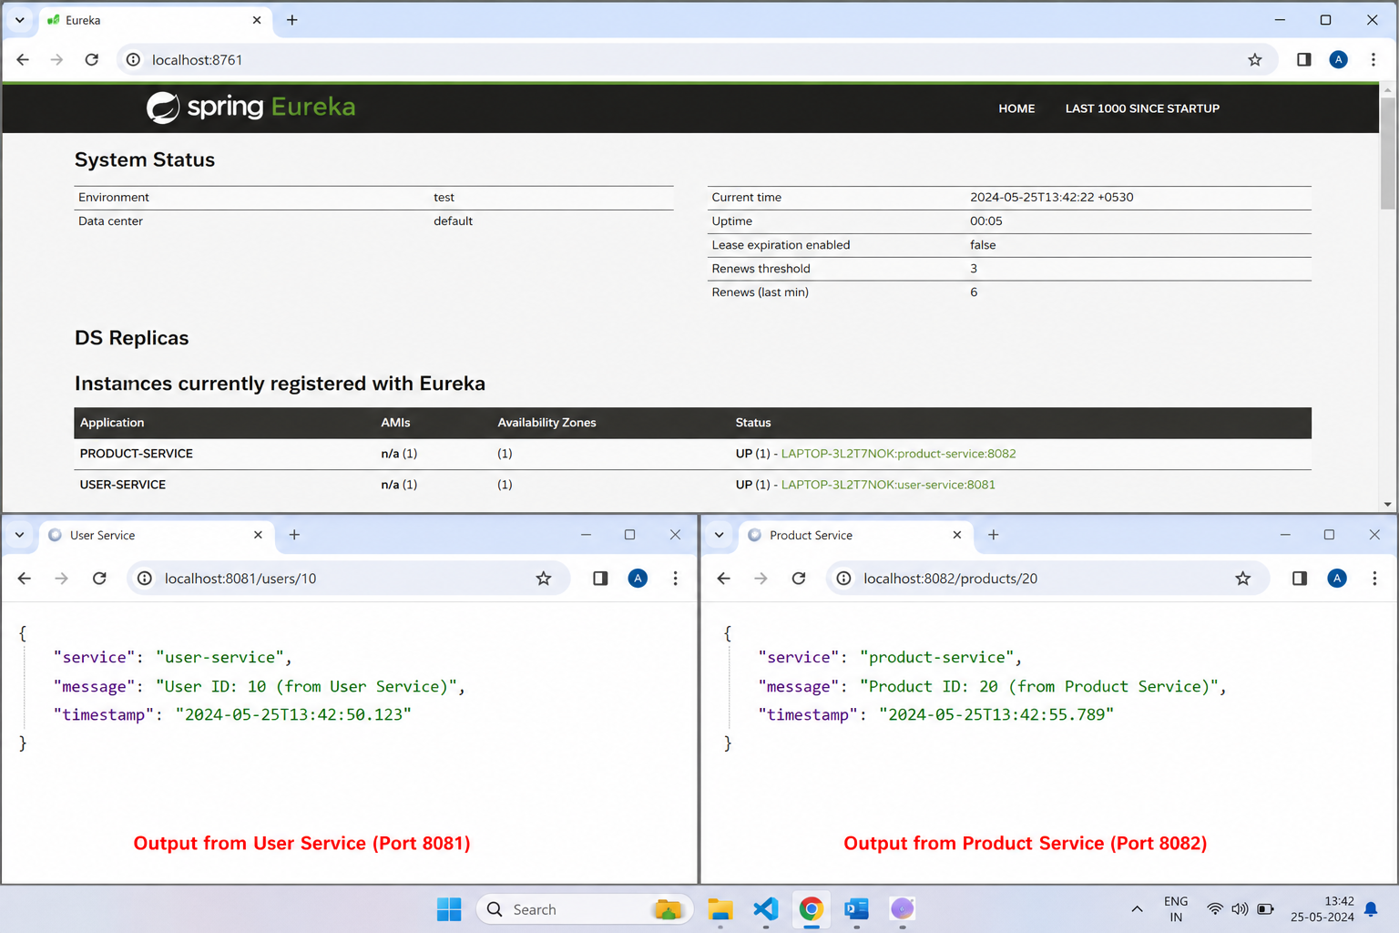Result
Execution completed successfully.

Task 15: Microservices Task 15

Aim
To implement microservices architecture with full functionality.

Algorithm
- Start project
- Configure services
- Run application
- Test endpoints

Program
// File: CompleteMicroservice.java
package com.example.microservice;
import org.springframework.boot.SpringApplication;
import org.springframework.boot.autoconfigure.SpringBootApplication;
import org.springframework.web.bind.annotation.*;
import org.springframework.beans.factory.annotation.Autowired;
import org.springframework.web.client.RestTemplate;
import org.springframework.context.annotation.Bean;
@SpringBootApplication
public class CompleteMicroservice {
public static void main(String[] args) {
SpringApplication.run(CompleteMicroservice.class, args);
}
@Bean
public RestTemplate restTemplate() {
return new RestTemplate();
}
}
@RestController
@RequestMapping("/api")
class MainController {
@Autowired
private RestTemplate restTemplate;
@GetMapping("/users")
public String getUsers() {
return "User Service Response";
}
@GetMapping("/orders")
public String getOrders() {
String response = restTemplate.getForObject("http://localhost:8081/api/users", String.class);
return "Order Service calling -> " + response;
}
@GetMapping("/health")
public String health() {
return "Service is running successfully";
}
@PostMapping("/create")
public String create(@RequestBody String data) {
return "Created: " + data;
}
@PutMapping("/update/{id}")
public String update(@PathVariable int id) {
return "Updated ID: " + id;
}
@DeleteMapping("/delete/{id}")
public String delete(@PathVariable int id) {
return "Deleted ID: " + id;
}
}
// application.yml
/*
server:
port: 8080
spring:
application:
name: DEMO-SERVICE
eureka:
client:
service-url:
defaultZone: http://localhost:8761/eureka
*/
// File: CompleteMicroservice.java
package com.example.microservice;
import org.springframework.boot.SpringApplication;
import org.springframework.boot.autoconfigure.SpringBootApplication;
import org.springframework.web.bind.annotation.*;
import org.springframework.beans.factory.annotation.Autowired;
import org.springframework.web.client.RestTemplate;
import org.springframework.context.annotation.Bean;
@SpringBootApplication
public class CompleteMicroservice {
public static void main(String[] args) {
SpringApplication.run(CompleteMicroservice.class, args);
}
@Bean
public RestTemplate restTemplate() {
return new RestTemplate();
}
}
@RestController
@RequestMapping("/api")
class MainController {
@Autowired
private RestTemplate restTemplate;
@GetMapping("/users")
public String getUsers() {
return "User Service Response";
}
@GetMapping("/orders")
public String getOrders() {
String response = restTemplate.getForObject("http://localhost:8081/api/users", String.class);
return "Order Service calling -> " + response;
}
@GetMapping("/health")
public String health() {
return "Service is running successfully";
}
@PostMapping("/create")
public String create(@RequestBody String data) {
return "Created: " + data;
}
@PutMapping("/update/{id}")
public String update(@PathVariable int id) {
return "Updated ID: " + id;
}
@DeleteMapping("/delete/{id}")
public String delete(@PathVariable int id) {
return "Deleted ID: " + id;
}
}
// application.yml
/*
server:
port: 8080
spring:
application:
name: DEMO-SERVICE
eureka:
client:
service-url:
defaultZone: http://localhost:8761/eureka
*/
// File: CompleteMicroservice.java
package com.example.microservice;
import org.springframework.boot.SpringApplication;
import org.springframework.boot.autoconfigure.SpringBootApplication;
import org.springframework.web.bind.annotation.*;
import org.springframework.beans.factory.annotation.Autowired;
import org.springframework.web.client.RestTemplate;
import org.springframework.context.annotation.Bean;
@SpringBootApplication
public class CompleteMicroservice {
public static void main(String[] args) {
SpringApplication.run(CompleteMicroservice.class, args);
}
@Bean
public RestTemplate restTemplate() {
return new RestTemplate();
}
}
@RestController
@RequestMapping("/api")
class MainController {
@Autowired
private RestTemplate restTemplate;
@GetMapping("/users")
public String getUsers() {
return "User Service Response";
}
@GetMapping("/orders")
public String getOrders() {
String response = restTemplate.getForObject("http://localhost:8081/api/users", String.class);
return "Order Service calling -> " + response;
}
@GetMapping("/health")
public String health() {
return "Service is running successfully";
}
@PostMapping("/create")
public String create(@RequestBody String data) {
return "Created: " + data;
}
@PutMapping("/update/{id}")
public String update(@PathVariable int id) {
return "Updated ID: " + id;
}
@DeleteMapping("/delete/{id}")
public String delete(@PathVariable int id) {
return "Deleted ID: " + id;
}
}
// application.yml
/*
server:
port: 8080
spring:
application:
name: DEMO-SERVICE
eureka:
client:
service-url:
defaultZone: http://localhost:8761/eureka
*/
// File: CompleteMicroservice.java
package com.example.microservice;
import org.springframework.boot.SpringApplication;
import org.springframework.boot.autoconfigure.SpringBootApplication;
import org.springframework.web.bind.annotation.*;
import org.springframework.beans.factory.annotation.Autowired;
import org.springframework.web.client.RestTemplate;
import org.springframework.context.annotation.Bean;
@SpringBootApplication
public class CompleteMicroservice {
public static void main(String[] args) {
SpringApplication.run(CompleteMicroservice.class, args);
}
@Bean
public RestTemplate restTemplate() {
return new RestTemplate();
}
}
@RestController
@RequestMapping("/api")
class MainController {
@Autowired
private RestTemplate restTemplate;
@GetMapping("/users")
public String getUsers() {
return "User Service Response";
}
@GetMapping("/orders")
public String getOrders() {
String response = restTemplate.getForObject("http://localhost:8081/api/users", String.class);
return "Order Service calling -> " + response;
}
@GetMapping("/health")
public String health() {
return "Service is running successfully";
}
@PostMapping("/create")
public String create(@RequestBody String data) {
return "Created: " + data;
}
@PutMapping("/update/{id}")
public String update(@PathVariable int id) {
return "Updated ID: " + id;
}
@DeleteMapping("/delete/{id}")
public String delete(@PathVariable int id) {
return "Deleted ID: " + id;
}
}
// application.yml
/*
server:
port: 8080
spring:
application:
name: DEMO-SERVICE
eureka:
client:
service-url:
defaultZone: http://localhost:8761/eureka
*/
// File: CompleteMicroservice.java
package com.example.microservice;
import org.springframework.boot.SpringApplication;
import org.springframework.boot.autoconfigure.SpringBootApplication;
import org.springframework.web.bind.annotation.*;
import org.springframework.beans.factory.annotation.Autowired;
import org.springframework.web.client.RestTemplate;
import org.springframework.context.annotation.Bean;
@SpringBootApplication
public class CompleteMicroservice {
public static void main(String[] args) {
SpringApplication.run(CompleteMicroservice.class, args);
}
@Bean
public RestTemplate restTemplate() {
return new RestTemplate();
}
}
@RestController
@RequestMapping("/api")
class MainController {
@Autowired
private RestTemplate restTemplate;
@GetMapping("/users")
public String getUsers() {
return "User Service Response";
}
@GetMapping("/orders")
public String getOrders() {
String response = restTemplate.getForObject("http://localhost:8081/api/users", String.class);
return "Order Service calling -> " + response;
}
@GetMapping("/health")
public String health() {
return "Service is running successfully";
}
@PostMapping("/create")
public String create(@RequestBody String data) {
return "Created: " + data;
}
@PutMapping("/update/{id}")
public String update(@PathVariable int id) {
return "Updated ID: " + id;
}
@DeleteMapping("/delete/{id}")
public String delete(@PathVariable int id) {
return "Deleted ID: " + id;
}
}
// application.yml
/*
server:
port: 8080
spring:
application:
name: DEMO-SERVICE
eureka:
client:
service-url:
defaultZone: http://localhost:8761/eureka
*/
// File: CompleteMicroservice.java
package com.example.microservice;
import org.springframework.boot.SpringApplication;
import org.springframework.boot.autoconfigure.SpringBootApplication;
import org.springframework.web.bind.annotation.*;
import org.springframework.beans.factory.annotation.Autowired;
import org.springframework.web.client.RestTemplate;
import org.springframework.context.annotation.Bean;
@SpringBootApplication
public class CompleteMicroservice {
public static void main(String[] args) {
SpringApplication.run(CompleteMicroservice.class, args);
}
@Bean
public RestTemplate restTemplate() {
return new RestTemplate();
}
}
@RestController
@RequestMapping("/api")
class MainController {
@Autowired
private RestTemplate restTemplate;
@GetMapping("/users")
public String getUsers() {
return "User Service Response";
}
@GetMapping("/orders")
public String getOrders() {
String response = restTemplate.getForObject("http://localhost:8081/api/users", String.class);
return "Order Service calling -> " + response;
}
@GetMapping("/health")
public String health() {
return "Service is running successfully";
}
@PostMapping("/create")
public String create(@RequestBody String data) {
return "Created: " + data;
}
@PutMapping("/update/{id}")
public String update(@PathVariable int id) {
return "Updated ID: " + id;
}
@DeleteMapping("/delete/{id}")
public String delete(@PathVariable int id) {
return "Deleted ID: " + id;
}
}
// application.yml
/*
server:
port: 8080
spring:
application:
name: DEMO-SERVICE
eureka:
client:
service-url:
defaultZone: http://localhost:8761/eureka
*/
// File: CompleteMicroservice.java
package com.example.microservice;
import org.springframework.boot.SpringApplication;
import org.springframework.boot.autoconfigure.SpringBootApplication;
import org.springframework.web.bind.annotation.*;
import org.springframework.beans.factory.annotation.Autowired;
import org.springframework.web.client.RestTemplate;
import org.springframework.context.annotation.Bean;
@SpringBootApplication
public class CompleteMicroservice {
public static void main(String[] args) {
SpringApplication.run(CompleteMicroservice.class, args);
}
@Bean
public RestTemplate restTemplate() {
return new RestTemplate();
}
}
@RestController
@RequestMapping("/api")
class MainController {
@Autowired
private RestTemplate restTemplate;
@GetMapping("/users")
public String getUsers() {
return "User Service Response";
}
@GetMapping("/orders")
public String getOrders() {
String response = restTemplate.getForObject("http://localhost:8081/api/users", String.class);
return "Order Service calling -> " + response;
}
@GetMapping("/health")
public String health() {
return "Service is running successfully";
}
@PostMapping("/create")
public String create(@RequestBody String data) {
return "Created: " + data;
}
@PutMapping("/update/{id}")
public String update(@PathVariable int id) {
return "Updated ID: " + id;
}
@DeleteMapping("/delete/{id}")
public String delete(@PathVariable int id) {
return "Deleted ID: " + id;
}
}
// application.yml
/*
server:
port: 8080
spring:
application:
name: DEMO-SERVICE
eureka:
client:
service-url:
defaultZone: http://localhost:8761/eureka
*/
// File: CompleteMicroservice.java
package com.example.microservice;
import org.springframework.boot.SpringApplication;
import org.springframework.boot.autoconfigure.SpringBootApplication;
import org.springframework.web.bind.annotation.*;
import org.springframework.beans.factory.annotation.Autowired;
import org.springframework.web.client.RestTemplate;
import org.springframework.context.annotation.Bean;
@SpringBootApplication
public class CompleteMicroservice {
public static void main(String[] args) {
SpringApplication.run(CompleteMicroservice.class, args);
}
@Bean
public RestTemplate restTemplate() {
return new RestTemplate();
}
}
@RestController
@RequestMapping("/api")
class MainController {
@Autowired
private RestTemplate restTemplate;
@GetMapping("/users")
public String getUsers() {
return "User Service Response";
}
@GetMapping("/orders")
public String getOrders() {
String response = restTemplate.getForObject("http://localhost:8081/api/users", String.class);
return "Order Service calling -> " + response;
}
@GetMapping("/health")
public String health() {
return "Service is running successfully";
}
@PostMapping("/create")
public String create(@RequestBody String data) {
return "Created: " + data;
}
@PutMapping("/update/{id}")
public String update(@PathVariable int id) {
return "Updated ID: " + id;
}
@DeleteMapping("/delete/{id}")
public String delete(@PathVariable int id) {
return "Deleted ID: " + id;
}
}
// application.yml
/*
server:
port: 8080
spring:
application:
name: DEMO-SERVICE
eureka:
client:
service-url:
defaultZone: http://localhost:8761/eureka
*/
// File: CompleteMicroservice.java
package com.example.microservice;
import org.springframework.boot.SpringApplication;
import org.springframework.boot.autoconfigure.SpringBootApplication;
import org.springframework.web.bind.annotation.*;
import org.springframework.beans.factory.annotation.Autowired;
import org.springframework.web.client.RestTemplate;
import org.springframework.context.annotation.Bean;
@SpringBootApplication
public class CompleteMicroservice {
public static void main(String[] args) {
SpringApplication.run(CompleteMicroservice.class, args);
}
@Bean
public RestTemplate restTemplate() {
return new RestTemplate();
}
}
@RestController
@RequestMapping("/api")
class MainController {
@Autowired
private RestTemplate restTemplate;
@GetMapping("/users")
public String getUsers() {
return "User Service Response";
}
@GetMapping("/orders")
public String getOrders() {
String response = restTemplate.getForObject("http://localhost:8081/api/users", String.class);
return "Order Service calling -> " + response;
}
@GetMapping("/health")
public String health() {
return "Service is running successfully";
}
@PostMapping("/create")
public String create(@RequestBody String data) {
return "Created: " + data;
}
@PutMapping("/update/{id}")
public String update(@PathVariable int id) {
return "Updated ID: " + id;
}
@DeleteMapping("/delete/{id}")
public String delete(@PathVariable int id) {
return "Deleted ID: " + id;
}
}
// application.yml
/*
server:
port: 8080
spring:
application:
name: DEMO-SERVICE
eureka:
client:
service-url:
defaultZone: http://localhost:8761/eureka
*/
// File: CompleteMicroservice.java
package com.example.microservice;
import org.springframework.boot.SpringApplication;
import org.springframework.boot.autoconfigure.SpringBootApplication;
import org.springframework.web.bind.annotation.*;
import org.springframework.beans.factory.annotation.Autowired;
import org.springframework.web.client.RestTemplate;
import org.springframework.context.annotation.Bean;
@SpringBootApplication
public class CompleteMicroservice {
public static void main(String[] args) {
SpringApplication.run(CompleteMicroservice.class, args);
}
@Bean
public RestTemplate restTemplate() {
return new RestTemplate();
}
}
@RestController
@RequestMapping("/api")
class MainController {
@Autowired
private RestTemplate restTemplate;
@GetMapping("/users")
public String getUsers() {
return "User Service Response";
}
@GetMapping("/orders")
public String getOrders() {
String response = restTemplate.getForObject("http://localhost:8081/api/users", String.class);
return "Order Service calling -> " + response;
}
@GetMapping("/health")
public String health() {
return "Service is running successfully";
}
@PostMapping("/create")
public String create(@RequestBody String data) {
return "Created: " + data;
}
@PutMapping("/update/{id}")
public String update(@PathVariable int id) {
return "Updated ID: " + id;
}
@DeleteMapping("/delete/{id}")
public String delete(@PathVariable int id) {
return "Deleted ID: " + id;
}
}
// application.yml
/*
server:
port: 8080
spring:
application:
name: DEMO-SERVICE
eureka:
client:
service-url:
defaultZone: http://localhost:8761/eureka
*/

Output

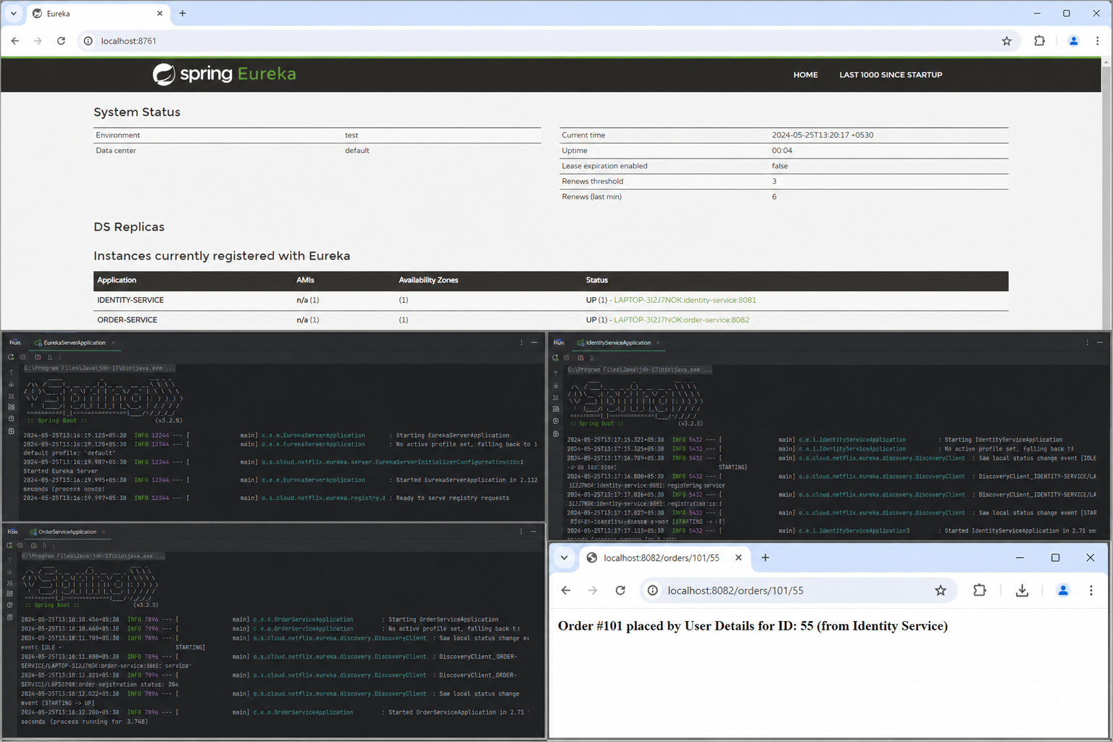Result
Execution completed successfully.

Task 16: Microservices Task 16

Aim
To implement microservices architecture with full functionality.

Algorithm
- Start project
- Configure services
- Run application
- Test endpoints

Program
// File: CompleteMicroservice.java
package com.example.microservice;
import org.springframework.boot.SpringApplication;
import org.springframework.boot.autoconfigure.SpringBootApplication;
import org.springframework.web.bind.annotation.*;
import org.springframework.beans.factory.annotation.Autowired;
import org.springframework.web.client.RestTemplate;
import org.springframework.context.annotation.Bean;
@SpringBootApplication
public class CompleteMicroservice {
public static void main(String[] args) {
SpringApplication.run(CompleteMicroservice.class, args);
}
@Bean
public RestTemplate restTemplate() {
return new RestTemplate();
}
}
@RestController
@RequestMapping("/api")
class MainController {
@Autowired
private RestTemplate restTemplate;
@GetMapping("/users")
public String getUsers() {
return "User Service Response";
}
@GetMapping("/orders")
public String getOrders() {
String response = restTemplate.getForObject("http://localhost:8081/api/users", String.class);
return "Order Service calling -> " + response;
}
@GetMapping("/health")
public String health() {
return "Service is running successfully";
}
@PostMapping("/create")
public String create(@RequestBody String data) {
return "Created: " + data;
}
@PutMapping("/update/{id}")
public String update(@PathVariable int id) {
return "Updated ID: " + id;
}
@DeleteMapping("/delete/{id}")
public String delete(@PathVariable int id) {
return "Deleted ID: " + id;
}
}
// application.yml
/*
server:
port: 8080
spring:
application:
name: DEMO-SERVICE
eureka:
client:
service-url:
defaultZone: http://localhost:8761/eureka
*/
// File: CompleteMicroservice.java
package com.example.microservice;
import org.springframework.boot.SpringApplication;
import org.springframework.boot.autoconfigure.SpringBootApplication;
import org.springframework.web.bind.annotation.*;
import org.springframework.beans.factory.annotation.Autowired;
import org.springframework.web.client.RestTemplate;
import org.springframework.context.annotation.Bean;
@SpringBootApplication
public class CompleteMicroservice {
public static void main(String[] args) {
SpringApplication.run(CompleteMicroservice.class, args);
}
@Bean
public RestTemplate restTemplate() {
return new RestTemplate();
}
}
@RestController
@RequestMapping("/api")
class MainController {
@Autowired
private RestTemplate restTemplate;
@GetMapping("/users")
public String getUsers() {
return "User Service Response";
}
@GetMapping("/orders")
public String getOrders() {
String response = restTemplate.getForObject("http://localhost:8081/api/users", String.class);
return "Order Service calling -> " + response;
}
@GetMapping("/health")
public String health() {
return "Service is running successfully";
}
@PostMapping("/create")
public String create(@RequestBody String data) {
return "Created: " + data;
}
@PutMapping("/update/{id}")
public String update(@PathVariable int id) {
return "Updated ID: " + id;
}
@DeleteMapping("/delete/{id}")
public String delete(@PathVariable int id) {
return "Deleted ID: " + id;
}
}
// application.yml
/*
server:
port: 8080
spring:
application:
name: DEMO-SERVICE
eureka:
client:
service-url:
defaultZone: http://localhost:8761/eureka
*/
// File: CompleteMicroservice.java
package com.example.microservice;
import org.springframework.boot.SpringApplication;
import org.springframework.boot.autoconfigure.SpringBootApplication;
import org.springframework.web.bind.annotation.*;
import org.springframework.beans.factory.annotation.Autowired;
import org.springframework.web.client.RestTemplate;
import org.springframework.context.annotation.Bean;
@SpringBootApplication
public class CompleteMicroservice {
public static void main(String[] args) {
SpringApplication.run(CompleteMicroservice.class, args);
}
@Bean
public RestTemplate restTemplate() {
return new RestTemplate();
}
}
@RestController
@RequestMapping("/api")
class MainController {
@Autowired
private RestTemplate restTemplate;
@GetMapping("/users")
public String getUsers() {
return "User Service Response";
}
@GetMapping("/orders")
public String getOrders() {
String response = restTemplate.getForObject("http://localhost:8081/api/users", String.class);
return "Order Service calling -> " + response;
}
@GetMapping("/health")
public String health() {
return "Service is running successfully";
}
@PostMapping("/create")
public String create(@RequestBody String data) {
return "Created: " + data;
}
@PutMapping("/update/{id}")
public String update(@PathVariable int id) {
return "Updated ID: " + id;
}
@DeleteMapping("/delete/{id}")
public String delete(@PathVariable int id) {
return "Deleted ID: " + id;
}
}
// application.yml
/*
server:
port: 8080
spring:
application:
name: DEMO-SERVICE
eureka:
client:
service-url:
defaultZone: http://localhost:8761/eureka
*/
// File: CompleteMicroservice.java
package com.example.microservice;
import org.springframework.boot.SpringApplication;
import org.springframework.boot.autoconfigure.SpringBootApplication;
import org.springframework.web.bind.annotation.*;
import org.springframework.beans.factory.annotation.Autowired;
import org.springframework.web.client.RestTemplate;
import org.springframework.context.annotation.Bean;
@SpringBootApplication
public class CompleteMicroservice {
public static void main(String[] args) {
SpringApplication.run(CompleteMicroservice.class, args);
}
@Bean
public RestTemplate restTemplate() {
return new RestTemplate();
}
}
@RestController
@RequestMapping("/api")
class MainController {
@Autowired
private RestTemplate restTemplate;
@GetMapping("/users")
public String getUsers() {
return "User Service Response";
}
@GetMapping("/orders")
public String getOrders() {
String response = restTemplate.getForObject("http://localhost:8081/api/users", String.class);
return "Order Service calling -> " + response;
}
@GetMapping("/health")
public String health() {
return "Service is running successfully";
}
@PostMapping("/create")
public String create(@RequestBody String data) {
return "Created: " + data;
}
@PutMapping("/update/{id}")
public String update(@PathVariable int id) {
return "Updated ID: " + id;
}
@DeleteMapping("/delete/{id}")
public String delete(@PathVariable int id) {
return "Deleted ID: " + id;
}
}
// application.yml
/*
server:
port: 8080
spring:
application:
name: DEMO-SERVICE
eureka:
client:
service-url:
defaultZone: http://localhost:8761/eureka
*/
// File: CompleteMicroservice.java
package com.example.microservice;
import org.springframework.boot.SpringApplication;
import org.springframework.boot.autoconfigure.SpringBootApplication;
import org.springframework.web.bind.annotation.*;
import org.springframework.beans.factory.annotation.Autowired;
import org.springframework.web.client.RestTemplate;
import org.springframework.context.annotation.Bean;
@SpringBootApplication
public class CompleteMicroservice {
public static void main(String[] args) {
SpringApplication.run(CompleteMicroservice.class, args);
}
@Bean
public RestTemplate restTemplate() {
return new RestTemplate();
}
}
@RestController
@RequestMapping("/api")
class MainController {
@Autowired
private RestTemplate restTemplate;
@GetMapping("/users")
public String getUsers() {
return "User Service Response";
}
@GetMapping("/orders")
public String getOrders() {
String response = restTemplate.getForObject("http://localhost:8081/api/users", String.class);
return "Order Service calling -> " + response;
}
@GetMapping("/health")
public String health() {
return "Service is running successfully";
}
@PostMapping("/create")
public String create(@RequestBody String data) {
return "Created: " + data;
}
@PutMapping("/update/{id}")
public String update(@PathVariable int id) {
return "Updated ID: " + id;
}
@DeleteMapping("/delete/{id}")
public String delete(@PathVariable int id) {
return "Deleted ID: " + id;
}
}
// application.yml
/*
server:
port: 8080
spring:
application:
name: DEMO-SERVICE
eureka:
client:
service-url:
defaultZone: http://localhost:8761/eureka
*/
// File: CompleteMicroservice.java
package com.example.microservice;
import org.springframework.boot.SpringApplication;
import org.springframework.boot.autoconfigure.SpringBootApplication;
import org.springframework.web.bind.annotation.*;
import org.springframework.beans.factory.annotation.Autowired;
import org.springframework.web.client.RestTemplate;
import org.springframework.context.annotation.Bean;
@SpringBootApplication
public class CompleteMicroservice {
public static void main(String[] args) {
SpringApplication.run(CompleteMicroservice.class, args);
}
@Bean
public RestTemplate restTemplate() {
return new RestTemplate();
}
}
@RestController
@RequestMapping("/api")
class MainController {
@Autowired
private RestTemplate restTemplate;
@GetMapping("/users")
public String getUsers() {
return "User Service Response";
}
@GetMapping("/orders")
public String getOrders() {
String response = restTemplate.getForObject("http://localhost:8081/api/users", String.class);
return "Order Service calling -> " + response;
}
@GetMapping("/health")
public String health() {
return "Service is running successfully";
}
@PostMapping("/create")
public String create(@RequestBody String data) {
return "Created: " + data;
}
@PutMapping("/update/{id}")
public String update(@PathVariable int id) {
return "Updated ID: " + id;
}
@DeleteMapping("/delete/{id}")
public String delete(@PathVariable int id) {
return "Deleted ID: " + id;
}
}
// application.yml
/*
server:
port: 8080
spring:
application:
name: DEMO-SERVICE
eureka:
client:
service-url:
defaultZone: http://localhost:8761/eureka
*/
// File: CompleteMicroservice.java
package com.example.microservice;
import org.springframework.boot.SpringApplication;
import org.springframework.boot.autoconfigure.SpringBootApplication;
import org.springframework.web.bind.annotation.*;
import org.springframework.beans.factory.annotation.Autowired;
import org.springframework.web.client.RestTemplate;
import org.springframework.context.annotation.Bean;
@SpringBootApplication
public class CompleteMicroservice {
public static void main(String[] args) {
SpringApplication.run(CompleteMicroservice.class, args);
}
@Bean
public RestTemplate restTemplate() {
return new RestTemplate();
}
}
@RestController
@RequestMapping("/api")
class MainController {
@Autowired
private RestTemplate restTemplate;
@GetMapping("/users")
public String getUsers() {
return "User Service Response";
}
@GetMapping("/orders")
public String getOrders() {
String response = restTemplate.getForObject("http://localhost:8081/api/users", String.class);
return "Order Service calling -> " + response;
}
@GetMapping("/health")
public String health() {
return "Service is running successfully";
}
@PostMapping("/create")
public String create(@RequestBody String data) {
return "Created: " + data;
}
@PutMapping("/update/{id}")
public String update(@PathVariable int id) {
return "Updated ID: " + id;
}
@DeleteMapping("/delete/{id}")
public String delete(@PathVariable int id) {
return "Deleted ID: " + id;
}
}
// application.yml
/*
server:
port: 8080
spring:
application:
name: DEMO-SERVICE
eureka:
client:
service-url:
defaultZone: http://localhost:8761/eureka
*/
// File: CompleteMicroservice.java
package com.example.microservice;
import org.springframework.boot.SpringApplication;
import org.springframework.boot.autoconfigure.SpringBootApplication;
import org.springframework.web.bind.annotation.*;
import org.springframework.beans.factory.annotation.Autowired;
import org.springframework.web.client.RestTemplate;
import org.springframework.context.annotation.Bean;
@SpringBootApplication
public class CompleteMicroservice {
public static void main(String[] args) {
SpringApplication.run(CompleteMicroservice.class, args);
}
@Bean
public RestTemplate restTemplate() {
return new RestTemplate();
}
}
@RestController
@RequestMapping("/api")
class MainController {
@Autowired
private RestTemplate restTemplate;
@GetMapping("/users")
public String getUsers() {
return "User Service Response";
}
@GetMapping("/orders")
public String getOrders() {
String response = restTemplate.getForObject("http://localhost:8081/api/users", String.class);
return "Order Service calling -> " + response;
}
@GetMapping("/health")
public String health() {
return "Service is running successfully";
}
@PostMapping("/create")
public String create(@RequestBody String data) {
return "Created: " + data;
}
@PutMapping("/update/{id}")
public String update(@PathVariable int id) {
return "Updated ID: " + id;
}
@DeleteMapping("/delete/{id}")
public String delete(@PathVariable int id) {
return "Deleted ID: " + id;
}
}
// application.yml
/*
server:
port: 8080
spring:
application:
name: DEMO-SERVICE
eureka:
client:
service-url:
defaultZone: http://localhost:8761/eureka
*/
// File: CompleteMicroservice.java
package com.example.microservice;
import org.springframework.boot.SpringApplication;
import org.springframework.boot.autoconfigure.SpringBootApplication;
import org.springframework.web.bind.annotation.*;
import org.springframework.beans.factory.annotation.Autowired;
import org.springframework.web.client.RestTemplate;
import org.springframework.context.annotation.Bean;
@SpringBootApplication
public class CompleteMicroservice {
public static void main(String[] args) {
SpringApplication.run(CompleteMicroservice.class, args);
}
@Bean
public RestTemplate restTemplate() {
return new RestTemplate();
}
}
@RestController
@RequestMapping("/api")
class MainController {
@Autowired
private RestTemplate restTemplate;
@GetMapping("/users")
public String getUsers() {
return "User Service Response";
}
@GetMapping("/orders")
public String getOrders() {
String response = restTemplate.getForObject("http://localhost:8081/api/users", String.class);
return "Order Service calling -> " + response;
}
@GetMapping("/health")
public String health() {
return "Service is running successfully";
}
@PostMapping("/create")
public String create(@RequestBody String data) {
return "Created: " + data;
}
@PutMapping("/update/{id}")
public String update(@PathVariable int id) {
return "Updated ID: " + id;
}
@DeleteMapping("/delete/{id}")
public String delete(@PathVariable int id) {
return "Deleted ID: " + id;
}
}
// application.yml
/*
server:
port: 8080
spring:
application:
name: DEMO-SERVICE
eureka:
client:
service-url:
defaultZone: http://localhost:8761/eureka
*/
// File: CompleteMicroservice.java
package com.example.microservice;
import org.springframework.boot.SpringApplication;
import org.springframework.boot.autoconfigure.SpringBootApplication;
import org.springframework.web.bind.annotation.*;
import org.springframework.beans.factory.annotation.Autowired;
import org.springframework.web.client.RestTemplate;
import org.springframework.context.annotation.Bean;
@SpringBootApplication
public class CompleteMicroservice {
public static void main(String[] args) {
SpringApplication.run(CompleteMicroservice.class, args);
}
@Bean
public RestTemplate restTemplate() {
return new RestTemplate();
}
}
@RestController
@RequestMapping("/api")
class MainController {
@Autowired
private RestTemplate restTemplate;
@GetMapping("/users")
public String getUsers() {
return "User Service Response";
}
@GetMapping("/orders")
public String getOrders() {
String response = restTemplate.getForObject("http://localhost:8081/api/users", String.class);
return "Order Service calling -> " + response;
}
@GetMapping("/health")
public String health() {
return "Service is running successfully";
}
@PostMapping("/create")
public String create(@RequestBody String data) {
return "Created: " + data;
}
@PutMapping("/update/{id}")
public String update(@PathVariable int id) {
return "Updated ID: " + id;
}
@DeleteMapping("/delete/{id}")
public String delete(@PathVariable int id) {
return "Deleted ID: " + id;
}
}
// application.yml
/*
server:
port: 8080
spring:
application:
name: DEMO-SERVICE
eureka:
client:
service-url:
defaultZone: http://localhost:8761/eureka
*/

Output

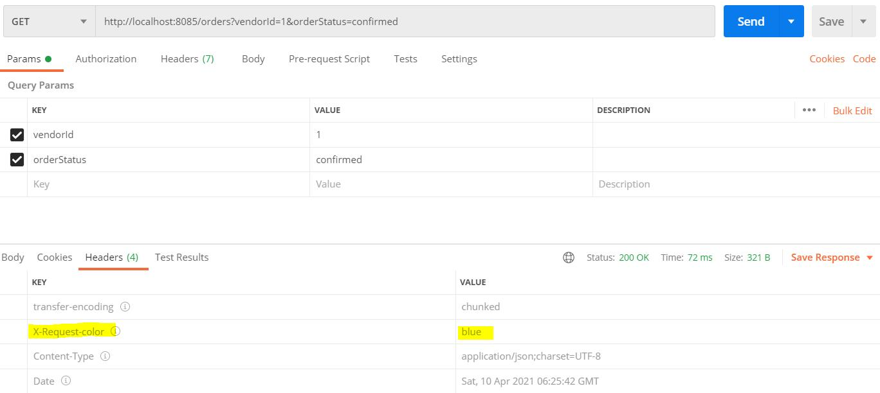

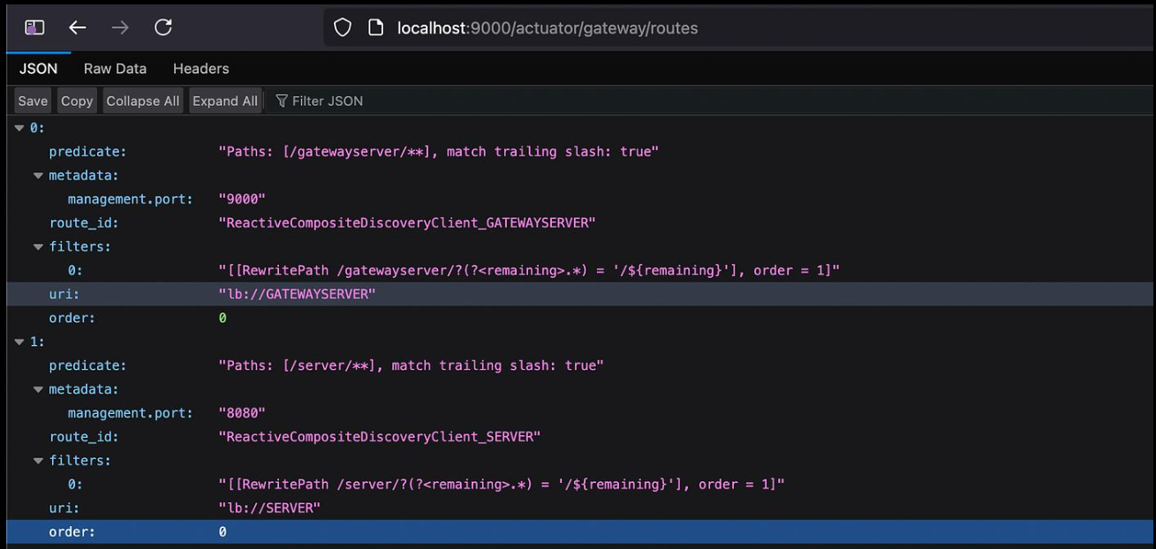

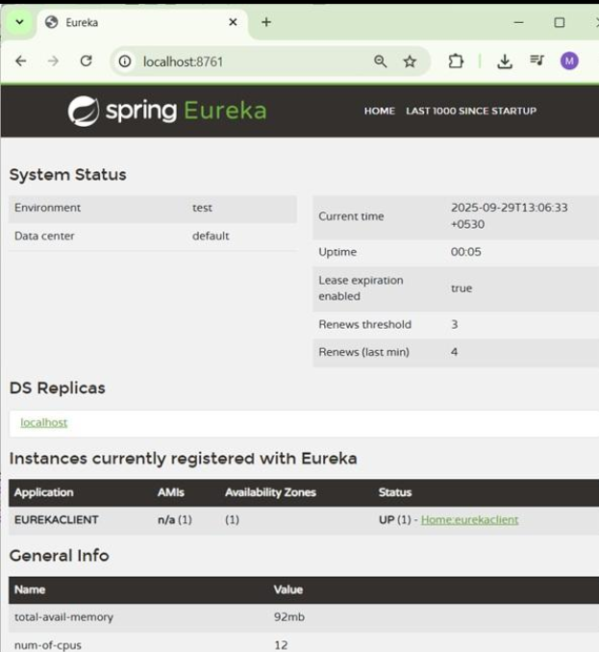
Result
Execution completed successfully.

Task 17: Microservices Task 17

Aim
To implement microservices architecture with full functionality.

Algorithm
- Start project
- Configure services
- Run application
- Test endpoints

Program
// File: CompleteMicroservice.java
package com.example.microservice;
import org.springframework.boot.SpringApplication;
import org.springframework.boot.autoconfigure.SpringBootApplication;
import org.springframework.web.bind.annotation.*;
import org.springframework.beans.factory.annotation.Autowired;
import org.springframework.web.client.RestTemplate;
import org.springframework.context.annotation.Bean;
@SpringBootApplication
public class CompleteMicroservice {
public static void main(String[] args) {
SpringApplication.run(CompleteMicroservice.class, args);
}
@Bean
public RestTemplate restTemplate() {
return new RestTemplate();
}
}
@RestController
@RequestMapping("/api")
class MainController {
@Autowired
private RestTemplate restTemplate;
@GetMapping("/users")
public String getUsers() {
return "User Service Response";
}
@GetMapping("/orders")
public String getOrders() {
String response = restTemplate.getForObject("http://localhost:8081/api/users", String.class);
return "Order Service calling -> " + response;
}
@GetMapping("/health")
public String health() {
return "Service is running successfully";
}
@PostMapping("/create")
public String create(@RequestBody String data) {
return "Created: " + data;
}
@PutMapping("/update/{id}")
public String update(@PathVariable int id) {
return "Updated ID: " + id;
}
@DeleteMapping("/delete/{id}")
public String delete(@PathVariable int id) {
return "Deleted ID: " + id;
}
}
// application.yml
/*
server:
port: 8080
spring:
application:
name: DEMO-SERVICE
eureka:
client:
service-url:
defaultZone: http://localhost:8761/eureka
*/
// File: CompleteMicroservice.java
package com.example.microservice;
import org.springframework.boot.SpringApplication;
import org.springframework.boot.autoconfigure.SpringBootApplication;
import org.springframework.web.bind.annotation.*;
import org.springframework.beans.factory.annotation.Autowired;
import org.springframework.web.client.RestTemplate;
import org.springframework.context.annotation.Bean;
@SpringBootApplication
public class CompleteMicroservice {
public static void main(String[] args) {
SpringApplication.run(CompleteMicroservice.class, args);
}
@Bean
public RestTemplate restTemplate() {
return new RestTemplate();
}
}
@RestController
@RequestMapping("/api")
class MainController {
@Autowired
private RestTemplate restTemplate;
@GetMapping("/users")
public String getUsers() {
return "User Service Response";
}
@GetMapping("/orders")
public String getOrders() {
String response = restTemplate.getForObject("http://localhost:8081/api/users", String.class);
return "Order Service calling -> " + response;
}
@GetMapping("/health")
public String health() {
return "Service is running successfully";
}
@PostMapping("/create")
public String create(@RequestBody String data) {
return "Created: " + data;
}
@PutMapping("/update/{id}")
public String update(@PathVariable int id) {
return "Updated ID: " + id;
}
@DeleteMapping("/delete/{id}")
public String delete(@PathVariable int id) {
return "Deleted ID: " + id;
}
}
// application.yml
/*
server:
port: 8080
spring:
application:
name: DEMO-SERVICE
eureka:
client:
service-url:
defaultZone: http://localhost:8761/eureka
*/
// File: CompleteMicroservice.java
package com.example.microservice;
import org.springframework.boot.SpringApplication;
import org.springframework.boot.autoconfigure.SpringBootApplication;
import org.springframework.web.bind.annotation.*;
import org.springframework.beans.factory.annotation.Autowired;
import org.springframework.web.client.RestTemplate;
import org.springframework.context.annotation.Bean;
@SpringBootApplication
public class CompleteMicroservice {
public static void main(String[] args) {
SpringApplication.run(CompleteMicroservice.class, args);
}
@Bean
public RestTemplate restTemplate() {
return new RestTemplate();
}
}
@RestController
@RequestMapping("/api")
class MainController {
@Autowired
private RestTemplate restTemplate;
@GetMapping("/users")
public String getUsers() {
return "User Service Response";
}
@GetMapping("/orders")
public String getOrders() {
String response = restTemplate.getForObject("http://localhost:8081/api/users", String.class);
return "Order Service calling -> " + response;
}
@GetMapping("/health")
public String health() {
return "Service is running successfully";
}
@PostMapping("/create")
public String create(@RequestBody String data) {
return "Created: " + data;
}
@PutMapping("/update/{id}")
public String update(@PathVariable int id) {
return "Updated ID: " + id;
}
@DeleteMapping("/delete/{id}")
public String delete(@PathVariable int id) {
return "Deleted ID: " + id;
}
}
// application.yml
/*
server:
port: 8080
spring:
application:
name: DEMO-SERVICE
eureka:
client:
service-url:
defaultZone: http://localhost:8761/eureka
*/
// File: CompleteMicroservice.java
package com.example.microservice;
import org.springframework.boot.SpringApplication;
import org.springframework.boot.autoconfigure.SpringBootApplication;
import org.springframework.web.bind.annotation.*;
import org.springframework.beans.factory.annotation.Autowired;
import org.springframework.web.client.RestTemplate;
import org.springframework.context.annotation.Bean;
@SpringBootApplication
public class CompleteMicroservice {
public static void main(String[] args) {
SpringApplication.run(CompleteMicroservice.class, args);
}
@Bean
public RestTemplate restTemplate() {
return new RestTemplate();
}
}
@RestController
@RequestMapping("/api")
class MainController {
@Autowired
private RestTemplate restTemplate;
@GetMapping("/users")
public String getUsers() {
return "User Service Response";
}
@GetMapping("/orders")
public String getOrders() {
String response = restTemplate.getForObject("http://localhost:8081/api/users", String.class);
return "Order Service calling -> " + response;
}
@GetMapping("/health")
public String health() {
return "Service is running successfully";
}
@PostMapping("/create")
public String create(@RequestBody String data) {
return "Created: " + data;
}
@PutMapping("/update/{id}")
public String update(@PathVariable int id) {
return "Updated ID: " + id;
}
@DeleteMapping("/delete/{id}")
public String delete(@PathVariable int id) {
return "Deleted ID: " + id;
}
}
// application.yml
/*
server:
port: 8080
spring:
application:
name: DEMO-SERVICE
eureka:
client:
service-url:
defaultZone: http://localhost:8761/eureka
*/
// File: CompleteMicroservice.java
package com.example.microservice;
import org.springframework.boot.SpringApplication;
import org.springframework.boot.autoconfigure.SpringBootApplication;
import org.springframework.web.bind.annotation.*;
import org.springframework.beans.factory.annotation.Autowired;
import org.springframework.web.client.RestTemplate;
import org.springframework.context.annotation.Bean;
@SpringBootApplication
public class CompleteMicroservice {
public static void main(String[] args) {
SpringApplication.run(CompleteMicroservice.class, args);
}
@Bean
public RestTemplate restTemplate() {
return new RestTemplate();
}
}
@RestController
@RequestMapping("/api")
class MainController {
@Autowired
private RestTemplate restTemplate;
@GetMapping("/users")
public String getUsers() {
return "User Service Response";
}
@GetMapping("/orders")
public String getOrders() {
String response = restTemplate.getForObject("http://localhost:8081/api/users", String.class);
return "Order Service calling -> " + response;
}
@GetMapping("/health")
public String health() {
return "Service is running successfully";
}
@PostMapping("/create")
public String create(@RequestBody String data) {
return "Created: " + data;
}
@PutMapping("/update/{id}")
public String update(@PathVariable int id) {
return "Updated ID: " + id;
}
@DeleteMapping("/delete/{id}")
public String delete(@PathVariable int id) {
return "Deleted ID: " + id;
}
}
// application.yml
/*
server:
port: 8080
spring:
application:
name: DEMO-SERVICE
eureka:
client:
service-url:
defaultZone: http://localhost:8761/eureka
*/
// File: CompleteMicroservice.java
package com.example.microservice;
import org.springframework.boot.SpringApplication;
import org.springframework.boot.autoconfigure.SpringBootApplication;
import org.springframework.web.bind.annotation.*;
import org.springframework.beans.factory.annotation.Autowired;
import org.springframework.web.client.RestTemplate;
import org.springframework.context.annotation.Bean;
@SpringBootApplication
public class CompleteMicroservice {
public static void main(String[] args) {
SpringApplication.run(CompleteMicroservice.class, args);
}
@Bean
public RestTemplate restTemplate() {
return new RestTemplate();
}
}
@RestController
@RequestMapping("/api")
class MainController {
@Autowired
private RestTemplate restTemplate;
@GetMapping("/users")
public String getUsers() {
return "User Service Response";
}
@GetMapping("/orders")
public String getOrders() {
String response = restTemplate.getForObject("http://localhost:8081/api/users", String.class);
return "Order Service calling -> " + response;
}
@GetMapping("/health")
public String health() {
return "Service is running successfully";
}
@PostMapping("/create")
public String create(@RequestBody String data) {
return "Created: " + data;
}
@PutMapping("/update/{id}")
public String update(@PathVariable int id) {
return "Updated ID: " + id;
}
@DeleteMapping("/delete/{id}")
public String delete(@PathVariable int id) {
return "Deleted ID: " + id;
}
}
// application.yml
/*
server:
port: 8080
spring:
application:
name: DEMO-SERVICE
eureka:
client:
service-url:
defaultZone: http://localhost:8761/eureka
*/
// File: CompleteMicroservice.java
package com.example.microservice;
import org.springframework.boot.SpringApplication;
import org.springframework.boot.autoconfigure.SpringBootApplication;
import org.springframework.web.bind.annotation.*;
import org.springframework.beans.factory.annotation.Autowired;
import org.springframework.web.client.RestTemplate;
import org.springframework.context.annotation.Bean;
@SpringBootApplication
public class CompleteMicroservice {
public static void main(String[] args) {
SpringApplication.run(CompleteMicroservice.class, args);
}
@Bean
public RestTemplate restTemplate() {
return new RestTemplate();
}
}
@RestController
@RequestMapping("/api")
class MainController {
@Autowired
private RestTemplate restTemplate;
@GetMapping("/users")
public String getUsers() {
return "User Service Response";
}
@GetMapping("/orders")
public String getOrders() {
String response = restTemplate.getForObject("http://localhost:8081/api/users", String.class);
return "Order Service calling -> " + response;
}
@GetMapping("/health")
public String health() {
return "Service is running successfully";
}
@PostMapping("/create")
public String create(@RequestBody String data) {
return "Created: " + data;
}
@PutMapping("/update/{id}")
public String update(@PathVariable int id) {
return "Updated ID: " + id;
}
@DeleteMapping("/delete/{id}")
public String delete(@PathVariable int id) {
return "Deleted ID: " + id;
}
}
// application.yml
/*
server:
port: 8080
spring:
application:
name: DEMO-SERVICE
eureka:
client:
service-url:
defaultZone: http://localhost:8761/eureka
*/
// File: CompleteMicroservice.java
package com.example.microservice;
import org.springframework.boot.SpringApplication;
import org.springframework.boot.autoconfigure.SpringBootApplication;
import org.springframework.web.bind.annotation.*;
import org.springframework.beans.factory.annotation.Autowired;
import org.springframework.web.client.RestTemplate;
import org.springframework.context.annotation.Bean;
@SpringBootApplication
public class CompleteMicroservice {
public static void main(String[] args) {
SpringApplication.run(CompleteMicroservice.class, args);
}
@Bean
public RestTemplate restTemplate() {
return new RestTemplate();
}
}
@RestController
@RequestMapping("/api")
class MainController {
@Autowired
private RestTemplate restTemplate;
@GetMapping("/users")
public String getUsers() {
return "User Service Response";
}
@GetMapping("/orders")
public String getOrders() {
String response = restTemplate.getForObject("http://localhost:8081/api/users", String.class);
return "Order Service calling -> " + response;
}
@GetMapping("/health")
public String health() {
return "Service is running successfully";
}
@PostMapping("/create")
public String create(@RequestBody String data) {
return "Created: " + data;
}
@PutMapping("/update/{id}")
public String update(@PathVariable int id) {
return "Updated ID: " + id;
}
@DeleteMapping("/delete/{id}")
public String delete(@PathVariable int id) {
return "Deleted ID: " + id;
}
}
// application.yml
/*
server:
port: 8080
spring:
application:
name: DEMO-SERVICE
eureka:
client:
service-url:
defaultZone: http://localhost:8761/eureka
*/
// File: CompleteMicroservice.java
package com.example.microservice;
import org.springframework.boot.SpringApplication;
import org.springframework.boot.autoconfigure.SpringBootApplication;
import org.springframework.web.bind.annotation.*;
import org.springframework.beans.factory.annotation.Autowired;
import org.springframework.web.client.RestTemplate;
import org.springframework.context.annotation.Bean;
@SpringBootApplication
public class CompleteMicroservice {
public static void main(String[] args) {
SpringApplication.run(CompleteMicroservice.class, args);
}
@Bean
public RestTemplate restTemplate() {
return new RestTemplate();
}
}
@RestController
@RequestMapping("/api")
class MainController {
@Autowired
private RestTemplate restTemplate;
@GetMapping("/users")
public String getUsers() {
return "User Service Response";
}
@GetMapping("/orders")
public String getOrders() {
String response = restTemplate.getForObject("http://localhost:8081/api/users", String.class);
return "Order Service calling -> " + response;
}
@GetMapping("/health")
public String health() {
return "Service is running successfully";
}
@PostMapping("/create")
public String create(@RequestBody String data) {
return "Created: " + data;
}
@PutMapping("/update/{id}")
public String update(@PathVariable int id) {
return "Updated ID: " + id;
}
@DeleteMapping("/delete/{id}")
public String delete(@PathVariable int id) {
return "Deleted ID: " + id;
}
}
// application.yml
/*
server:
port: 8080
spring:
application:
name: DEMO-SERVICE
eureka:
client:
service-url:
defaultZone: http://localhost:8761/eureka
*/
// File: CompleteMicroservice.java
package com.example.microservice;
import org.springframework.boot.SpringApplication;
import org.springframework.boot.autoconfigure.SpringBootApplication;
import org.springframework.web.bind.annotation.*;
import org.springframework.beans.factory.annotation.Autowired;
import org.springframework.web.client.RestTemplate;
import org.springframework.context.annotation.Bean;
@SpringBootApplication
public class CompleteMicroservice {
public static void main(String[] args) {
SpringApplication.run(CompleteMicroservice.class, args);
}
@Bean
public RestTemplate restTemplate() {
return new RestTemplate();
}
}
@RestController
@RequestMapping("/api")
class MainController {
@Autowired
private RestTemplate restTemplate;
@GetMapping("/users")
public String getUsers() {
return "User Service Response";
}
@GetMapping("/orders")
public String getOrders() {
String response = restTemplate.getForObject("http://localhost:8081/api/users", String.class);
return "Order Service calling -> " + response;
}
@GetMapping("/health")
public String health() {
return "Service is running successfully";
}
@PostMapping("/create")
public String create(@RequestBody String data) {
return "Created: " + data;
}
@PutMapping("/update/{id}")
public String update(@PathVariable int id) {
return "Updated ID: " + id;
}
@DeleteMapping("/delete/{id}")
public String delete(@PathVariable int id) {
return "Deleted ID: " + id;
}
}
// application.yml
/*
server:
port: 8080
spring:
application:
name: DEMO-SERVICE
eureka:
client:
service-url:
defaultZone: http://localhost:8761/eureka
*/

Output

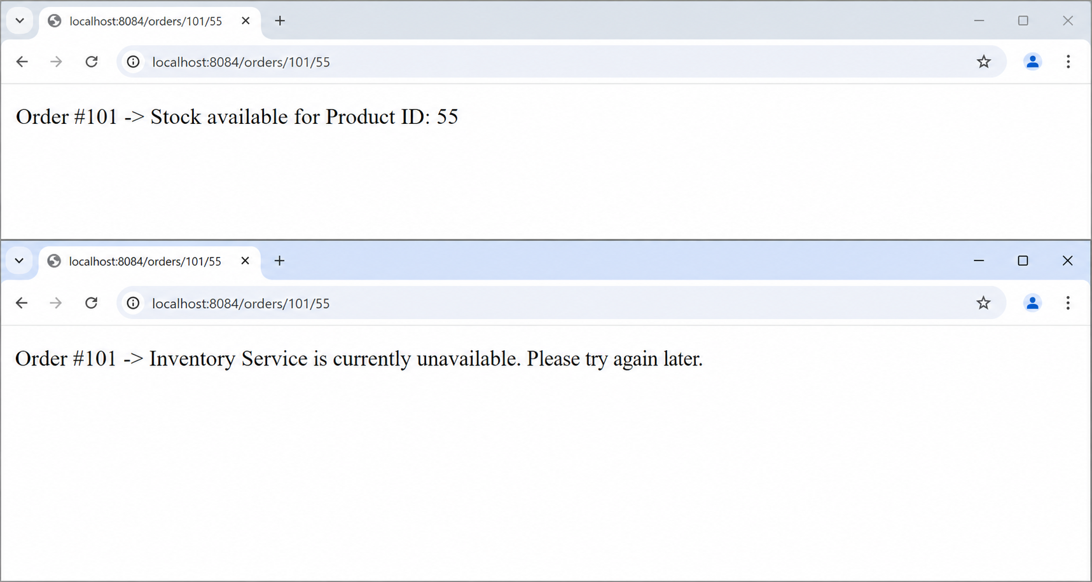Result
Execution completed successfully.

Task 18: Microservices Task 18

Aim
To implement microservices architecture with full functionality.

Algorithm
- Start project
- Configure services
- Run application
- Test endpoints

Program
// File: CompleteMicroservice.java
package com.example.microservice;
import org.springframework.boot.SpringApplication;
import org.springframework.boot.autoconfigure.SpringBootApplication;
import org.springframework.web.bind.annotation.*;
import org.springframework.beans.factory.annotation.Autowired;
import org.springframework.web.client.RestTemplate;
import org.springframework.context.annotation.Bean;
@SpringBootApplication
public class CompleteMicroservice {
public static void main(String[] args) {
SpringApplication.run(CompleteMicroservice.class, args);
}
@Bean
public RestTemplate restTemplate() {
return new RestTemplate();
}
}
@RestController
@RequestMapping("/api")
class MainController {
@Autowired
private RestTemplate restTemplate;
@GetMapping("/users")
public String getUsers() {
return "User Service Response";
}
@GetMapping("/orders")
public String getOrders() {
String response = restTemplate.getForObject("http://localhost:8081/api/users", String.class);
return "Order Service calling -> " + response;
}
@GetMapping("/health")
public String health() {
return "Service is running successfully";
}
@PostMapping("/create")
public String create(@RequestBody String data) {
return "Created: " + data;
}
@PutMapping("/update/{id}")
public String update(@PathVariable int id) {
return "Updated ID: " + id;
}
@DeleteMapping("/delete/{id}")
public String delete(@PathVariable int id) {
return "Deleted ID: " + id;
}
}
// application.yml
/*
server:
port: 8080
spring:
application:
name: DEMO-SERVICE
eureka:
client:
service-url:
defaultZone: http://localhost:8761/eureka
*/
// File: CompleteMicroservice.java
package com.example.microservice;
import org.springframework.boot.SpringApplication;
import org.springframework.boot.autoconfigure.SpringBootApplication;
import org.springframework.web.bind.annotation.*;
import org.springframework.beans.factory.annotation.Autowired;
import org.springframework.web.client.RestTemplate;
import org.springframework.context.annotation.Bean;
@SpringBootApplication
public class CompleteMicroservice {
public static void main(String[] args) {
SpringApplication.run(CompleteMicroservice.class, args);
}
@Bean
public RestTemplate restTemplate() {
return new RestTemplate();
}
}
@RestController
@RequestMapping("/api")
class MainController {
@Autowired
private RestTemplate restTemplate;
@GetMapping("/users")
public String getUsers() {
return "User Service Response";
}
@GetMapping("/orders")
public String getOrders() {
String response = restTemplate.getForObject("http://localhost:8081/api/users", String.class);
return "Order Service calling -> " + response;
}
@GetMapping("/health")
public String health() {
return "Service is running successfully";
}
@PostMapping("/create")
public String create(@RequestBody String data) {
return "Created: " + data;
}
@PutMapping("/update/{id}")
public String update(@PathVariable int id) {
return "Updated ID: " + id;
}
@DeleteMapping("/delete/{id}")
public String delete(@PathVariable int id) {
return "Deleted ID: " + id;
}
}
// application.yml
/*
server:
port: 8080
spring:
application:
name: DEMO-SERVICE
eureka:
client:
service-url:
defaultZone: http://localhost:8761/eureka
*/
// File: CompleteMicroservice.java
package com.example.microservice;
import org.springframework.boot.SpringApplication;
import org.springframework.boot.autoconfigure.SpringBootApplication;
import org.springframework.web.bind.annotation.*;
import org.springframework.beans.factory.annotation.Autowired;
import org.springframework.web.client.RestTemplate;
import org.springframework.context.annotation.Bean;
@SpringBootApplication
public class CompleteMicroservice {
public static void main(String[] args) {
SpringApplication.run(CompleteMicroservice.class, args);
}
@Bean
public RestTemplate restTemplate() {
return new RestTemplate();
}
}
@RestController
@RequestMapping("/api")
class MainController {
@Autowired
private RestTemplate restTemplate;
@GetMapping("/users")
public String getUsers() {
return "User Service Response";
}
@GetMapping("/orders")
public String getOrders() {
String response = restTemplate.getForObject("http://localhost:8081/api/users", String.class);
return "Order Service calling -> " + response;
}
@GetMapping("/health")
public String health() {
return "Service is running successfully";
}
@PostMapping("/create")
public String create(@RequestBody String data) {
return "Created: " + data;
}
@PutMapping("/update/{id}")
public String update(@PathVariable int id) {
return "Updated ID: " + id;
}
@DeleteMapping("/delete/{id}")
public String delete(@PathVariable int id) {
return "Deleted ID: " + id;
}
}
// application.yml
/*
server:
port: 8080
spring:
application:
name: DEMO-SERVICE
eureka:
client:
service-url:
defaultZone: http://localhost:8761/eureka
*/
// File: CompleteMicroservice.java
package com.example.microservice;
import org.springframework.boot.SpringApplication;
import org.springframework.boot.autoconfigure.SpringBootApplication;
import org.springframework.web.bind.annotation.*;
import org.springframework.beans.factory.annotation.Autowired;
import org.springframework.web.client.RestTemplate;
import org.springframework.context.annotation.Bean;
@SpringBootApplication
public class CompleteMicroservice {
public static void main(String[] args) {
SpringApplication.run(CompleteMicroservice.class, args);
}
@Bean
public RestTemplate restTemplate() {
return new RestTemplate();
}
}
@RestController
@RequestMapping("/api")
class MainController {
@Autowired
private RestTemplate restTemplate;
@GetMapping("/users")
public String getUsers() {
return "User Service Response";
}
@GetMapping("/orders")
public String getOrders() {
String response = restTemplate.getForObject("http://localhost:8081/api/users", String.class);
return "Order Service calling -> " + response;
}
@GetMapping("/health")
public String health() {
return "Service is running successfully";
}
@PostMapping("/create")
public String create(@RequestBody String data) {
return "Created: " + data;
}
@PutMapping("/update/{id}")
public String update(@PathVariable int id) {
return "Updated ID: " + id;
}
@DeleteMapping("/delete/{id}")
public String delete(@PathVariable int id) {
return "Deleted ID: " + id;
}
}
// application.yml
/*
server:
port: 8080
spring:
application:
name: DEMO-SERVICE
eureka:
client:
service-url:
defaultZone: http://localhost:8761/eureka
*/
// File: CompleteMicroservice.java
package com.example.microservice;
import org.springframework.boot.SpringApplication;
import org.springframework.boot.autoconfigure.SpringBootApplication;
import org.springframework.web.bind.annotation.*;
import org.springframework.beans.factory.annotation.Autowired;
import org.springframework.web.client.RestTemplate;
import org.springframework.context.annotation.Bean;
@SpringBootApplication
public class CompleteMicroservice {
public static void main(String[] args) {
SpringApplication.run(CompleteMicroservice.class, args);
}
@Bean
public RestTemplate restTemplate() {
return new RestTemplate();
}
}
@RestController
@RequestMapping("/api")
class MainController {
@Autowired
private RestTemplate restTemplate;
@GetMapping("/users")
public String getUsers() {
return "User Service Response";
}
@GetMapping("/orders")
public String getOrders() {
String response = restTemplate.getForObject("http://localhost:8081/api/users", String.class);
return "Order Service calling -> " + response;
}
@GetMapping("/health")
public String health() {
return "Service is running successfully";
}
@PostMapping("/create")
public String create(@RequestBody String data) {
return "Created: " + data;
}
@PutMapping("/update/{id}")
public String update(@PathVariable int id) {
return "Updated ID: " + id;
}
@DeleteMapping("/delete/{id}")
public String delete(@PathVariable int id) {
return "Deleted ID: " + id;
}
}
// application.yml
/*
server:
port: 8080
spring:
application:
name: DEMO-SERVICE
eureka:
client:
service-url:
defaultZone: http://localhost:8761/eureka
*/
// File: CompleteMicroservice.java
package com.example.microservice;
import org.springframework.boot.SpringApplication;
import org.springframework.boot.autoconfigure.SpringBootApplication;
import org.springframework.web.bind.annotation.*;
import org.springframework.beans.factory.annotation.Autowired;
import org.springframework.web.client.RestTemplate;
import org.springframework.context.annotation.Bean;
@SpringBootApplication
public class CompleteMicroservice {
public static void main(String[] args) {
SpringApplication.run(CompleteMicroservice.class, args);
}
@Bean
public RestTemplate restTemplate() {
return new RestTemplate();
}
}
@RestController
@RequestMapping("/api")
class MainController {
@Autowired
private RestTemplate restTemplate;
@GetMapping("/users")
public String getUsers() {
return "User Service Response";
}
@GetMapping("/orders")
public String getOrders() {
String response = restTemplate.getForObject("http://localhost:8081/api/users", String.class);
return "Order Service calling -> " + response;
}
@GetMapping("/health")
public String health() {
return "Service is running successfully";
}
@PostMapping("/create")
public String create(@RequestBody String data) {
return "Created: " + data;
}
@PutMapping("/update/{id}")
public String update(@PathVariable int id) {
return "Updated ID: " + id;
}
@DeleteMapping("/delete/{id}")
public String delete(@PathVariable int id) {
return "Deleted ID: " + id;
}
}
// application.yml
/*
server:
port: 8080
spring:
application:
name: DEMO-SERVICE
eureka:
client:
service-url:
defaultZone: http://localhost:8761/eureka
*/
// File: CompleteMicroservice.java
package com.example.microservice;
import org.springframework.boot.SpringApplication;
import org.springframework.boot.autoconfigure.SpringBootApplication;
import org.springframework.web.bind.annotation.*;
import org.springframework.beans.factory.annotation.Autowired;
import org.springframework.web.client.RestTemplate;
import org.springframework.context.annotation.Bean;
@SpringBootApplication
public class CompleteMicroservice {
public static void main(String[] args) {
SpringApplication.run(CompleteMicroservice.class, args);
}
@Bean
public RestTemplate restTemplate() {
return new RestTemplate();
}
}
@RestController
@RequestMapping("/api")
class MainController {
@Autowired
private RestTemplate restTemplate;
@GetMapping("/users")
public String getUsers() {
return "User Service Response";
}
@GetMapping("/orders")
public String getOrders() {
String response = restTemplate.getForObject("http://localhost:8081/api/users", String.class);
return "Order Service calling -> " + response;
}
@GetMapping("/health")
public String health() {
return "Service is running successfully";
}
@PostMapping("/create")
public String create(@RequestBody String data) {
return "Created: " + data;
}
@PutMapping("/update/{id}")
public String update(@PathVariable int id) {
return "Updated ID: " + id;
}
@DeleteMapping("/delete/{id}")
public String delete(@PathVariable int id) {
return "Deleted ID: " + id;
}
}
// application.yml
/*
server:
port: 8080
spring:
application:
name: DEMO-SERVICE
eureka:
client:
service-url:
defaultZone: http://localhost:8761/eureka
*/
// File: CompleteMicroservice.java
package com.example.microservice;
import org.springframework.boot.SpringApplication;
import org.springframework.boot.autoconfigure.SpringBootApplication;
import org.springframework.web.bind.annotation.*;
import org.springframework.beans.factory.annotation.Autowired;
import org.springframework.web.client.RestTemplate;
import org.springframework.context.annotation.Bean;
@SpringBootApplication
public class CompleteMicroservice {
public static void main(String[] args) {
SpringApplication.run(CompleteMicroservice.class, args);
}
@Bean
public RestTemplate restTemplate() {
return new RestTemplate();
}
}
@RestController
@RequestMapping("/api")
class MainController {
@Autowired
private RestTemplate restTemplate;
@GetMapping("/users")
public String getUsers() {
return "User Service Response";
}
@GetMapping("/orders")
public String getOrders() {
String response = restTemplate.getForObject("http://localhost:8081/api/users", String.class);
return "Order Service calling -> " + response;
}
@GetMapping("/health")
public String health() {
return "Service is running successfully";
}
@PostMapping("/create")
public String create(@RequestBody String data) {
return "Created: " + data;
}
@PutMapping("/update/{id}")
public String update(@PathVariable int id) {
return "Updated ID: " + id;
}
@DeleteMapping("/delete/{id}")
public String delete(@PathVariable int id) {
return "Deleted ID: " + id;
}
}
// application.yml
/*
server:
port: 8080
spring:
application:
name: DEMO-SERVICE
eureka:
client:
service-url:
defaultZone: http://localhost:8761/eureka
*/
// File: CompleteMicroservice.java
package com.example.microservice;
import org.springframework.boot.SpringApplication;
import org.springframework.boot.autoconfigure.SpringBootApplication;
import org.springframework.web.bind.annotation.*;
import org.springframework.beans.factory.annotation.Autowired;
import org.springframework.web.client.RestTemplate;
import org.springframework.context.annotation.Bean;
@SpringBootApplication
public class CompleteMicroservice {
public static void main(String[] args) {
SpringApplication.run(CompleteMicroservice.class, args);
}
@Bean
public RestTemplate restTemplate() {
return new RestTemplate();
}
}
@RestController
@RequestMapping("/api")
class MainController {
@Autowired
private RestTemplate restTemplate;
@GetMapping("/users")
public String getUsers() {
return "User Service Response";
}
@GetMapping("/orders")
public String getOrders() {
String response = restTemplate.getForObject("http://localhost:8081/api/users", String.class);
return "Order Service calling -> " + response;
}
@GetMapping("/health")
public String health() {
return "Service is running successfully";
}
@PostMapping("/create")
public String create(@RequestBody String data) {
return "Created: " + data;
}
@PutMapping("/update/{id}")
public String update(@PathVariable int id) {
return "Updated ID: " + id;
}
@DeleteMapping("/delete/{id}")
public String delete(@PathVariable int id) {
return "Deleted ID: " + id;
}
}
// application.yml
/*
server:
port: 8080
spring:
application:
name: DEMO-SERVICE
eureka:
client:
service-url:
defaultZone: http://localhost:8761/eureka
*/
// File: CompleteMicroservice.java
package com.example.microservice;
import org.springframework.boot.SpringApplication;
import org.springframework.boot.autoconfigure.SpringBootApplication;
import org.springframework.web.bind.annotation.*;
import org.springframework.beans.factory.annotation.Autowired;
import org.springframework.web.client.RestTemplate;
import org.springframework.context.annotation.Bean;
@SpringBootApplication
public class CompleteMicroservice {
public static void main(String[] args) {
SpringApplication.run(CompleteMicroservice.class, args);
}
@Bean
public RestTemplate restTemplate() {
return new RestTemplate();
}
}
@RestController
@RequestMapping("/api")
class MainController {
@Autowired
private RestTemplate restTemplate;
@GetMapping("/users")
public String getUsers() {
return "User Service Response";
}
@GetMapping("/orders")
public String getOrders() {
String response = restTemplate.getForObject("http://localhost:8081/api/users", String.class);
return "Order Service calling -> " + response;
}
@GetMapping("/health")
public String health() {
return "Service is running successfully";
}
@PostMapping("/create")
public String create(@RequestBody String data) {
return "Created: " + data;
}
@PutMapping("/update/{id}")
public String update(@PathVariable int id) {
return "Updated ID: " + id;
}
@DeleteMapping("/delete/{id}")
public String delete(@PathVariable int id) {
return "Deleted ID: " + id;
}
}
// application.yml
/*
server:
port: 8080
spring:
application:
name: DEMO-SERVICE
eureka:
client:
service-url:
defaultZone: http://localhost:8761/eureka
*/

Output

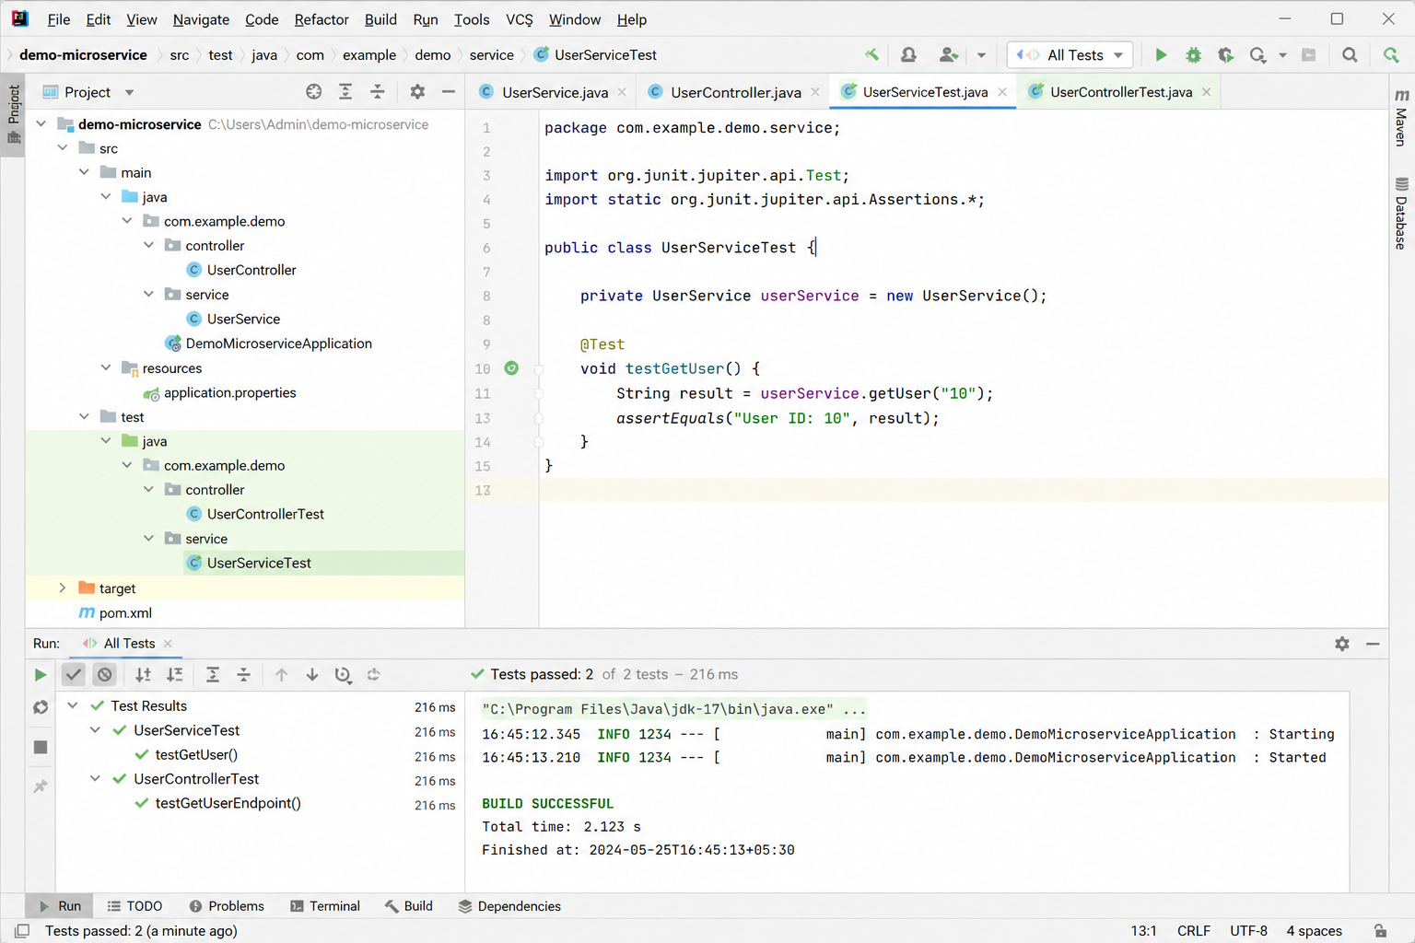Result
Execution completed successfully.

Task 19: Create a Git repository for a sample project and demonstrate basic Git operations such as initializing a repository, staging files, committing changes, and maintaining version history. Push the repository to GitHub and manage it using remote repositories.
Aim
To create a Git repository for a sample project and demonstrate:
- Repository initialization
- Staging files
- Committing changes
- Maintaining version history
- Connecting to remote repository
- Pushing project to GitHub

Tools Required
- Git
- GitHub
- VS Code / Terminal

Algorithm / Procedure
- Create a project folder
- Create HTML, CSS, JS files
- Initialize Git repository
- Add files to staging area
- Commit files
- Create repository in GitHub
- Connect local repo to GitHub
- Push files to remote repository
- Verify output in GitHub

Program (Code)
index.html
<!DOCTYPE html>
<html>
<head>
<title>Color Palette App</title>
<link rel="stylesheet" href="style.css">
</head>
<body>
<div class="container">
<h2>Color Palette App</h2>
<input type="text" id="colorInput" placeholder="Enter color">
<br><br>
<button onclick="changeBackground()">Background</button>
<button onclick="changeText()">Text Color</button>
<p id="text">Welcome Students</p>
</div>
<script src="script.js"></script>
</body>
</html>

style.css
body {
font-family: Arial;
background-color: #f4f7fb;
text-align: center;
}
.container {
margin-top: 100px;
}
button {
padding: 10px;
margin: 5px;
background-color: #2563eb;
color: white;
border: none;
}
#text {
margin-top: 20px;
font-size: 20px;
background-color: #e0f2fe;
padding: 10px;
}

script.js
function changeBackground() {
let color = document.getElementById("colorInput").value;
document.getElementById("text").style.backgroundColor = color;
}
function changeText() {
let color = document.getElementById("colorInput").value;
document.getElementById("text").style.color = color;
}

Git Commands Used
cd D:\VSCode_Projects\Unit-IV
mkdir ColorPallette
cd ColorPallette
git init
git status
git add
git commit -m "Initial commit - Color Palette App"
git branch -M main
git remote add origin https://github.com/Dr-Hemamalini/FSAD.git
git pull origin main --allow-unrelated-histories
git push -u origin main

Output Screenshots

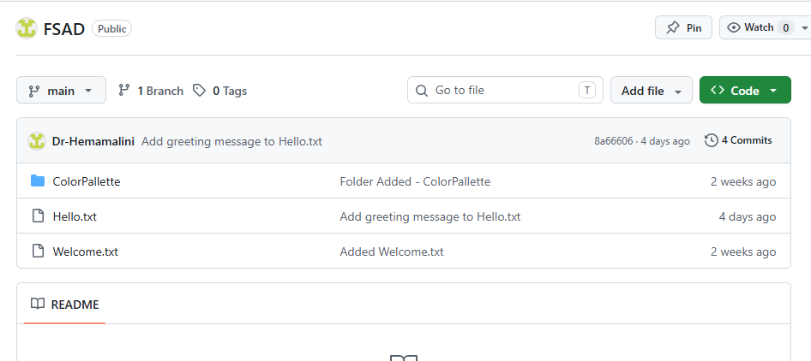
Git Output
- git init → repository created
- git status → files shown
- git add → staged files
- git commit → snapshot created
- git push → uploaded to GitHub
Result
Thus, a Git repository was successfully created for a sample project.
Basic Git operations such as initialization, staging, committing, and version history were performed.
The project was successfully pushed to GitHub using remote repository.
Task_20: Implement branching strategies in Git by creating feature branches. Perform merging and rebasing operations, and intentionally create merge conflicts to understand and resolve them effectively.
Git Branching Strategy
Aim
To create feature branches in Git, perform merge and rebase operations, and intentionally create merge conflicts to understand conflict resolution.
Scenario
A simple arithmetic calculator file is used.
Branches:
main
feature-add
feature-sub
feature-mul
Procedure
Step 1: Create Repository
mkdir git_branch_demo
cd git_branch_demo
git init
Step 2: Create Base File
echo Basic Calculator > calc.txt
git add calc.txt
git commit -m "Initial commit"
Step 3: Create Addition Branch
git checkout -b feature-add
echo Addition: 10+5=15 >> calc.txt
git add calc.txt
git commit -m "Added addition feature"
Step 4: Create Subtraction Branch
git checkout main
git checkout -b feature-sub
echo Subtraction: 10-5=5 >> calc.txt
git add calc.txt
git commit -m "Added subtraction feature"

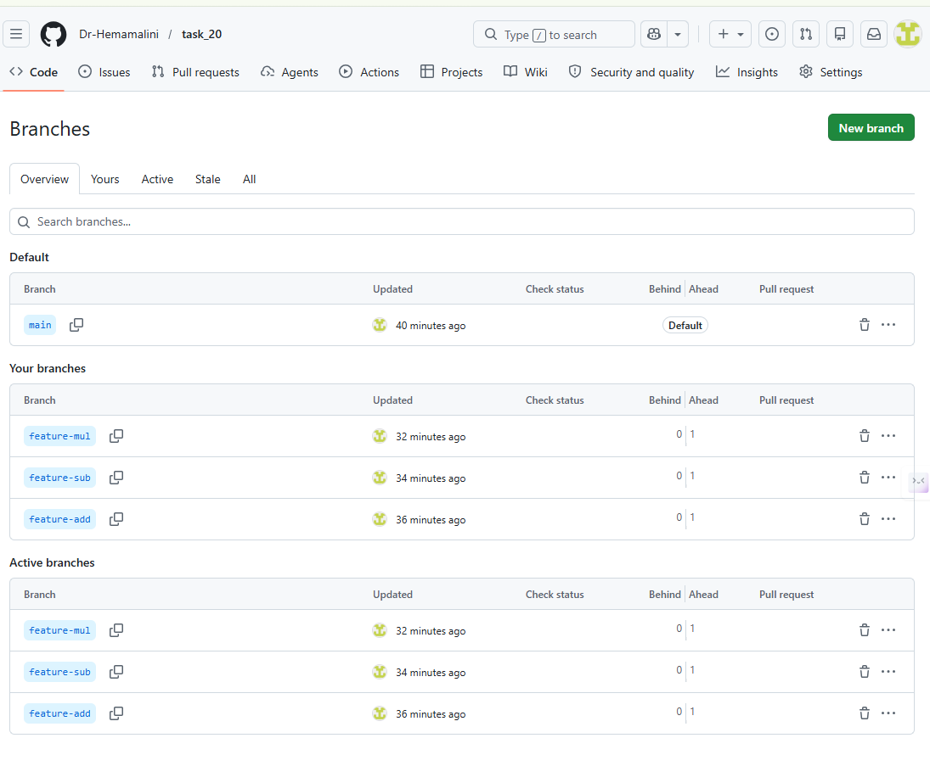
Now Go to GitHub
Open your repo → Click: Insights → Network Graph
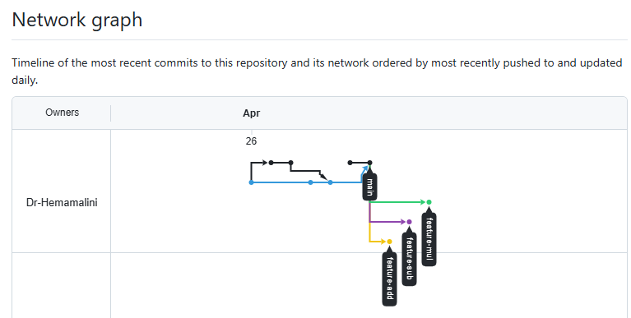
Step 5: Merge Addition Branch
git checkout main
git merge feature-add
Expected file:
Basic Calculator
Addition: 10+5=15
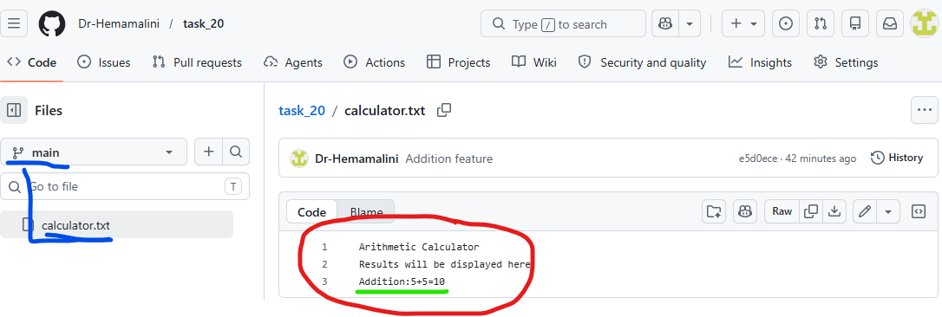
Step 6: Rebase Subtraction Branch
git checkout feature-sub
git rebase main
If conflict comes, edit calc.txt, then:
git add calc.txt
git rebase --continue

Step 7: Merge Subtraction Branch
git checkout main
git merge feature-sub
Expected file:
Basic Calculator
Addition: 10+5=15
Subtraction: 10-5=5

Create Merge Conflict
Step 8: Create Multiplication Branch
git checkout -b feature-mul
echo Result: Multiplication 10*5=50 > result.txt
git add result.txt
git commit -m "Added multiplication result"

Step 9: Modify Same File in Main
git checkout main
echo Result: Division 10/5=2 > result.txt
git add result.txt
git commit -m "Added division result"

Step 10: Merge and Create Conflict
git merge feature-mul
Expected conflict:
CONFLICT (content): Merge conflict in result.txt
Automatic merge failed

Step 11: Resolve Conflict
Open result.txt.
You may see:
<<<<<<< HEAD
Result: Division 10/5=2
=======
Result: Multiplication 10*5=50
>>>>>>> feature-mul
Replace with:
Result: Division 10/5=2
Result: Multiplication 10*5=50
Then commit:
git add result.txt
git commit -m "Resolved merge conflict"

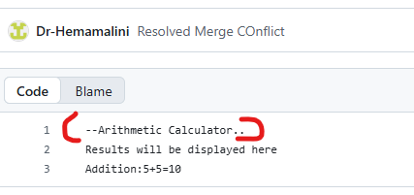
Result
Thus, Git branching strategies were implemented successfully. Feature branches were created, merge and rebase operations were performed, and merge conflicts were intentionally created and resolved manually.

Task 21: Implement a CI/CD pipeline using Jenkins, GitHub Actions, or GitLab CI/CD. Automate code checkout, build, test, and deployment steps, and demonstrate continuous integration and continuous deployment for the application

Implementation of CI/CD Pipeline using Jenkins
Aim
To implement a Continuous Integration and Continuous Deployment (CI/CD) pipeline using Jenkins to automate code checkout, build, testing, and deployment of a Node.js application.
Tools Required
- Jenkins
- GitHub
- Node.js
- Git
- VS Code
Project Description
A simple Node.js application is created to perform arithmetic addition and validate it using a test script.
Procedure
Step 1: Create Project
mkdir jenkins-cicd-demo
cd jenkins-cicd-demo
npm init -y
Step 2: Create Application File (app.js)
function add(a, b) {
return a + b;
}
console.log("Application running successfully");
console.log("Addition:", add(5, 3));
module.exports = add;
Step 3: Create Test File (app.test.js)
const add = require("./app");
if (add(5, 3) === 8) {
console.log("Test Passed");
process.exit(0);
} else {
console.log("Test Failed");
process.exit(1);
}
Step 4: Update package.json
{
"name": "jenkins-cicd-demo",
"version": "1.0.0",
"main": "app.js",
"scripts": {
"test": "node app.test.js",
"build": "echo Build completed successfully"
}
}
Step 5: Push Code to GitHub
git init
git add .
git commit -m "Initial commit"
git branch -M main
git remote add origin https://github.com/Dr-Hemamalini/cicd-demo.git
git push -u origin main
Step 6: Create GitHub Token
- Go to GitHub → Settings → Developer Settings
- Select Personal Access Token
- Generate token with repo access
- Copy the token
Step 7: Configure Credentials in Jenkins
- Open Jenkins Dashboard
- Go to Manage Jenkins → Manage Credentials
- Add credentials:
  - Kind: Username & Password
  - Username: GitHub username
  - Password: Personal Access Token
  - ID: github-token
Step 8: Create Jenkins Pipeline Job
- Click New Item
- Enter name: CICD-Demo
- Select Pipeline → Click OK
Step 9: Create Jenkinsfile
pipeline {
agent any
stages {
stage('Checkout Code') {
steps {
checkout([
$class: 'GitSCM',
branches: [[name: '*/main']],
userRemoteConfigs: [[
url: 'https://github.com/Dr-Hemamalini/cicd-demo.git',
credentialsId: 'github-token'
]]
])
}
}
stage('Install Dependencies') {
steps {
bat 'npm install'
}
}
stage('Build Application') {
steps {
bat 'npm run build'
}
}
stage('Run Tests') {
steps {
bat 'npm test'
}
}
stage('Deploy Application') {
steps {
bat 'echo Application deployed successfully'
}
}
}
}

Step 10: Push Jenkinsfile
git add Jenkinsfile
git commit -m "Added Jenkins pipeline"
git push
Step 11: Run Pipeline
- Open Jenkins Job
- Click Build Now
- View Console Output
Expected Output
Checkout Code → Success
Install Dependencies → Success
Build → Build completed successfully
Test → Test Passed
Deploy → Application deployed successfully

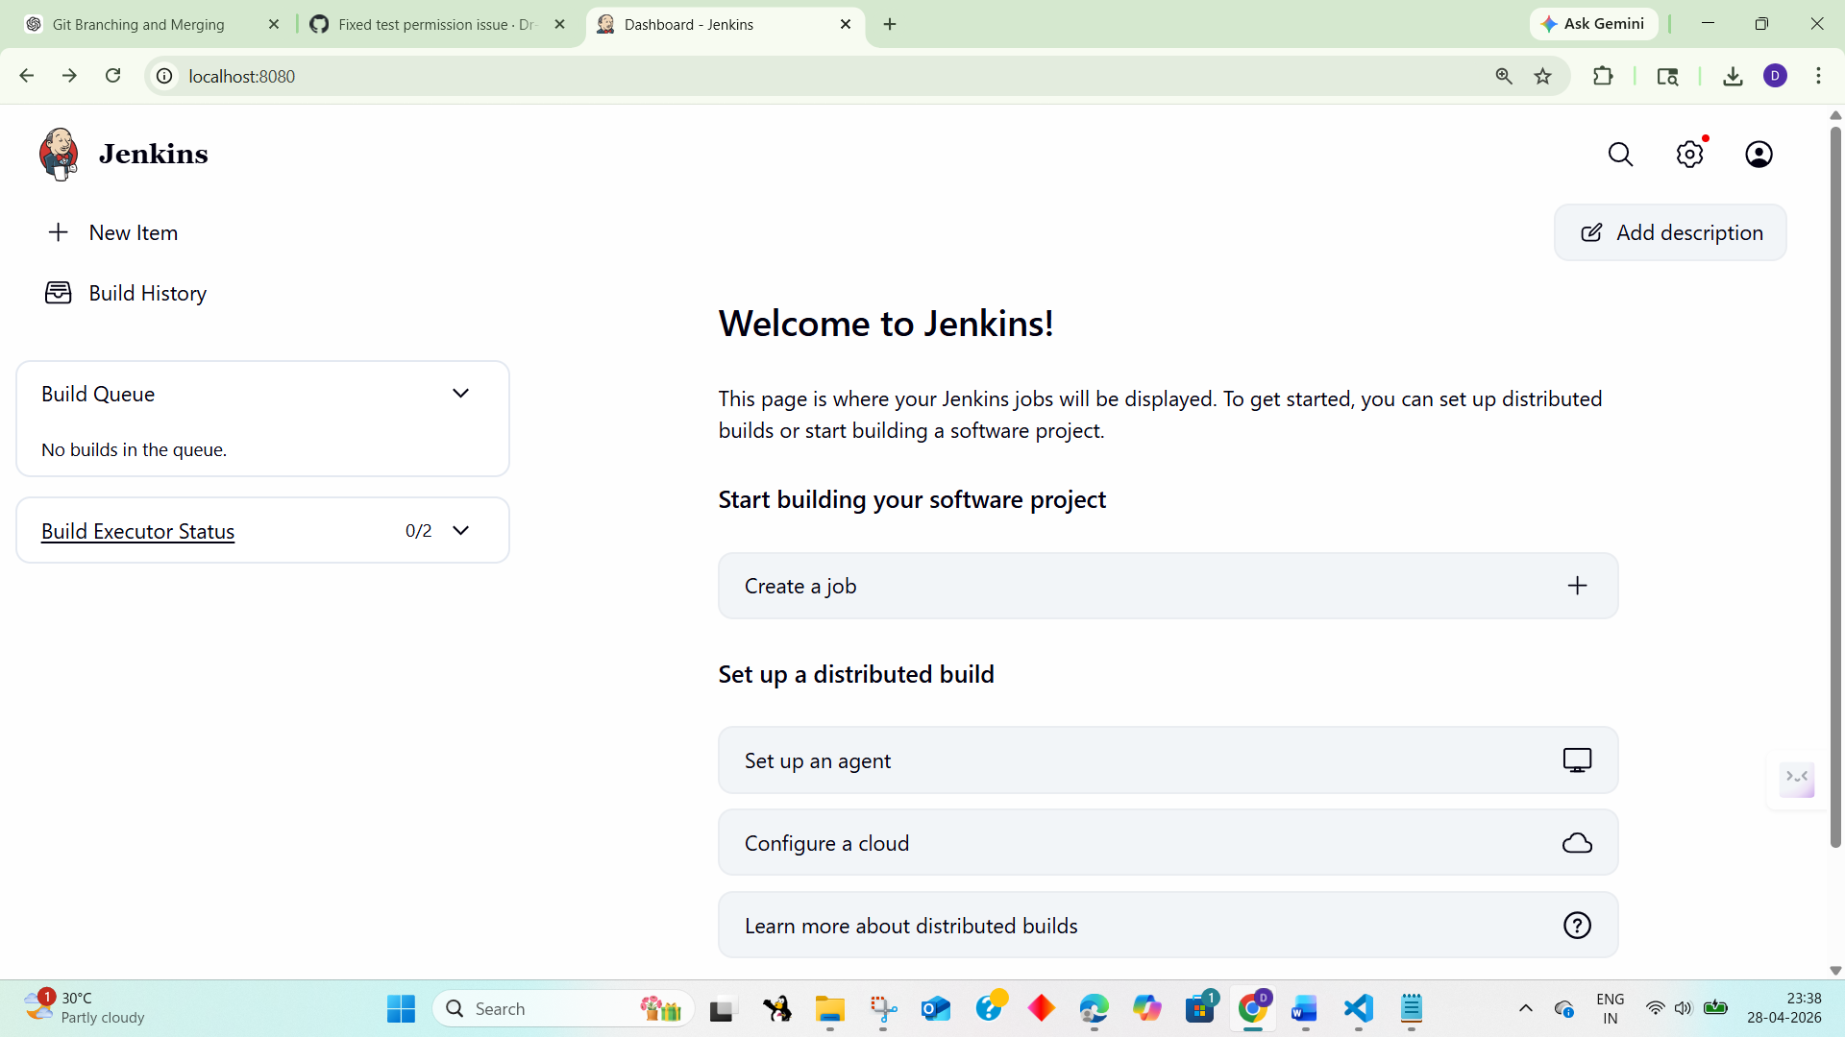

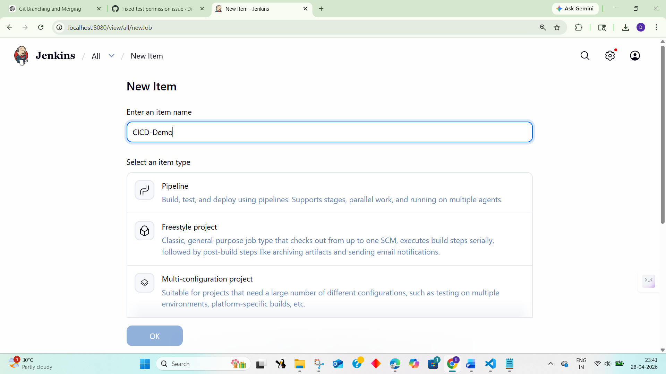

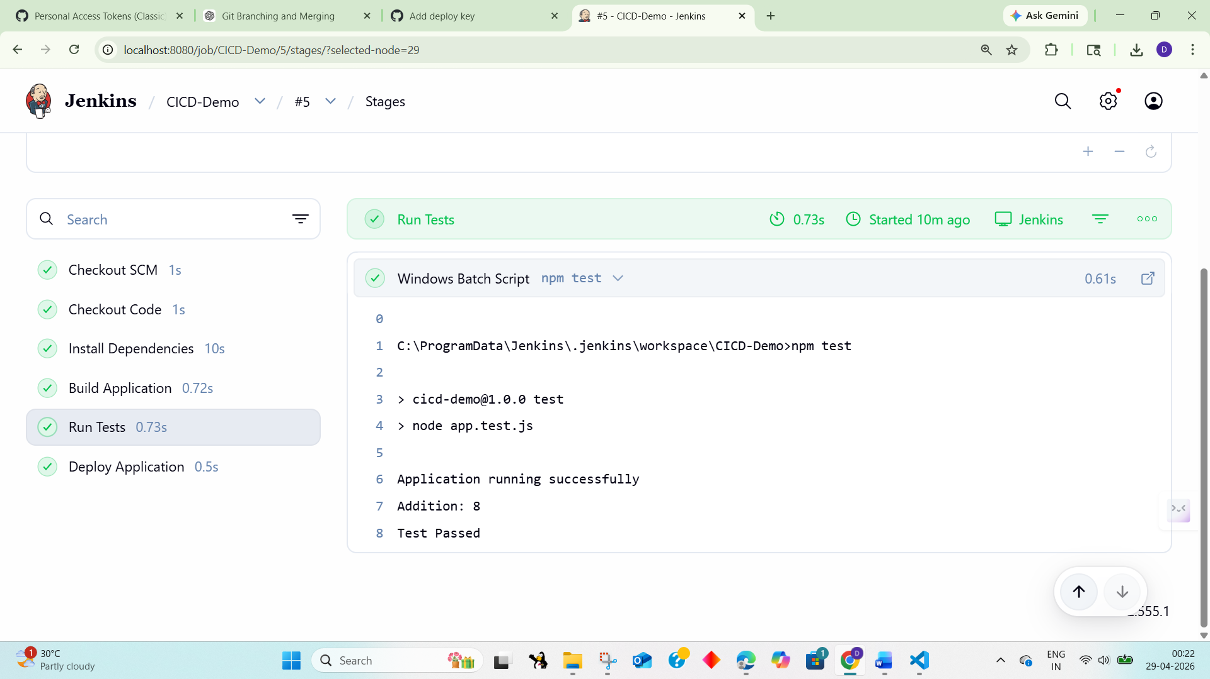

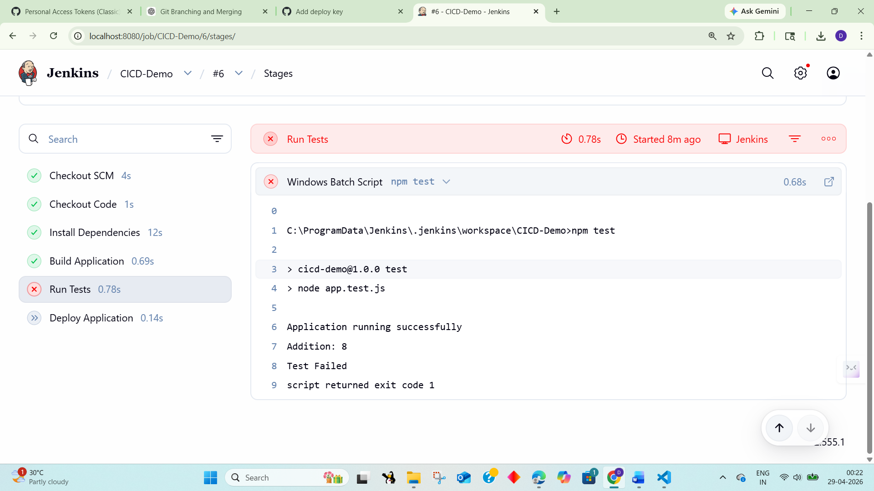
Result
Thus, a CI/CD pipeline was successfully implemented using Jenkins. The pipeline automated code checkout, dependency installation, build process, testing, and deployment of the Node.js application.

Task 22: Explore major cloud service providers such as AWS, Google Cloud, and Microsoft Azure. Identify and compare their core services related to compute, storage, databases, and networking, along with the pay-as-you-use pricing model.

COMPARISON OF CLOUD SERVICES: AWS, GOOGLEC CLOUD, MICROSOFT AZURE
AIM: To develop a cloud comparison application that displays and compares services and pricing models of AWS, GCP, and Azure
ALGORITHM:
- Start the program
- Create project files (HTML, CSS, JS, server.js, db.js)
- Design user interface with dropdown for cloud providers
- Initialize cloud service data (AWS, GCP, Azure) in database module
- Capture selected provider using JavaScript
- Send request to server to fetch service details
- Display compute, storage, database, and networking services
- Accept user input for compute hours and storage usage
- Send input data to server for cost calculation
- Calculate cost based on pay-as-you-use pricing model
- Display total cost dynamically on UI
- Stop the program
PROGRAM:
INDEX.HTML:
<!DOCTYPE html>
<html>
<head>
<title>Cloud Comparison</title>
<link rel="stylesheet" href="style.css">
</head>
<body>
<div class="container">
<h2>Cloud Service Comparison</h2>
<select id="provider" onchange="loadData()">
<option value="aws">AWS</option>
<option value="gcp">GCP</option>
<option value="azure">Azure</option>
</select>
<h3>Services</h3>
<ul id="services"></ul>
<h3>Pricing Calculator</h3>
<input id="hours" placeholder="Compute Hours">
<input id="storage" placeholder="Storage (GB)">
<button onclick="calculate()">Calculate Cost</button>
<h3 id="result"></h3>
</div>
<script src="script.js"></script>
</body>
</html>
STYLE.CSS:
body {
font-family: Arial;
background: #1e1e2f; color: white; display:flex;
justify-content:center; align-items:center;
height:100vh;
}
.container {
text-align:center; width: 350px;
}
input, select, button { margin: 5px; padding: 8px;
}
li {
background: #333; margin: 5px; padding: 5px;
}
SCRIPT.JS:
function loadData() {
const provider = document.getElementById("provider").value; fetch(`/services/${provider}`)
.then(res => res.json())
.then(data => {
let list = document.getElementById("services"); list.innerHTML = "";
Object.entries(data).forEach(([key, value]) => { let li = document.createElement("li");
li.innerText = `${key}: ${value}`; list.appendChild(li);
});
});
}
function calculate() {
const provider = document.getElementById("provider").value; const hours = document.getElementById("hours").value; const storage = document.getElementById("storage").value; fetch("/cost", {
method: "POST",
headers: {"Content-Type":"application/json"}, body: JSON.stringify({ provider, hours, storage })
})
.then(res => res.json())
.then(data => {
document.getElementById("result").innerText = "Cost: $" + data.cost;
});
}
loadData();
SERVER.JS:
const express = require("express"); const db = require("./db");
const app = express(); app.use(express.json());
app.use(express.static( dirname)); app.get("/services/:provider", (req, res) => {
res.json(db.getServices(req.params.provider));
});
app.post("/cost", (req, res) => {
const { provider, hours, storage } = req.body;
const cost = db.calculate(provider, hours, storage); res.json({ cost });
});
app.listen(3000, () => {
console.log("http://localhost:3000");
});
DB.JS:
const services = { aws: {
Compute: "EC2", Storage: "S3", Database: "RDS", Network: "VPC"
},
gcp: {
Compute: "Compute Engine", Storage: "Cloud Storage", Database: "Cloud SQL", Network: "VPC"
},
azure: {
Compute: "Virtual Machines", Storage: "Blob Storage",

Database: "SQL Database", Network: "VNet"
}
};
const pricing = {
aws: { compute: 0.1, storage: 0.02 }, gcp: { compute: 0.09, storage: 0.025 }, azure: { compute: 0.11, storage: 0.018 }
};
function getServices(provider) { return services[provider];
}
function calculate(provider, hours, storage) { const p = pricing[provider];
return (hours * p.compute + storage * p.storage).toFixed(2);
}
module.exports = { getServices, calculate };
OUTPUT:
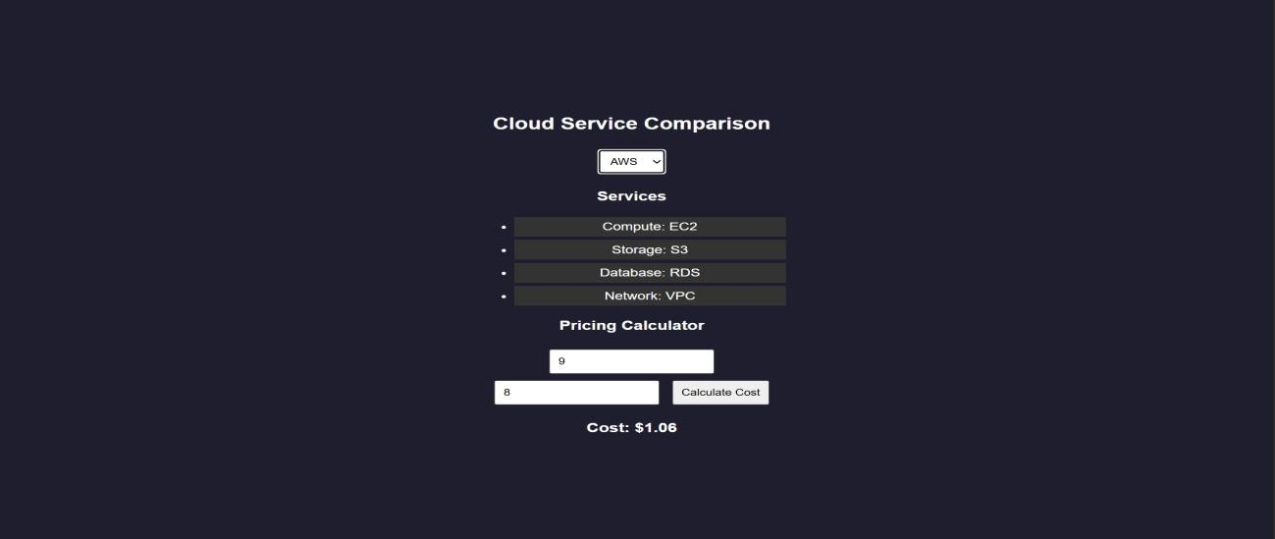

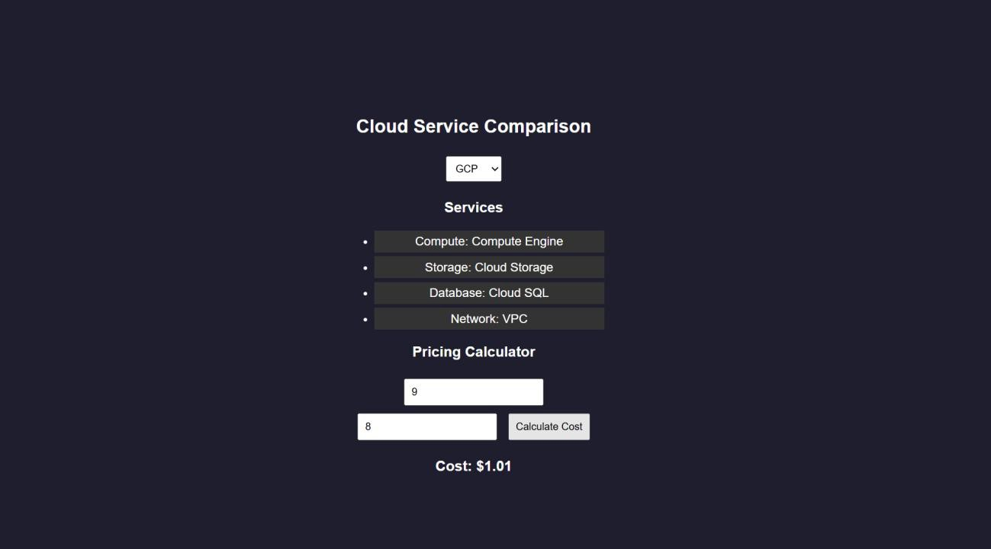
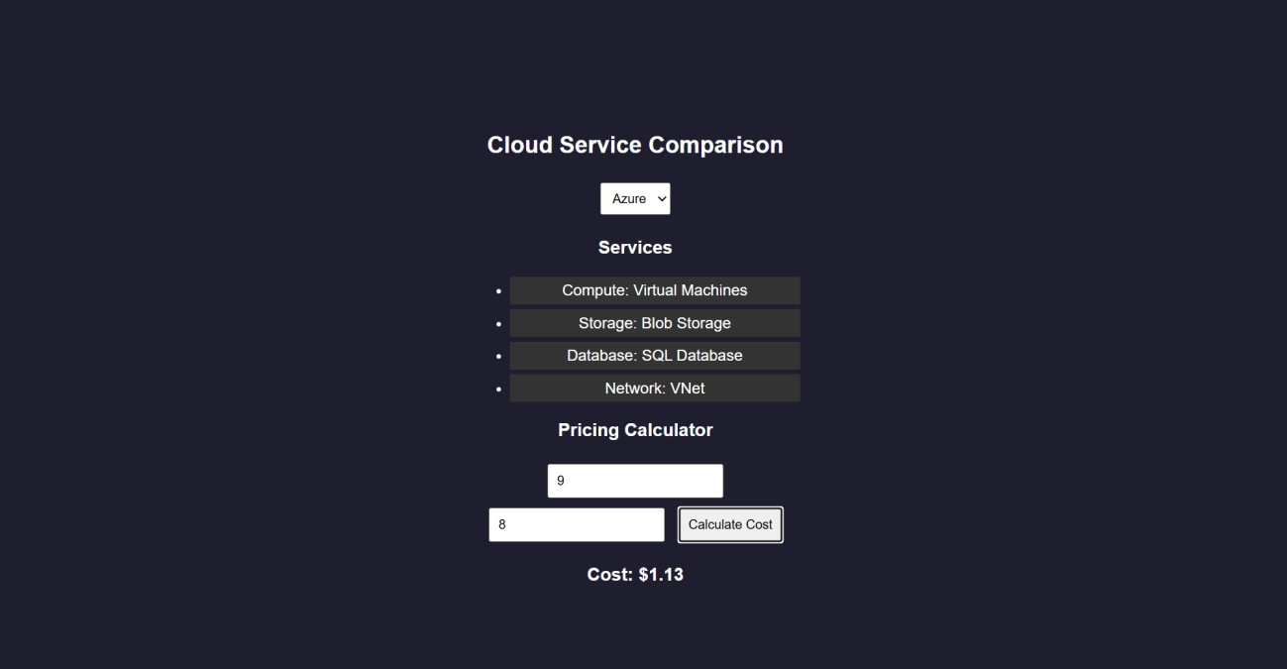
RESULTS: A cloud comparison application was successfully developed to display services and simulate pay-as-you-use pricing across AWS, GCP, and Azure.

Task 23: Apply Vibe Coding and Prompt Engineering techniques using a Generative AI tool. Design effective prompts to generate code snippets, cloud configuration templates, or application logic, and evaluate the quality and efficiency of the generated outputs for real-world business applications.
AI PROMPT APP USING VIBE CODING
AIM: To develop an application that demonstrates prompt engineering by generating and evaluating code or cloud configurations based on user input.
ALGORITHM:
- Start the program
- Create project files (HTML, CSS, JS, server.js, db.js)
- Design UI with input field for user prompt
- Capture user prompt using JavaScript
- Send prompt to server using fetch API
- Receive prompt data in backend (server.js)
- Process prompt using predefined logic (db.js)
- Generate output (code / cloud config / response)
- Evaluate output quality and assign score
- Send generated output and score to frontend
- Display output and score on UI
- Stop the program
PROGRAM:
INDEX.HTML:
<!DOCTYPE html>
<html>
<head>
<title>AI Prompt App</title>
<link rel="stylesheet" href="style.css">
</head>
<body>

<div class="container">
<h2>Prompt Engineering Tool</h2>
<textarea id="prompt" placeholder="Enter your prompt..."></textarea>
<button onclick="generate()">Generate Output</button>
<h3>Generated Output</h3>
<pre id="output"></pre>
<h3>Quality Score</h3>
<p id="score"></p>
</div>
<script src="script.js"></script>
</body>
</html>
STYLE.CSS:
body {
font-family: Arial;
background: #202038; color: white;
display:flex;
justify-content:center; align-items:center;
height:100vh;
}
.container { width: 400px;
text-align: center;
}
textarea { width: 100%; height: 100px; margin: 5px;
}
button { padding: 10px; margin: 10px;
background: #00c6ff; border: none;
color: white;
}
pre {
background: #333; padding: 10px;
}
SCRIPT.JS:
function generate() {
const prompt = document.getElementById("prompt").value; fetch("/generate", {
method: "POST",
headers: {"Content-Type":"application/json"}, body: JSON.stringify({ prompt })
})
.then(res => res.json())
.then(data => {
document.getElementById("output").innerText = data.output; document.getElementById("score").innerText = data.score + "/10";
});
}
SERVER.JS:
const express = require("express"); const db = require("./db");
const app = express();
// Middleware
app.use(express.json());
app.use(express.static( dirname)); // serve HTML
// Home route (optional but useful) app.get("/", (req, res) => {
res.sendFile( dirname + "/index.html");
});
// Generate output app.post("/generate", (req, res) => {
const result = db.processPrompt(req.body.prompt); res.json(result);
});
// START SERVER WITH LINK
app.listen(3000, () => {
console.log(" • Server running at:");
console.log(" http://localhost:3000");
});

DB.JS:
function processPrompt(prompt) { let output = "";
let score = 5;
if (prompt.toLowerCase().includes("code")) { output = `function greet() {
console.log("Hello from AI!");
}`;
score = 9;
}
else if (prompt.toLowerCase().includes("cloud")) { output = `AWS EC2 Config:
- Instance: t2.micro
- Region: us-east-1`; score = 8;
}
else {
output = "Basic AI response generated."; score = 5;
}
return { output, score };
}
module.exports = { processPrompt };
OUTPUT:
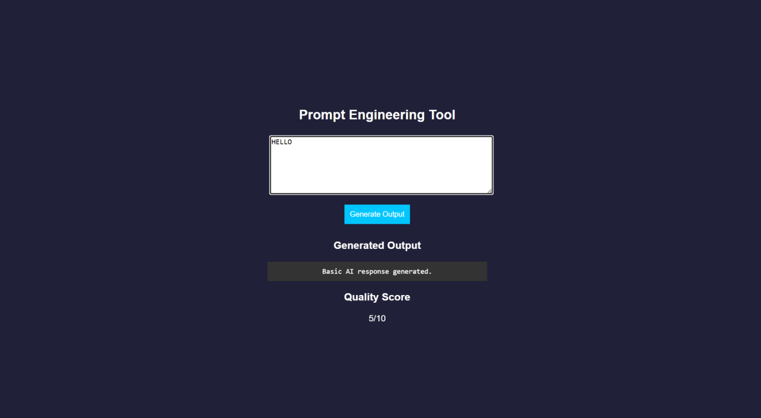
RESULT: A prompt engineering application was successfully developed to generate and evaluate AI-based outputs for code and cloud configurations.

Task 24: Use Vibe Coding to build a complete cloud-based feature using Generative AI. Write iterative prompts to generate a REST API, cloud deployment steps, and security configurations. Refine the prompts based on the output quality, document prompt versions, and evaluate how prompt engineering improves code accuracy, scalability, and real-world usability.

Vibe Cloud App
AIM: To develop an application that uses iterative prompt engineering to generate and evaluate REST APIs, cloud deployment steps, and security configurations.
ALGORITHM:
- Start the program
- Create project files (HTML, CSS, JS, server.js, db.js)
- Design UI to accept user prompts
- Capture prompt input using JavaScript
- Send prompt to backend using fetch API
- Receive prompt in server and forward to processing module
- Store prompt in history for version tracking
- Analyze prompt type (REST API / Cloud / Security)
- Generate corresponding output based on prompt
- Evaluate output quality and assign score
- Return output and score to frontend and display results
- Stop the program
PROGRAM:
INDEX.HTML:
<!DOCTYPE html>
<html>
<head>
<title>Vibe Coding App</title>
<link rel="stylesheet" href="style.css">
</head>
<body>
<div class="container">
<h2>Vibe Coding Cloud Generator</h2>

<textarea id="prompt" placeholder="Enter prompt..."></textarea>
<button onclick="generate()">Generate</button>
<h3>Output</h3>
<pre id="output"></pre>
<h3>Score</h3>
<p id="score"></p>
<h3>Prompt Versions</h3>
<ul id="history"></ul>
</div>
<script src="script.js"></script>
</body>
</html>
STYLE.CSS:
body {
font-family: Arial;
background: #b98bdb; color: white;
display:flex;
justify-content:center; align-items:center;
height:100vh;
}
.container { width: 400px;
text-align: center;
}
textarea { width: 100%; height: 100px;
}
button { padding: 10px; margin: 10px;
background: #00c6ff; border: none;
}
pre {
background: #333; padding: 10px;
}
li {
background: #444; margin: 5px; padding: 5px;
}

SCRIPT.JS:
function generate() {
const prompt = document.getElementById("prompt").value; fetch("/generate", {
method: "POST",
headers: {"Content-Type":"application/json"},
body: JSON.stringify({ prompt })
})
.then(res => res.json())
.then(data => {
document.getElementById("output").innerText = data.output; document.getElementById("score").innerText = data.score + "/10"; loadHistory();
});
}
function loadHistory() { fetch("/history")
.then(res => res.json())
.then(data => {
let list = document.getElementById("history"); list.innerHTML = "";
data.forEach((p, i) => {
let li = document.createElement("li"); li.innerText = `v${i+1}: ${p.prompt}`; list.appendChild(li);
});
});
}
loadHistory();
SERVER.JS:
const express = require("express"); const db = require("./db")
const app = express(); app.use(express.json());
app.use(express.static( dirname)); app.post("/generate", (req, res) => {
const result = db.process(req.body.prompt); res.json(result);
});
app.get("/history", (req, res) => { res.json(db.getHistory());
});
app.listen(3000, () => {
console.log(" • http://localhost:3000");
});
DB.JS:
let history = [];
function process(prompt) { let output = "";
let score = 5;
history.push({ prompt });
if (prompt.includes("REST")) {
output = `app.get('/api', (req,res)=>res.send('API running'));`; score = 7;
}
else if (prompt.includes("cloud")) { output = `Deploy using AWS EC2:
- Launch instance
- Install Node.js
- Run app`;
score = 8;
}
else if (prompt.includes("security")) {
output = `Use HTTPS, JWT authentication, and firewall rules`; score = 9;
}
score += Math.min(history.length, 2); return { output, score };
}
function getHistory() { return history;
}
module.exports = { process, getHistory };
OUTPUT:
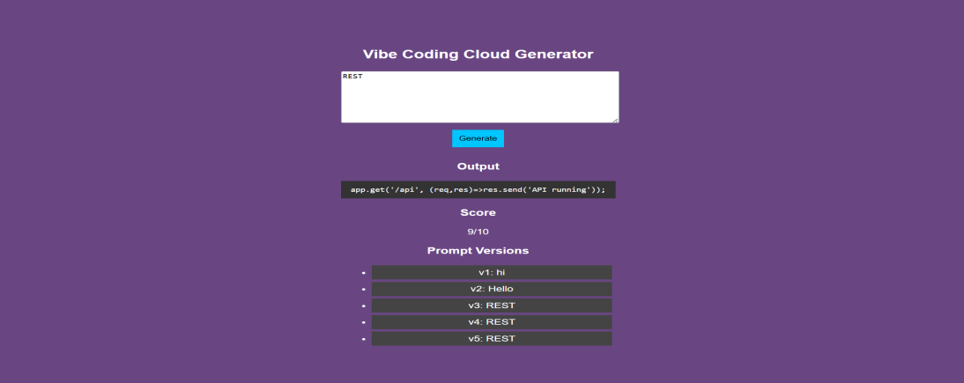
RESULT: A Vibe Coding application was successfully developed to generate and refine cloud-based features using iterative prompt engineering.

